Quick start 测试scapp，通过conda-pack

# 所需的文件在scapp_test_1.tar.gz

# SCAPP_0.tar.gz

# scapp_test_23_3_18.tar.gz

#

# 在1234.5678.91011.121这个服务器上

# 登录node1节点（在tc6001上也行，不过一般不要在登录节点跑东西吧）

# ssh node1

------------------

# 有conda就不用再装了

wget https://repo.anaconda.com/miniconda/Miniconda3-latest-Linux-x86_64.sh

bash Miniconda3-latest-Linux-x86_64.sh

source ~/.bashrc

conda --version

# conda 23.1.0

# 有conda就不用再装了

------------------

# 创建一个测试环境

conda create -n test_xx_xx_xx --offline

# 查看装在哪个文件夹下了，我是"/home/xxx/miniconda3/envs"

cd /home/xxx/miniconda3/envs

mkdir SCAPP_0

# 将SCAPP_0.tar.gz移到该目录SCAPP_0下，并解压

tar -zxvf SCAPP_0.tar.gz

# 回到工作目录

# 激活conda环境

conda activate SCAPP_0

python -m ipykernel install --user --name=SCAPP_0 --display-name='Environment (SCAPP_0)'

jupyter server --generate-config

jupyter server password

# 接下来输入要设置的密码.

# 确认以后会生成后缀为.json的文件，通过笔记本打开，复制hashed密码.

# 同样方式打开后缀为.py同名文件，拉到最后，添加或修改以下内容：

c.NotebookApp.allow_remote_access = True #允许远程连接

c.NotebookApp.ip='*' # 设置所有ip皆可访问

c.NotebookApp.password = u'xxxxxxxxxx' #之前复制的密码,或者输入的字符

c.NotebookApp.notebook_dir = '/xxx/xxx/xxx' # 启动的默认目录

c.NotebookApp.open_browser = False # 禁止自动打开浏览器

c.NotebookApp.port =8888 #任意指定一个端口

# 保存退出.

# 解压scapp_test_23_3_18.tar.gz

tar -zxvf scapp_test_23_3_18.tar.gz

cd scapp_test_23_3_18

# 激活jupyter notebook

jupyter notebook

# 之后会弹出这样一些信息

# [I 19:28:51.970 NotebookApp] http://node1:123451/

# 查看ip信息，将得到的网址替换"http://node1:123451/"中的"node1"

ifconfig

# 打开浏览器，输入网址（这里也可能会直接自动弹出网页）

# 如果是在node1上，那么是1234.5678.91011.128:123451

# 如果是在tc6001上，那么是1234.5678.91011.121:123451

# 会看到这样的界面，可能要输入执行"jupyter server password"时设置的密码

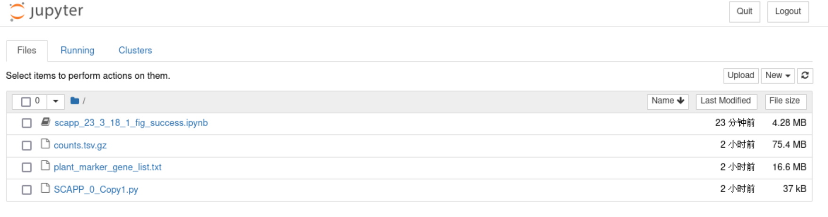

#或者可能需要点这个，"Open with FireFox Web Browser"

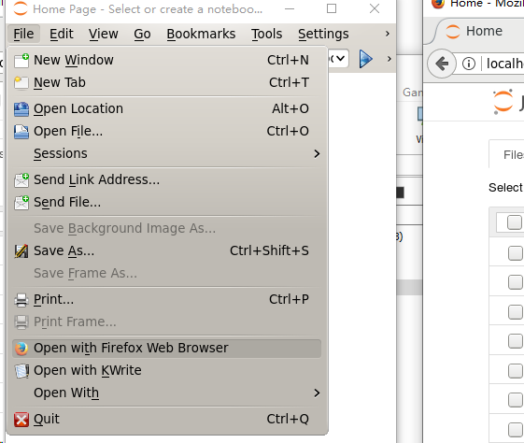

# 选中第一个文件"scapp_23_3_18_1_fig_success.ipynb"，然后Duplicate

# 打开"scapp_23_3_18_1_fig_success.ipynb"和"scapp_23_3_18_1_fig_success-Copy1.ipynb"

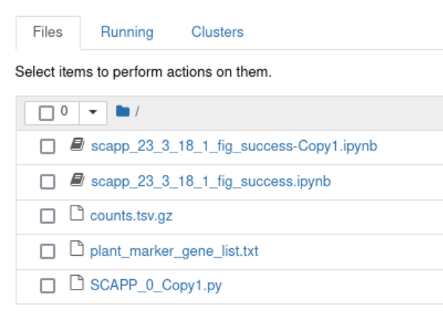

# 在"scapp_23_3_18_1_fig_success-Copy1.ipynb"中，按几下run，等待，所有可执行代码，执行完

# 看看结果是不是跟"scapp_23_3_18_1_fig_success.ipynb"里的差不多，差不多就成了

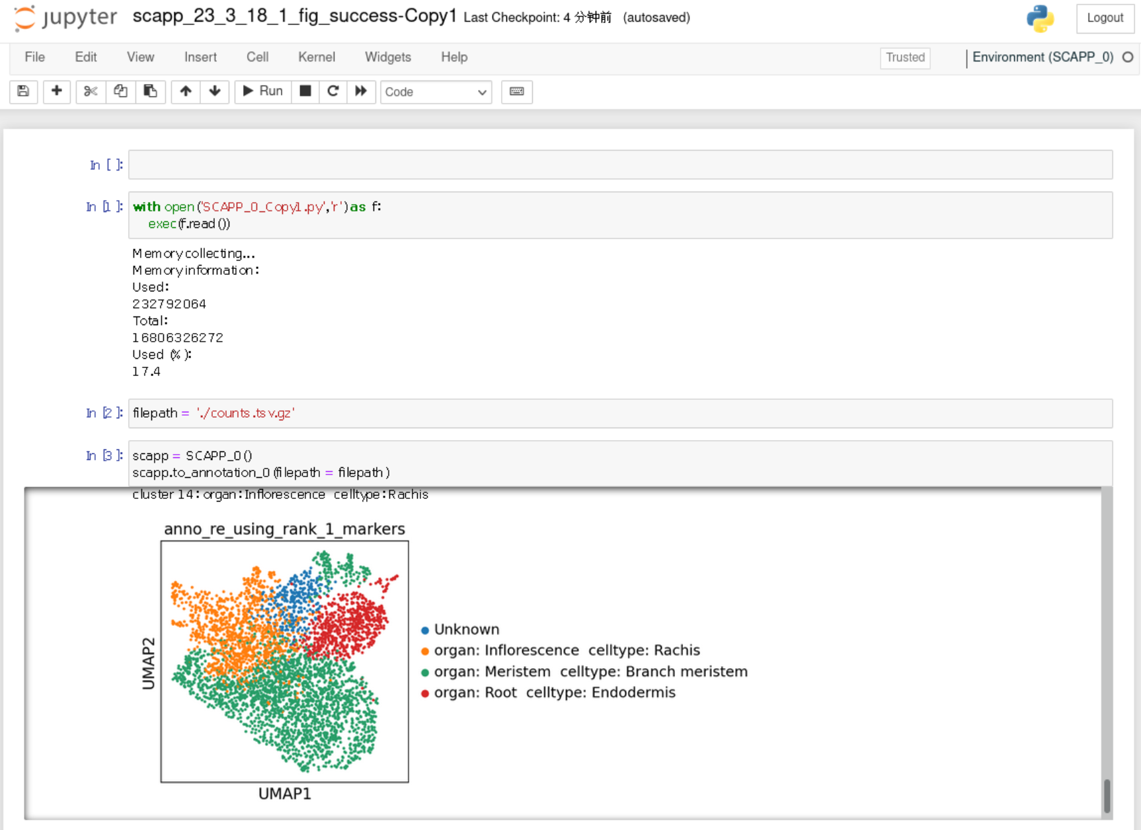

如果从零开始安装的话

cat /proc/version

# Linux version 3.10.0-693.el7.x86_64 (builder@kbuilder.dev.centos.org) (gcc version 4.8.5 20150623 (Red Hat 4.8.5-16) (GCC))

cat /etc/redhat-release

# CentOS Linux release 7.4.1708 (Core)

conda --version

# conda 4.12.0

conda create -n SCAPP_0 --offline

conda activate SCAPP_0

conda install python=3.8

pip install jupyter d2l torch torchvision

conda list |grep jupyter

# jupyter 1.0.0 pypi_0 pypi

# jupyter-client 8.0.3 pypi_0 pypi

# jupyter-console 6.6.1 pypi_0 pypi

# jupyter-core 5.2.0 pypi_0 pypi

# jupyter-events 0.6.3 pypi_0 pypi

# jupyter-server 2.3.0 pypi_0 pypi

# jupyter-server-terminals 0.4.4 pypi_0 pypi

# jupyterlab-pygments 0.2.2 pypi_0 pypi

# jupyterlab-widgets 3.0.5 pypi_0 pypi

conda list |grep d2l

# d2l 0.17.6 pypi_0 pypi

conda list|grep torch

# torch 1.13.1 pypi_0 pypi

# torchvision 0.14.1 pypi_0 pypi

conda install -c conda-forge scanpy

conda list|grep scanpy

# scanpy 1.9.2 pyhd8ed1ab_0 conda-forge

python -m ipykernel install --user --name=SCAPP_0 --display-name='Environment (SCAPP_0)'

conda install -c conda-forge pytables

conda list|grep pytables

# pytables 3.7.0 py38hf19a122_1

conda install -c conda-forge leidenalg

conda list|grep leidenalg

# leidenalg 0.9.1 py38h8dc9893_0 conda-forge

conda install -c bioconda harmonypy

conda list |grep harmonypy

# harmonypy 0.0.6 pyhdfd78af_0 bioconda

pip install optuna -i https://pypi.tuna.tsinghua.edu.cn/simple

pip list|grep optuna

# optuna 3.1.0

pip install optuna-dashboard -i https://pypi.tuna.tsinghua.edu.cn/simple

pip list|grep optuna-dashboard

# optuna-dashboard 0.8.1

pip install plotly -i https://pypi.tuna.tsinghua.edu.cn/simple

pip list|grep plotly

# plotly 5.13.1

conda install -c bioconda -c conda-forge scrublet

conda list|grep scrublet

# scrublet 0.2.3 pyh5e36f6f_1 bioconda

pip install doubletdetection

pip list|grep doubletdetection

# doubletdetection 4.2

conda install -c r -c conda-forge r-irkernel

conda list | grep r-irkernel

# r-irkernel 1.3 r40hc72bb7e_0 conda-forge

conda install -c conda-forge conda-pack

# conda-forge/noarch::conda-pack-0.7.0-pyh6c4a22f_0

使用requirements.txt进行安装

激活conda环境

conda activate <environment_name>

用requirements.txt进行安装

conda install --file requirements.txt

查看SCAPP_Tutorial_0和SCAPP_API_0

建议使用jupyter notebook或vscode查看.ipynb文件。

若查看.html文件，建议多使用Ctrl+F跳转到想要查看的部分。

**Tutorials**

  1 Quick start

    1.1 Use counts.tsv.gz

      1.1.1 Single file

      1.1.2 Multiple files

    1.2 Use matrix.mtx.gz

      1.2.1 Single file

      1.2.2 Multiple files

    1.3 Use anndata

  2 Specific processes

    2.1 Filteration

    2.2 Select highly variable genes

    2.3 Select differentially expressed genes

    2.4 Annotation

  3 Extensions (temporarily unavailable)

    3.1 Doublet detection (temporarily unavailable)

**1 Quick start**

**1.1 Use counts.tsv.gz**

**1.1.1 Single file**

In [1]:

**import** warnings

warnings**.**filterwarnings("ignore")

In [2]:

**with** open('SCAPP_0_Copy1.py','r') **as** f:

exec(f**.**read())

Memory collecting...

Memory information:

Used:

235982848

Total:

201226063872

Used (%):

10.0

In [3]:

filepath **=** '~/data/rice/PRJNA767589/SRR16127058/counts.tsv.gz'

In [4]:

scapp **=** SCAPP_0()

scapp**.**to_annotation_0(filepath **=** filepath)

scanpy==1.9.2 anndata==0.8.0 umap==0.5.3 numpy==1.21.5 scipy==1.7.3 pandas==1.5.2 scikit-learn==1.2.1 statsmodels==0.13.5 python-igraph==0.10.4 louvain==0.8.0 pynndescent==0.5.8

Before filter

normalizing counts per cell

finished (0:00:00)

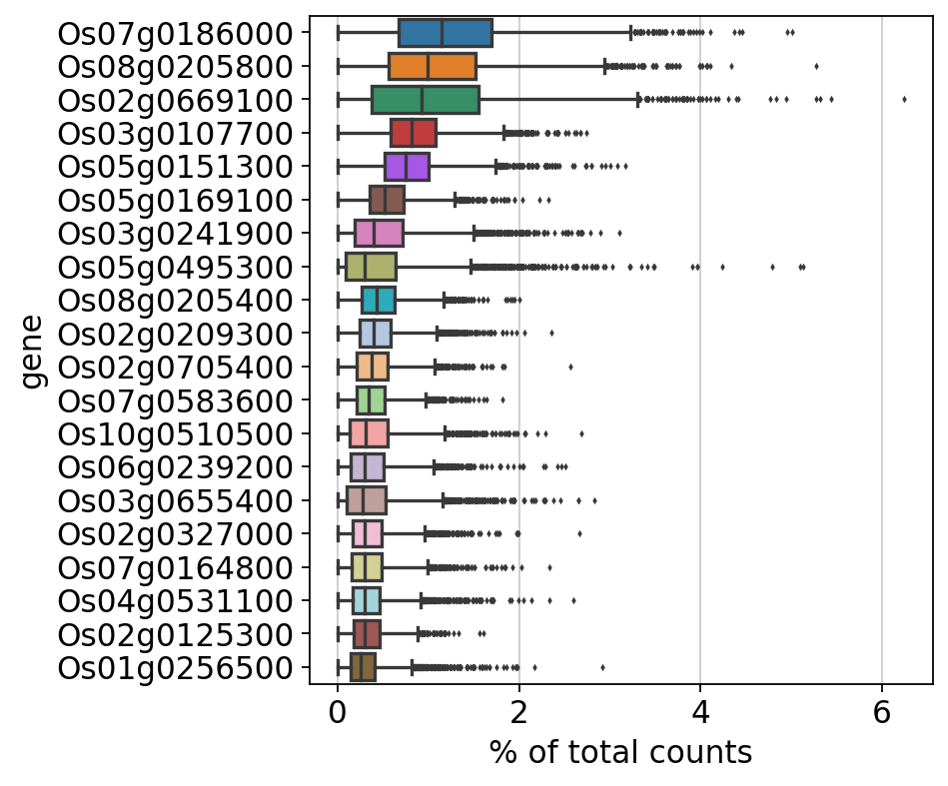

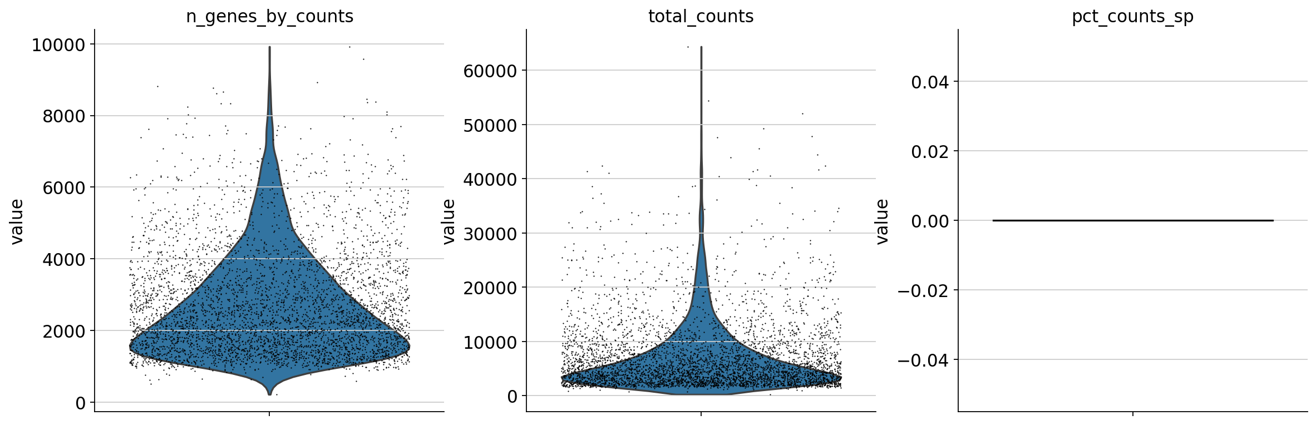

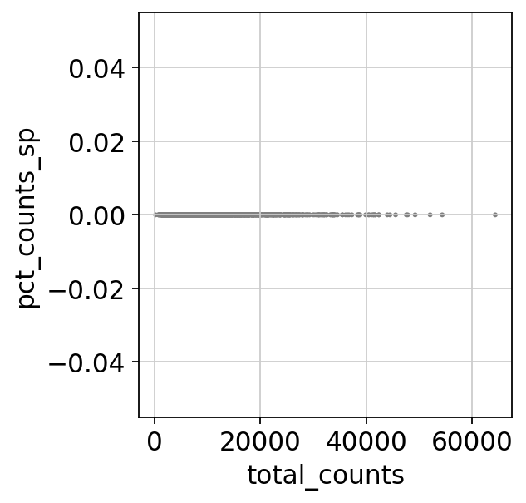

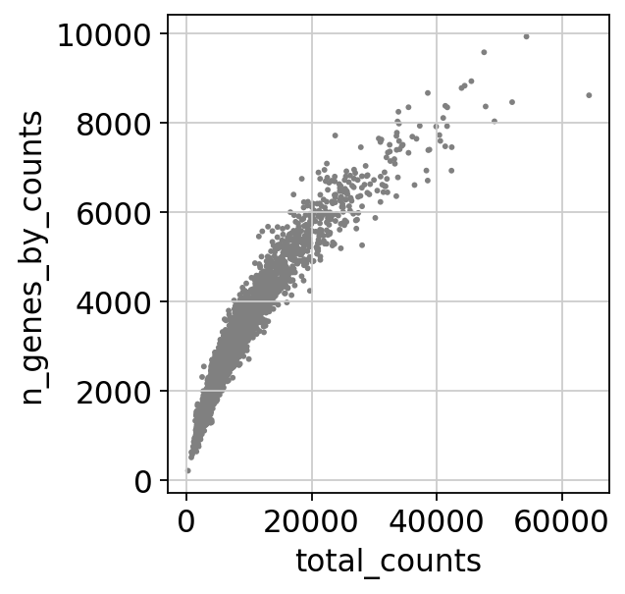

After filter

filtered out 2998 genes that are detected in less than 3 cells

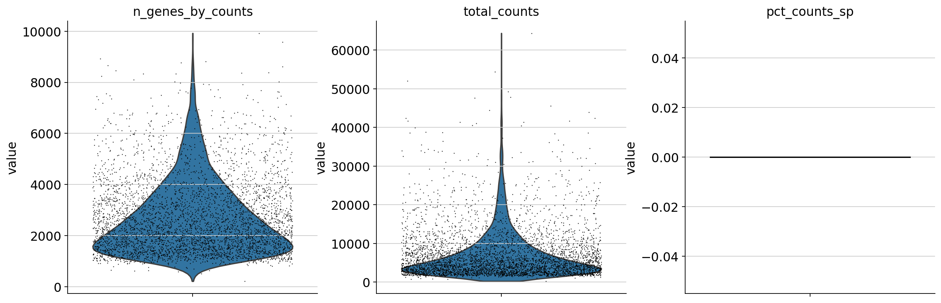





Before filter

count 4336.000000

mean 7103.151983

std 6376.242052

min 249.000000

25% 3012.000000

50% 4970.000000

75% 8760.250000

max 64352.000000

Name: total_counts, dtype: float64

count 4336.000000

mean 2698.808118

std 1424.931102

min 215.000000

25% 1605.750000

50% 2324.000000

75% 3431.500000

max 9922.000000

Name: n_genes_by_counts, dtype: float64

count 4336.0

mean 0.0

std 0.0

min 0.0

25% 0.0

50% 0.0

75% 0.0

max 0.0

Name: pct_counts_sp, dtype: float64

After filter

count 4336.000000

mean 7103.151983

std 6376.242052

min 249.000000

25% 3012.000000

50% 4970.000000

75% 8760.250000

max 64352.000000

Name: total_counts, dtype: float64

count 4336.000000

mean 2698.808118

std 1424.931102

min 215.000000

25% 1605.750000

50% 2324.000000

75% 3431.500000

max 9922.000000

Name: n_genes_by_counts, dtype: float64

count 4336.0

mean 0.0

std 0.0

min 0.0

25% 0.0

50% 0.0

75% 0.0

max 0.0

Name: pct_counts_sp, dtype: float64

normalizing counts per cell

finished (0:00:00)

extracting highly variable genes

finished (0:00:00)

--> added

'highly_variable', boolean vector (adata.var)

'means', float vector (adata.var)

'dispersions', float vector (adata.var)

'dispersions_norm', float vector (adata.var)

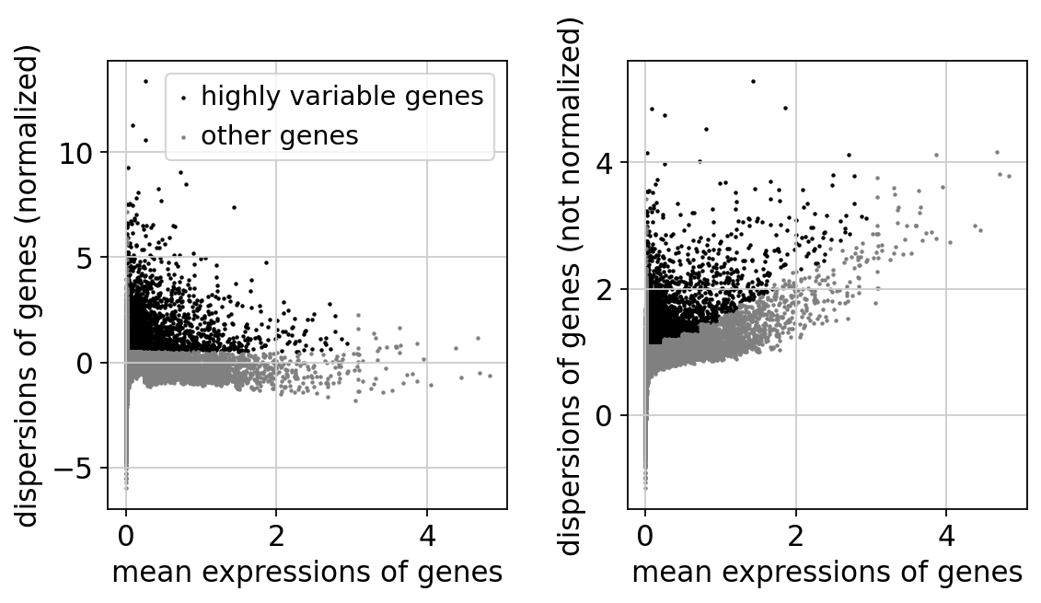

regressing out ['total_counts']

sparse input is densified and may lead to high memory use

finished (0:00:21)

computing PCA

on highly variable genes

with n_comps=50

finished (0:00:00)

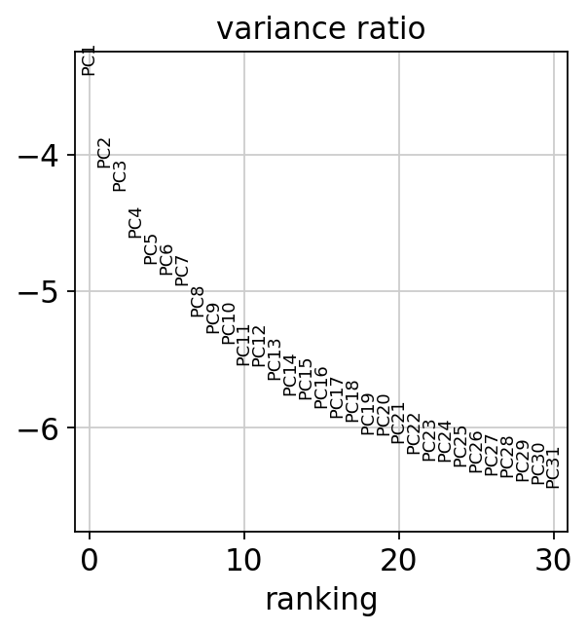

computing neighbors

using 'X_pca' with n_pcs = 40

finished: added to `.uns['neighbors']`

`.obsp['distances']`, distances for each pair of neighbors

`.obsp['connectivities']`, weighted adjacency matrix (0:00:03)

computing UMAP

finished: added

'X_umap', UMAP coordinates (adata.obsm) (0:00:13)

running Leiden clustering

finished: found 15 clusters and added

'leiden', the cluster labels (adata.obs, categorical) (0:00:00)

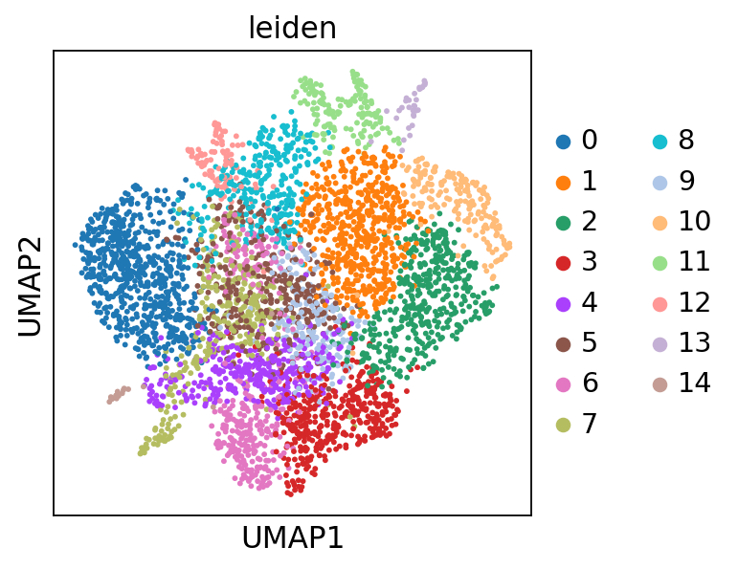

running PAGA

finished: added

'paga/connectivities', connectivities adjacency (adata.uns)

'paga/connectivities_tree', connectivities subtree (adata.uns) (0:00:00)

--> added 'pos', the PAGA positions (adata.uns['paga'])

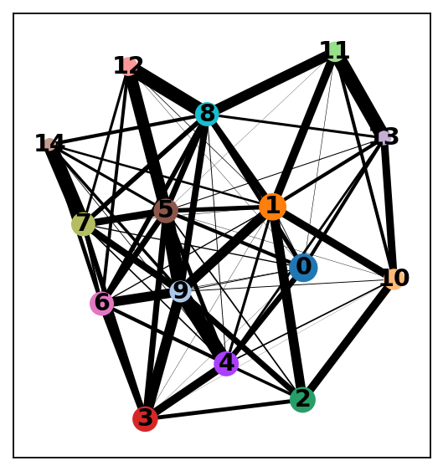

computing UMAP

finished: added

'X_umap', UMAP coordinates (adata.obsm) (0:00:13)

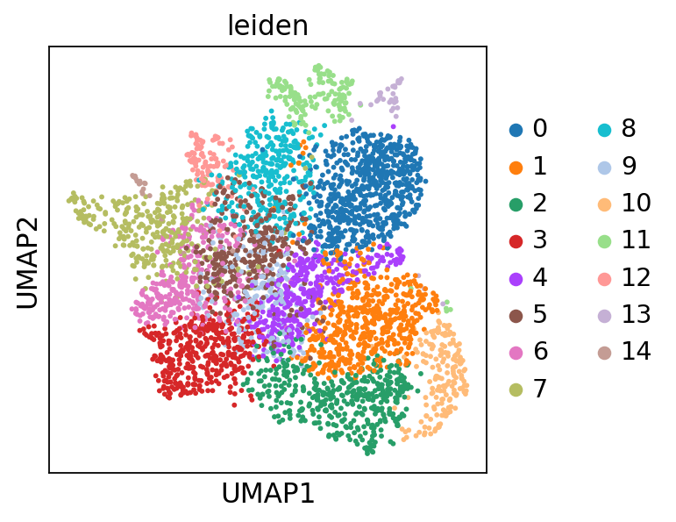

ranking genes

finished: added to `.uns['rank_genes_groups']`

'names', sorted np.recarray to be indexed by group ids

'scores', sorted np.recarray to be indexed by group ids

'logfoldchanges', sorted np.recarray to be indexed by group ids

'pvals', sorted np.recarray to be indexed by group ids

'pvals_adj', sorted np.recarray to be indexed by group ids (0:00:01)

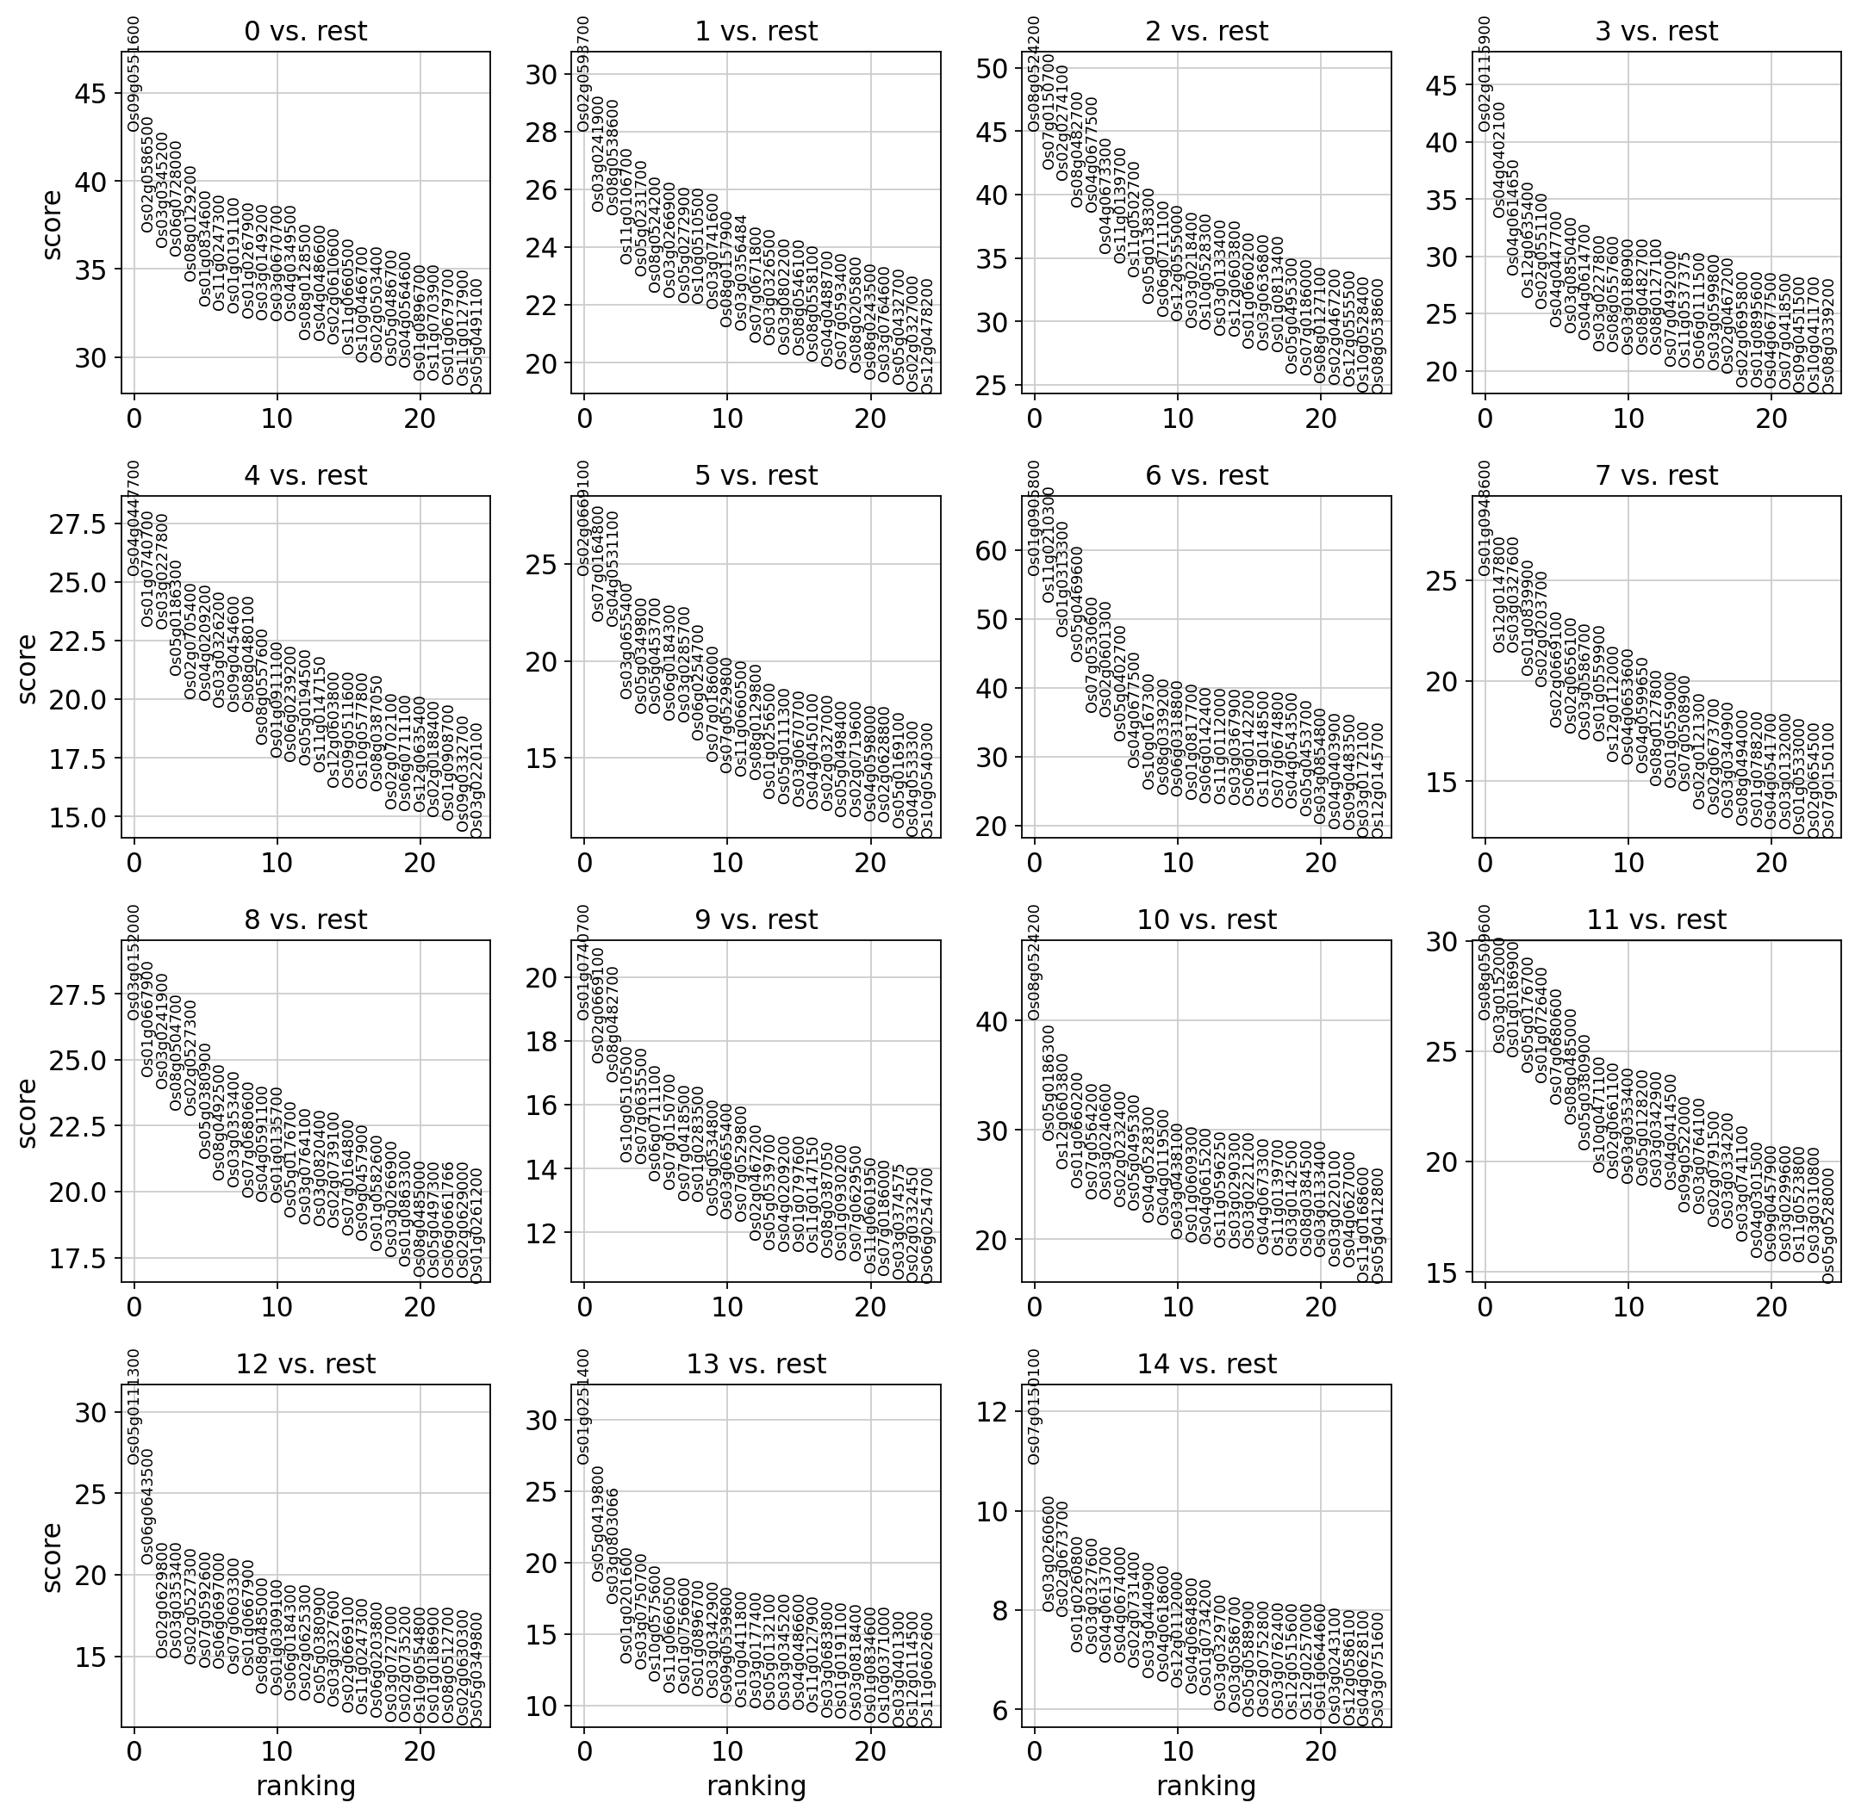

The below is the top marker gene list for each cluster.

You can change the annotation result according to this.

The list of top marker genes

col : clusters

0 1 2 3 4 \

0 Os09g0551600 Os02g0593700 Os08g0524200 Os02g0115900 Os04g0447700

1 Os02g0586500 Os03g0241900 Os07g0150700 Os04g0402100 Os01g0740700

2 Os03g0345200 Os08g0538600 Os02g0274100 Os04g0614650 Os03g0227800

3 Os06g0728000 Os11g0106700 Os08g0482700 Os12g0635400 Os05g0186300

4 Os08g0129200 Os05g0231700 Os04g0677500 Os02g0551100 Os02g0705400

5 Os01g0834600 Os08g0524200 Os04g0673300 Os04g0447700 Os04g0209200

6 Os11g0247300 Os03g0266900 Os11g0139700 Os03g0850400 Os03g0326200

7 Os01g0191100 Os05g0272900 Os11g0502700 Os04g0614700 Os09g0454600

8 Os01g0267900 Os10g0510500 Os05g0138300 Os03g0227800 Os08g0480100

9 Os03g0149200 Os03g0741600 Os06g0711100 Os08g0557600 Os08g0557600

10 Os03g0670700 Os08g0157900 Os12g0555000 Os03g0180900 Os01g0911100

11 Os04g0349500 Os03g0356484 Os03g0218400 Os08g0482700 Os06g0239200

12 Os08g0128500 Os07g0671800 Os10g0528300 Os08g0127100 Os05g0194500

13 Os04g0486600 Os03g0326500 Os03g0133400 Os07g0492000 Os11g0147150

14 Os02g0610600 Os03g0802200 Os12g0603800 Os11g0537375 Os12g0603800

15 Os11g0660500 Os08g0546100 Os01g0660200 Os06g0111500 Os09g0511600

16 Os10g0466700 Os08g0558100 Os03g0636800 Os03g0599800 Os10g0577800

17 Os02g0503400 Os04g0488700 Os01g0813400 Os02g0467200 Os08g0387050

18 Os05g0486700 Os07g0593400 Os05g0495300 Os02g0695800 Os02g0702100

19 Os04g0564600 Os08g0205800 Os07g0186000 Os01g0895600 Os06g0711100

5 6 7 8 9 \

0 Os02g0669100 Os01g0905800 Os01g0948600 Os03g0152000 Os01g0740700

1 Os07g0164800 Os11g0210300 Os12g0147800 Os01g0667900 Os02g0669100

2 Os04g0531100 Os01g0313300 Os03g0327600 Os03g0241900 Os08g0482700

3 Os03g0655400 Os05g0469600 Os01g0839900 Os08g0504700 Os10g0510500

4 Os05g0349800 Os07g0530600 Os02g0203700 Os02g0527300 Os07g0635500

5 Os05g0453700 Os02g0601300 Os02g0669100 Os05g0380900 Os06g0711100

6 Os06g0184300 Os05g0402700 Os02g0656100 Os08g0492500 Os07g0150700

7 Os03g0285700 Os04g0677500 Os03g0586700 Os03g0353400 Os07g0418500

8 Os06g0254700 Os10g0167300 Os01g0559900 Os07g0680600 Os01g0283500

9 Os07g0186000 Os08g0339200 Os12g0112000 Os04g0591100 Os05g0534800

10 Os07g0529800 Os06g0318800 Os04g0653600 Os01g0135700 Os03g0655400

11 Os11g0660500 Os01g0817700 Os04g0599650 Os05g0176700 Os07g0529800

12 Os08g0129800 Os06g0142400 Os08g0127800 Os03g0764100 Os02g0467200

13 Os01g0256500 Os11g0112000 Os01g0559000 Os03g0820400 Os05g0539700

14 Os05g0111300 Os03g0367900 Os07g0508900 Os02g0739100 Os04g0209200

15 Os03g0670700 Os06g0142200 Os02g0121300 Os07g0164800 Os01g0797600

16 Os04g0450100 Os11g0148500 Os02g0673700 Os09g0457900 Os11g0147150

17 Os02g0327000 Os07g0674800 Os03g0340900 Os01g0582600 Os08g0387050

18 Os05g0498400 Os04g0543500 Os08g0494000 Os03g0266900 Os01g0930200

19 Os02g0719600 Os05g0453700 Os01g0788200 Os01g0863300 Os07g0629500

10 11 12 13 14

0 Os08g0524200 Os08g0509600 Os05g0111300 Os01g0251400 Os07g0150100

1 Os05g0186300 Os03g0152000 Os06g0643500 Os05g0419800 Os03g0260600

2 Os12g0603800 Os01g0186900 Os02g0629800 Os03g0803066 Os02g0673700

3 Os01g0660200 Os05g0176700 Os03g0353400 Os01g0201600 Os01g0260800

4 Os07g0564200 Os01g0726400 Os02g0527300 Os03g0750700 Os03g0327600

5 Os03g0240600 Os07g0680600 Os07g0592600 Os10g0575600 Os04g0613700

6 Os02g0232400 Os08g0485000 Os06g0697000 Os11g0660500 Os04g0674000

7 Os05g0495300 Os05g0380900 Os07g0603300 Os01g0756600 Os02g0731400

8 Os04g0528300 Os10g0471100 Os01g0667900 Os01g0896700 Os03g0440900

9 Os04g0119500 Os02g0661100 Os08g0485000 Os03g0342900 Os04g0618600

10 Os03g0438100 Os03g0353400 Os01g0309100 Os09g0539800 Os12g0112000

11 Os01g0609300 Os05g0128200 Os06g0184300 Os10g0411800 Os04g0684800

12 Os04g0615200 Os03g0342900 Os02g0625300 Os03g0177400 Os01g0734200

13 Os11g0596250 Os04g0414500 Os05g0380900 Os05g0132100 Os03g0329700

14 Os03g0290300 Os09g0522000 Os03g0327600 Os03g0345200 Os03g0586700

15 Os03g0221200 Os03g0764100 Os02g0669100 Os04g0486600 Os05g051234500

16 Os04g0673300 Os02g0791500 Os11g0247300 Os11g0127900 Os02g0752800

17 Os11g0139700 Os03g0334200 Os06g0203800 Os03g0683800 Os03g0762400

18 Os03g0142500 Os03g0741100 Os03g0727000 Os01g0191100 Os12g0515600

19 Os08g0384500 Os04g0301500 Os02g0735200 Os03g0818400 Os12g0257000

Top marker genes and their p-values of each cluster:

0_n 0_p 1_n 1_p 2_n \

0 Os09g0551600 1.681748e-205 Os02g0593700 3.667034e-127 Os08g0524200

1 Os02g0586500 2.372192e-178 Os03g0241900 1.161719e-108 Os07g0150700

2 Os03g0345200 3.480940e-187 Os08g0538600 2.237875e-106 Os02g0274100

3 Os06g0728000 3.644451e-187 Os11g0106700 7.172267e-92 Os08g0482700

4 Os08g0129200 1.778459e-159 Os05g0231700 8.696977e-86 Os04g0677500

5 Os01g0834600 4.064781e-158 Os08g0524200 3.281534e-88 Os04g0673300

6 Os11g0247300 3.124184e-167 Os03g0266900 1.945636e-83 Os11g0139700

7 Os01g0191100 9.328110e-150 Os05g0272900 4.238090e-82 Os11g0502700

8 Os01g0267900 8.708761e-150 Os10g0510500 1.474702e-87 Os05g0138300

9 Os03g0149200 1.686698e-144 Os03g0741600 3.262648e-80 Os06g0711100

10 Os03g0670700 1.179258e-160 Os08g0157900 8.735753e-83 Os12g0555000

11 Os04g0349500 1.099961e-152 Os03g0356484 1.896218e-78 Os03g0218400

12 Os08g0128500 3.085829e-142 Os07g0671800 1.603483e-74 Os10g0528300

13 Os04g0486600 3.590997e-143 Os03g0326500 1.729414e-75 Os03g0133400

14 Os02g0610600 4.773060e-146 Os03g0802200 7.117985e-78 Os12g0603800

15 Os11g0660500 2.401629e-149 Os08g0546100 1.305257e-70 Os01g0660200

16 Os10g0466700 7.362816e-134 Os08g0558100 1.106885e-73 Os03g0636800

17 Os02g0503400 1.752288e-133 Os04g0488700 8.622327e-72 Os01g0813400

18 Os05g0486700 4.941014e-133 Os07g0593400 1.314962e-68 Os05g0495300

19 Os04g0564600 1.203587e-132 Os08g0205800 4.109613e-73 Os07g0186000

2_p 3_n 3_p 4_n 4_p \

0 1.103507e-241 Os02g0115900 3.297941e-166 Os04g0447700 1.583132e-89

1 5.430284e-230 Os04g0402100 2.331593e-133 Os01g0740700 5.888242e-80

2 3.388274e-208 Os04g0614650 7.570852e-107 Os03g0227800 4.109123e-80

3 7.845371e-218 Os12g0635400 1.184051e-108 Os05g0186300 2.897250e-70

4 8.540899e-183 Os02g0551100 3.847427e-95 Os02g0705400 7.711190e-68

5 3.323978e-151 Os04g0447700 3.781844e-88 Os04g0209200 3.157047e-63

6 4.484162e-168 Os03g0850400 5.783041e-81 Os03g0326200 3.758599e-60

7 4.286616e-137 Os04g0614700 5.155225e-78 Os09g0454600 2.560224e-61

8 1.915706e-131 Os03g0227800 7.554606e-78 Os08g0480100 3.981814e-62

9 9.352638e-143 Os08g0557600 8.384925e-77 Os08g0557600 3.266922e-57

10 2.455604e-113 Os03g0180900 1.015163e-75 Os01g0911100 3.190931e-53

11 1.262708e-111 Os08g0482700 7.574216e-83 Os06g0239200 3.840307e-53

12 7.468191e-126 Os08g0127100 3.000819e-72 Os05g0194500 3.568041e-51

13 1.270833e-114 Os07g0492000 7.612992e-68 Os11g0147150 9.570786e-50

14 1.405511e-118 Os11g0537375 9.439661e-68 Os12g0603800 1.579974e-47

15 2.569364e-103 Os06g0111500 1.057357e-67 Os09g0511600 8.724235e-46

16 7.898138e-111 Os03g0599800 1.779514e-66 Os10g0577800 6.147898e-47

17 5.800844e-121 Os02g0467200 4.006799e-68 Os08g0387050 8.043339e-46

18 1.177949e-106 Os02g0695800 3.226644e-58 Os02g0702100 1.780464e-43

19 3.033481e-105 Os01g0895600 1.725739e-58 Os06g0711100 2.756394e-43

... 10_n 10_p 11_n 11_p \

0 ... Os08g0524200 5.671376e-116 Os08g0509600 7.767042e-60

1 ... Os05g0186300 6.325638e-82 Os03g0152000 6.906382e-58

2 ... Os12g0603800 2.408662e-70 Os01g0186900 1.035474e-59

3 ... Os01g0660200 3.252578e-61 Os05g0176700 1.038682e-54

4 ... Os07g0564200 4.163678e-59 Os01g0726400 5.311923e-53

5 ... Os03g0240600 4.302199e-65 Os07g0680600 1.345562e-51

6 ... Os02g0232400 3.857376e-60 Os08g0485000 5.177793e-49

7 ... Os05g0495300 1.174986e-61 Os05g0380900 3.687351e-47

8 ... Os04g0528300 3.611778e-52 Os10g0471100 3.623886e-43

9 ... Os04g0119500 1.796198e-54 Os02g0661100 2.543556e-43

10 ... Os03g0438100 3.033153e-50 Os03g0353400 1.361203e-43

11 ... Os01g0609300 2.006968e-51 Os05g0128200 2.604395e-43

12 ... Os04g0615200 5.191125e-48 Os03g0342900 2.790156e-44

13 ... Os11g0596250 2.108408e-47 Os04g0414500 1.042040e-41

14 ... Os03g0290300 5.020454e-48 Os09g0522000 7.541781e-39

15 ... Os03g0221200 9.212138e-47 Os03g0764100 5.755347e-39

16 ... Os04g0673300 9.561669e-46 Os02g0791500 1.946306e-38

17 ... Os11g0139700 3.676455e-47 Os03g0334200 8.954524e-38

18 ... Os03g0142500 6.761866e-45 Os03g0741100 9.499812e-36

19 ... Os08g0384500 2.200831e-44 Os04g0301500 1.168208e-33

12_n 12_p 13_n 13_p 14_n \

0 Os05g0111300 6.160960e-49 Os01g0251400 3.325803e-23 Os07g0150100

1 Os06g0643500 7.318557e-39 Os05g0419800 1.376443e-18 Os03g0260600

2 Os02g0629800 8.612943e-28 Os03g0803066 1.791430e-17 Os02g0673700

3 Os03g0353400 9.874195e-29 Os01g0201600 3.928354e-14 Os01g0260800

4 Os02g0527300 1.460096e-27 Os03g0750700 8.657408e-14 Os03g0327600

5 Os07g0592600 9.286675e-27 Os10g0575600 5.237782e-13 Os04g0613700

6 Os06g0697000 1.648564e-26 Os11g0660500 2.639330e-12 Os04g0674000

7 Os07g0603300 8.076934e-26 Os01g0756600 3.357273e-12 Os02g0731400

8 Os01g0667900 1.750544e-26 Os01g0896700 4.357857e-12 Os03g0440900

9 Os08g0485000 2.473360e-23 Os03g0342900 5.426547e-12 Os04g0618600

10 Os01g0309100 5.377386e-23 Os09g0539800 1.399063e-11 Os12g0112000

11 Os06g0184300 5.756816e-23 Os10g0411800 3.192613e-11 Os04g0684800

12 Os02g0625300 1.958087e-22 Os03g0177400 3.464777e-11 Os01g0734200

13 Os05g0380900 2.575778e-22 Os05g0132100 4.938019e-11 Os03g0329700

14 Os03g0327600 6.206318e-22 Os03g0345200 4.473448e-11 Os03g0586700

15 Os02g0669100 1.859949e-21 Os04g0486600 4.836850e-11 Os05g051234500

16 Os11g0247300 5.386650e-21 Os11g0127900 7.077623e-11 Os02g0752800

17 Os06g0203800 4.257906e-20 Os03g0683800 2.102171e-10 Os03g0762400

18 Os03g0727000 2.770461e-19 Os01g0191100 2.214469e-10 Os12g0515600

19 Os02g0735200 2.975603e-19 Os03g0818400 2.872530e-10 Os12g0257000

14_p

0 1.596082e-09

1 2.475658e-07

2 2.923385e-07

3 1.125948e-06

4 1.048660e-06

5 1.608418e-06

6 1.440558e-06

7 2.036221e-06

8 2.846178e-06

9 3.458044e-06

10 4.389196e-06

11 5.605457e-06

12 5.848828e-06

13 1.134921e-05

14 1.149524e-05

15 1.379944e-05

16 1.407998e-05

17 1.570654e-05

18 1.582700e-05

19 1.613504e-05

[20 rows x 30 columns]

cluster 0: organ: Root celltype: Endodermis

cluster 1: organ: Inflorescence celltype: Rachis / organ: Meristem celltype: Branch meristem / organ: Spikelet celltype: Palea

cluster 2: organ: Inflorescence celltype: Meristem / organ: Inflorescence celltype: Rachis / organ: Leaf celltype: Mestome sheath / organ: Meristem celltype: Branch meristem / organ: Root celltype: Procambium / organ: Spikelet celltype: Floret meristem

cluster 3: organ: Inflorescence celltype: Rachis / organ: Leaf celltype: Large paremchyma / organ: Root celltype: Procambium / organ: Root celltype: Trichoblast / organ: Spikelet celltype: Spikelet identity cell

cluster 4: organ: Inflorescence celltype: Leaf / organ: Leaf celltype: Large paremchyma / organ: Root celltype: Cortex / organ: Spikelet celltype: Floret meristem / organ: Spikelet celltype: Spikelet identity cell / organ: Spikelet celltype: Spikelet supporting cell

cluster 5: organ: Inflorescence celltype: Rachis

cluster 6: organ: Inflorescence celltype: Rachis / organ: Leaf celltype: Mestome sheath

cluster 7: organ: Leaf celltype: Mestome sheath / organ: Root celltype: Procambium

cluster 8: organ: Inflorescence celltype: Meristem / organ: Meristem celltype: Inflorescence meristem / organ: Root celltype: Cortex / organ: Spikelet celltype: Cryptic bract

cluster 9: organ: Inflorescence celltype: Leaf / organ: Inflorescence celltype: Rachis / organ: Leaf celltype: Mesophyll / organ: Leaf celltype: Phloem / organ: Root celltype: Procambium / organ: Spikelet celltype: Floret meristem

cluster 10: organ: Inflorescence celltype: Meristem / organ: Leaf celltype: Large paremchyma / organ: Meristem celltype: Branch meristem / organ: Root celltype: Cortex / organ: Spikelet celltype: Floret meristem

cluster 11: organ: Inflorescence celltype: Meristem / organ: Meristem celltype: Branch meristem / organ: Spikelet celltype: Cryptic bract

cluster 12: organ: Inflorescence celltype: Rachis

cluster 13: organ: Spikelet celltype: Cryptic bract / organ: Spikelet celltype: Sterile lemma

cluster 14: organ: Leaf celltype: Mestome sheath / organ: Root celltype: Procambium

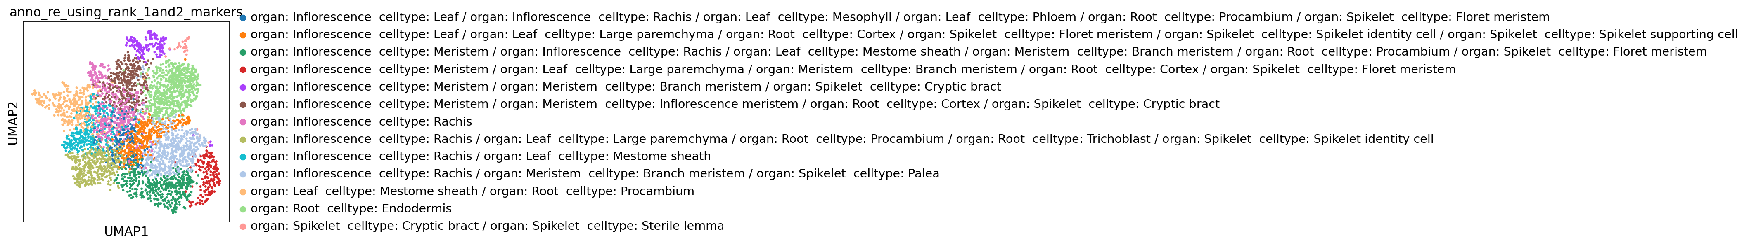

cluster 0: organ: Root celltype: Endodermis

cluster 1: organ: Meristem celltype: Branch meristem

cluster 2: organ: Meristem celltype: Branch meristem

cluster 3: organ: Meristem celltype: Branch meristem

cluster 4: organ: Meristem celltype: Branch meristem

cluster 5: organ: Inflorescence celltype: Rachis

cluster 6: organ: Inflorescence celltype: Rachis

cluster 7: organ: Inflorescence celltype: Rachis

cluster 8: Unknown

cluster 9: organ: Meristem celltype: Branch meristem

cluster 10: organ: Meristem celltype: Branch meristem

cluster 11: organ: Meristem celltype: Branch meristem

cluster 12: organ: Inflorescence celltype: Rachis

cluster 13: organ: Root celltype: Endodermis

cluster 14: organ: Inflorescence celltype: Rachis

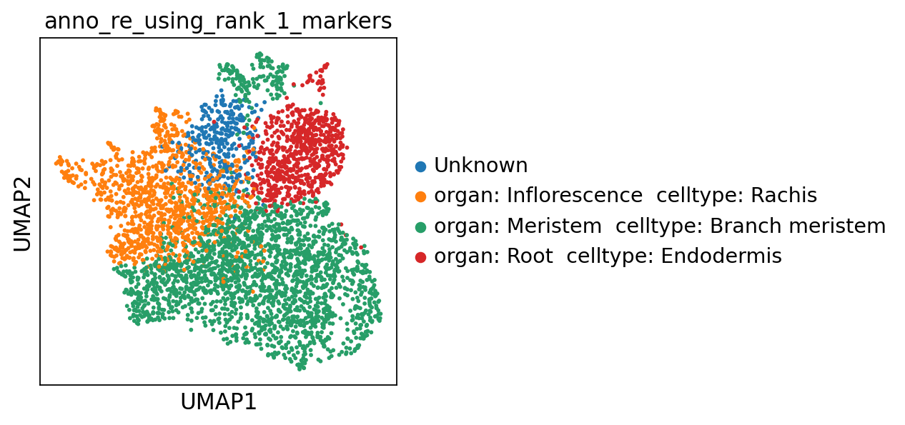

Memory collecting...

Memory information:

Used:

900554752

Total:

201226063872

Used (%):

10.3

In [5]:

**del** scapp

gc**.**collect()

**with** open('SCAPP_0_Copy1.py','r') **as** f:

exec(f**.**read())

Out[5]:

437

Memory collecting...

Memory information:

Used:

745672704

Total:

201226063872

Used (%):

10.2

**1.1.2 Multiple files**

In [ ]:

**with** open('SCAPP_0_Copy1.py','r') **as** f:

exec(f**.**read())

In [6]:

filepaths **=** ['~/data/rice/PRJNA767589/SRR16127058/counts.tsv.gz',

'~/data/rice/PRJNA767589/SRR16127059/counts.tsv.gz',

'~/data/rice/PRJNA767589/SRR16127057/counts.tsv.gz',

'~/data/rice/PRJNA767589/SRR16127055/counts.tsv.gz',

'~/data/rice/PRJNA767589/SRR16127056/counts.tsv.gz']

In [7]:

scapp **=** SCAPP_0()

scapp**.**to_annotation_0(filepaths **=** filepaths)

scanpy==1.9.2 anndata==0.8.0 umap==0.5.3 numpy==1.21.5 scipy==1.7.3 pandas==1.5.2 scikit-learn==1.2.1 statsmodels==0.13.5 python-igraph==0.10.4 louvain==0.8.0 pynndescent==0.5.8

Before filter

normalizing counts per cell

finished (0:00:01)

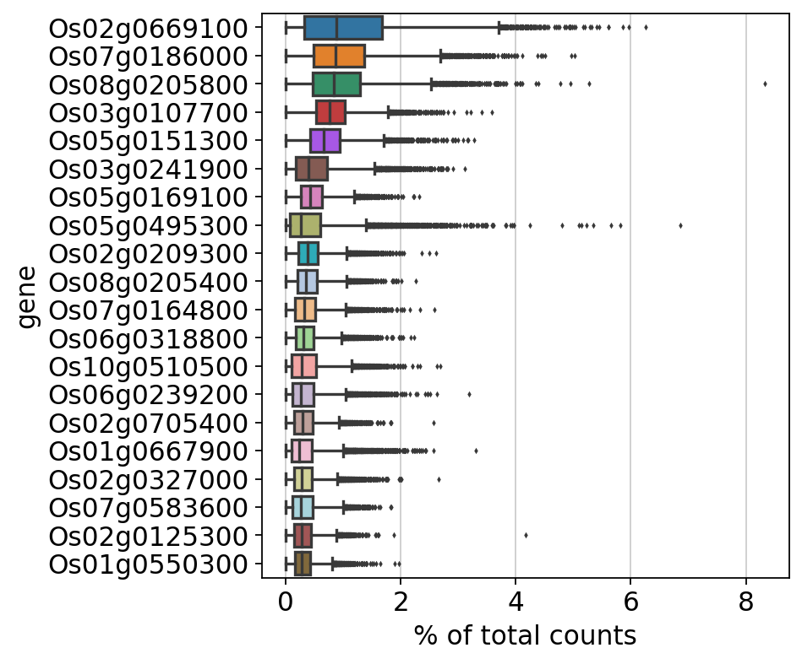

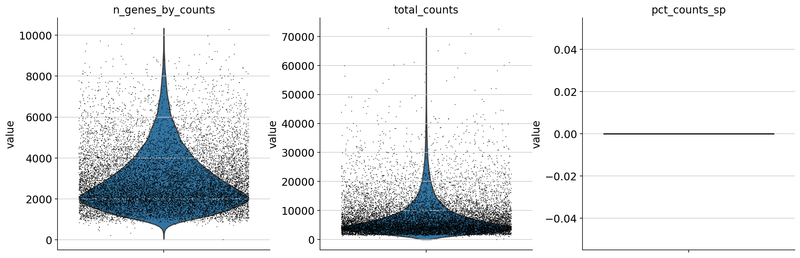

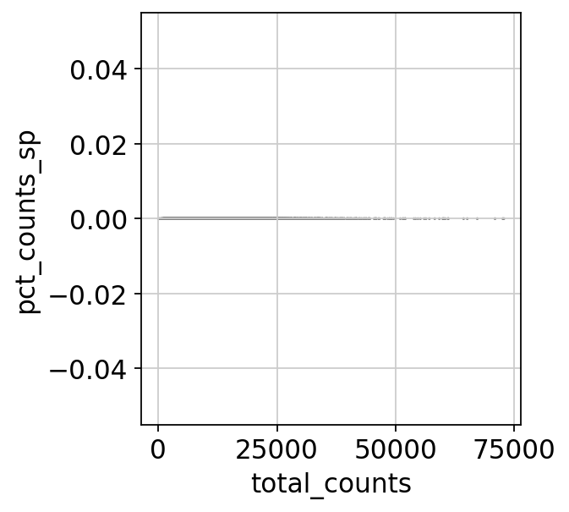

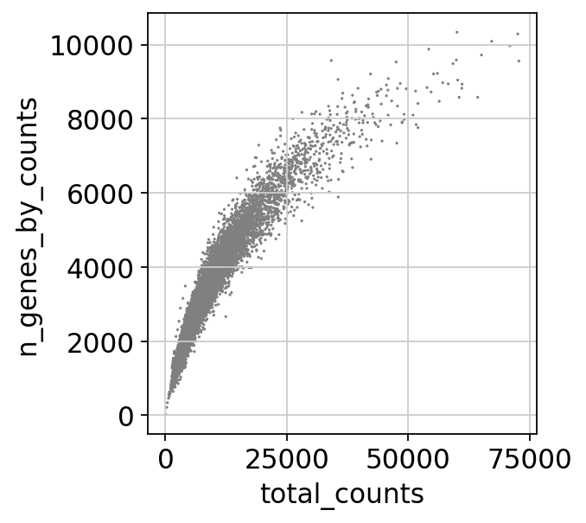

After filter

filtered out 1 cells that have less than 200 genes expressed

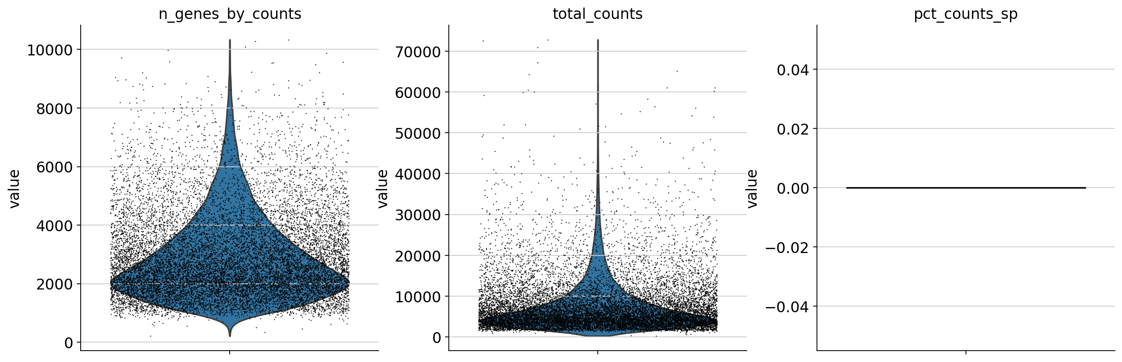

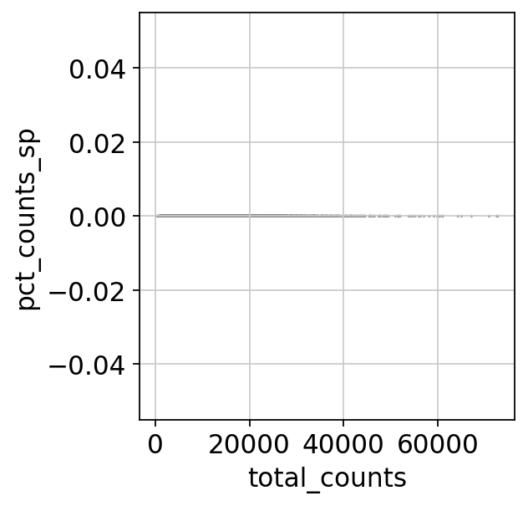

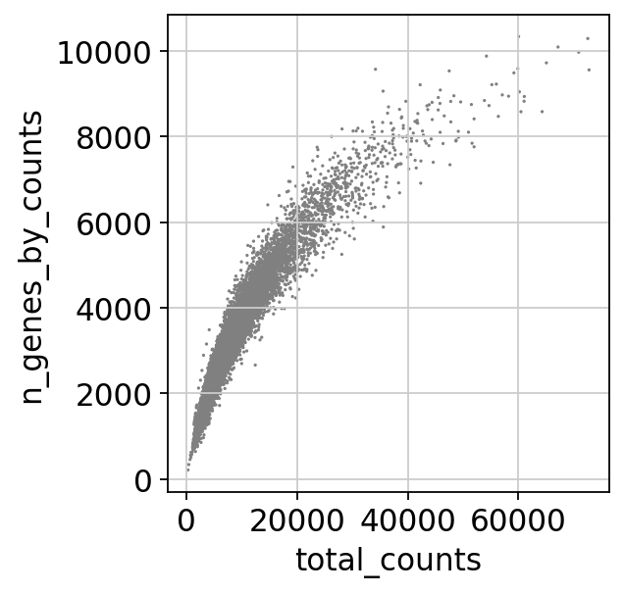

Before filter

count 13993.000000

mean 7659.320303

std 6639.957828

min 24.000000

25% 3611.000000

50% 5537.000000

75% 9241.000000

max 72805.000000

Name: total_counts, dtype: float64

count 13993.000000

mean 2899.904238

std 1436.280512

min 23.000000

25% 1862.000000

50% 2550.000000

75% 3615.000000

max 10335.000000

Name: n_genes_by_counts, dtype: float64

count 13993.0

mean 0.0

std 0.0

min 0.0

25% 0.0

50% 0.0

75% 0.0

max 0.0

Name: pct_counts_sp, dtype: float64

After filter

count 13992.000000

mean 7659.865995

std 6639.881330

min 249.000000

25% 3611.750000

50% 5538.000000

75% 9241.750000

max 72805.000000

Name: total_counts, dtype: float64

count 13992.000000

mean 2900.109848

std 1436.125882

min 215.000000

25% 1862.000000

50% 2550.000000

75% 3615.250000

max 10335.000000

Name: n_genes_by_counts, dtype: float64

count 13992.0

mean 0.0

std 0.0

min 0.0

25% 0.0

50% 0.0

75% 0.0

max 0.0

Name: pct_counts_sp, dtype: float64

normalizing counts per cell

finished (0:00:00)

extracting highly variable genes

finished (0:00:01)

--> added

'highly_variable', boolean vector (adata.var)

'means', float vector (adata.var)

'dispersions', float vector (adata.var)

'dispersions_norm', float vector (adata.var)

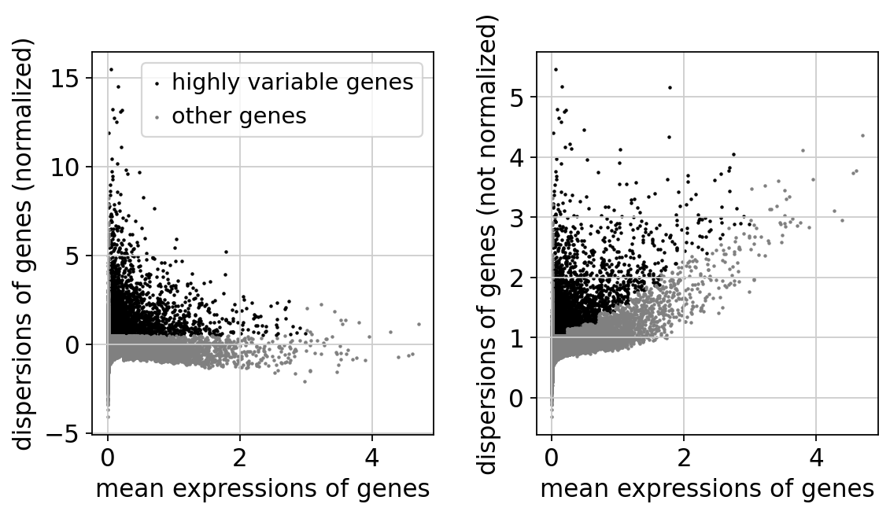

regressing out ['total_counts']

sparse input is densified and may lead to high memory use

finished (0:00:30)

computing PCA

on highly variable genes

with n_comps=50

finished (0:00:01)

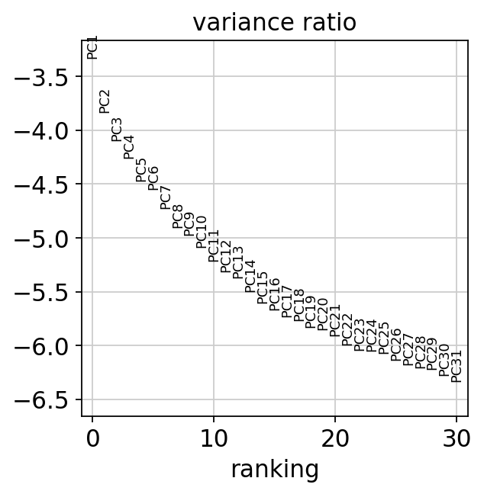

2023-03-23 21:44:38,808 - harmonypy - INFO - Iteration 1 of 10

2023-03-23 21:44:43,483 - harmonypy - INFO - Iteration 2 of 10

2023-03-23 21:44:47,048 - harmonypy - INFO - Converged after 2 iterations

computing neighbors

finished: added to `.uns['neighbors']`

`.obsp['distances']`, distances for each pair of neighbors

`.obsp['connectivities']`, weighted adjacency matrix (0:00:18)

computing UMAP

finished: added

'X_umap', UMAP coordinates (adata.obsm) (0:00:17)

running Leiden clustering

finished: found 19 clusters and added

'leiden', the cluster labels (adata.obs, categorical) (0:00:04)

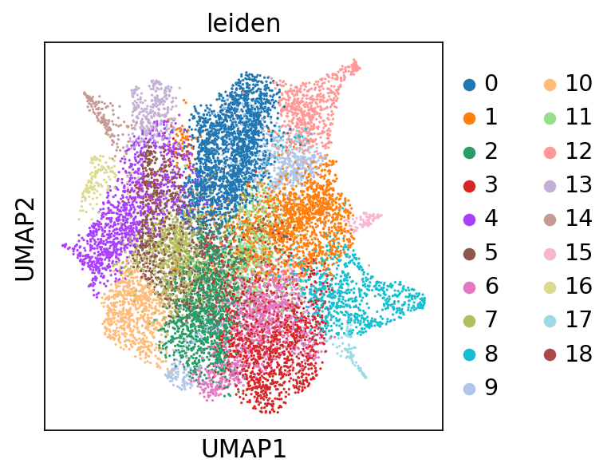

running PAGA

finished: added

'paga/connectivities', connectivities adjacency (adata.uns)

'paga/connectivities_tree', connectivities subtree (adata.uns) (0:00:00)

--> added 'pos', the PAGA positions (adata.uns['paga'])

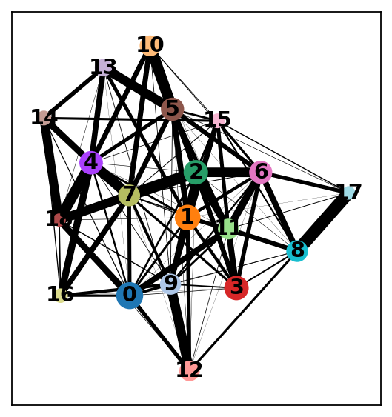

computing UMAP

finished: added

'X_umap', UMAP coordinates (adata.obsm) (0:00:17)

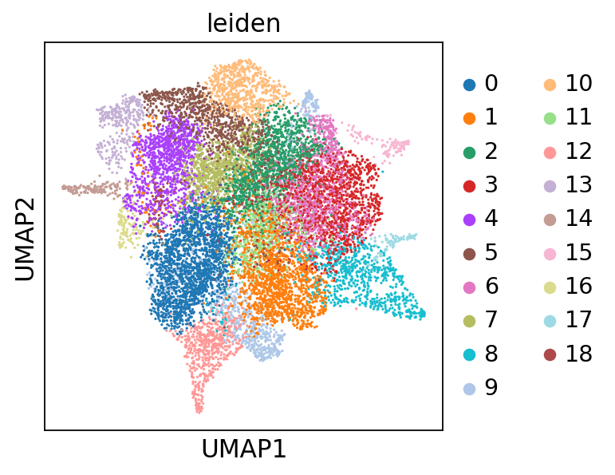

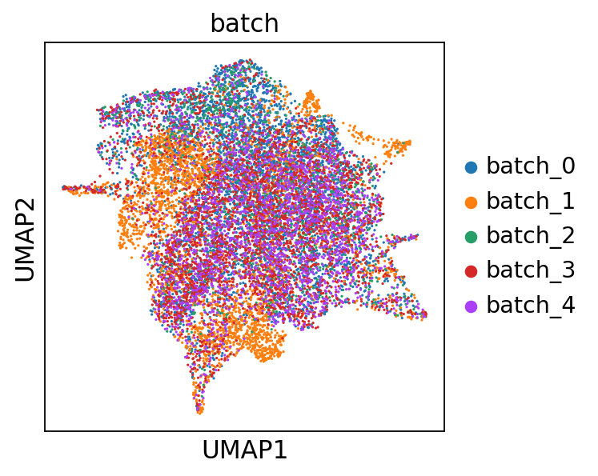

ranking genes

finished: added to `.uns['rank_genes_groups']`

'names', sorted np.recarray to be indexed by group ids

'scores', sorted np.recarray to be indexed by group ids

'logfoldchanges', sorted np.recarray to be indexed by group ids

'pvals', sorted np.recarray to be indexed by group ids

'pvals_adj', sorted np.recarray to be indexed by group ids (0:00:05)

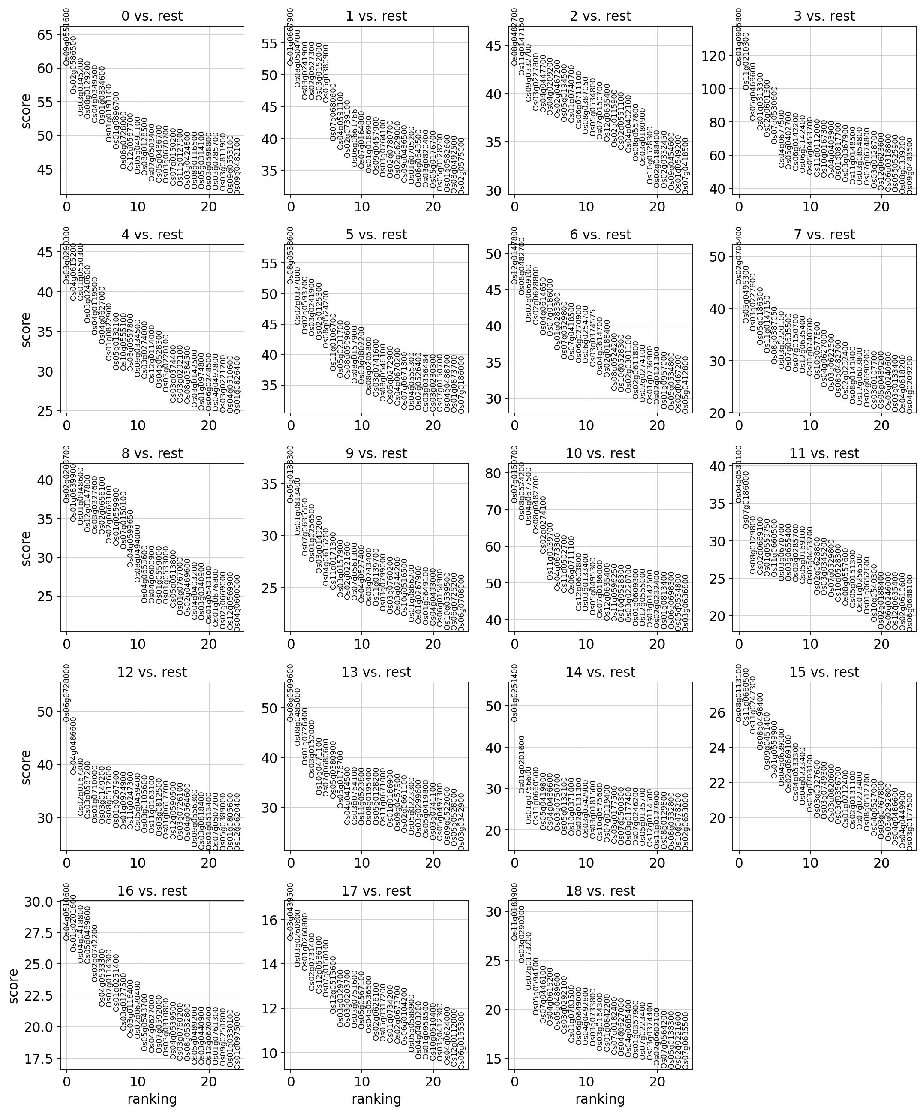

The below is the top marker gene list for each cluster.

You can change the annotation result according to this.

The list of top marker genes

col : clusters

0 1 2 3 4 \

0 Os09g0551600 Os01g0667900 Os08g0482700 Os01g0905800 Os03g0290300

1 Os02g0586500 Os08g0504700 Os11g0147150 Os11g0210300 Os04g0615200

2 Os03g0345200 Os03g0241900 Os09g0332700 Os05g0469600 Os01g0550300

3 Os08g0129200 Os02g0527300 Os03g0227800 Os01g0313300 Os03g0240600

4 Os04g0349500 Os03g0152000 Os04g0447700 Os02g0601300 Os04g0119500

5 Os01g0834600 Os05g0380900 Os04g0209200 Os07g0530600 Os04g0627000

6 Os01g0191100 Os07g0680600 Os02g0467200 Os04g0677500 Os01g0822900

7 Os01g0896700 Os04g0591100 Os05g0194500 Os05g0402700 Os05g0132100

8 Os06g0728000 Os02g0739100 Os01g0740700 Os06g0142200 Os10g0555100

9 Os12g0567700 Os06g0661766 Os06g0711100 Os06g0142400 Os08g0557800

10 Os05g0491100 Os07g0164800 Os08g0387050 Os05g0453700 Os09g0334500

11 Os08g0128500 Os01g0186900 Os05g0534800 Os11g0112000 Os03g0274000

12 Os02g0503400 Os09g0457900 Os07g0150700 Os10g0167300 Os12g0114000

13 Os05g0486700 Os03g0764100 Os12g0635400 Os04g0403900 Os04g0528300

14 Os03g0670700 Os02g0780700 Os02g0115900 Os01g0817700 Os03g0220100

15 Os07g0150200 Os02g0629000 Os02g0551100 Os03g0367900 Os03g0374400

16 Os11g0127900 Os09g0486500 Os04g0402100 Os11g0148500 Os03g0292100

17 Os03g0424800 Os01g0705200 Os08g0557600 Os03g0854800 Os08g0384500

18 Os08g0116500 Os06g0643500 Os03g0180900 Os07g0674800 Os03g0142500

19 Os05g0314100 Os03g0820400 Os10g0528300 Os03g0128700 Os01g0974800

5 6 7 8 9 \

0 Os08g0538600 Os12g0147800 Os02g0705400 Os02g0203700 Os05g0138300

1 Os02g0327000 Os08g0482700 Os05g0495300 Os01g0839900 Os01g0813400

2 Os02g0593700 Os02g0669100 Os03g0227800 Os01g0948600 Os07g0635500

3 Os03g0241900 Os02g0628800 Os05g0186300 Os12g0147800 Os01g0256500

4 Os02g0125300 Os04g0614650 Os11g0147150 Os03g0327600 Os03g0149200

5 Os08g0524200 Os07g0186000 Os08g0387050 Os02g0656100 Os04g0615200

6 Os11g0106700 Os01g0283300 Os03g0220100 Os02g0669100 Os11g0171300

7 Os05g0231700 Os07g0529800 Os07g0635500 Os01g0559900 Os03g0157900

8 Os08g0509600 Os07g0418500 Os07g0150700 Os07g0150100 Os02g0221600

9 Os08g0157900 Os06g0270900 Os12g0635400 Os04g0599650 Os07g0561300

10 Os03g0802200 Os06g0254700 Os01g0740700 Os08g0494000 Os04g0527400

11 Os08g0205800 Os03g0374575 Os10g0577800 Os04g0653600 Os03g0743400

12 Os03g0741600 Os04g0614700 Os04g0627000 Os04g0600900 Os11g0139700

13 Os08g0546100 Os02g0188400 Os03g0622500 Os01g0559000 Os03g0799000

14 Os05g0272900 Os08g0524200 Os08g0482700 Os01g0533000 Os03g0760200

15 Os04g0670200 Os10g0528300 Os02g0232400 Os05g0513800 Os03g0244200

16 Os07g0671800 Os02g0301100 Os08g0141400 Os01g0767000 Os10g0516500

17 Os04g0555300 Os02g0611800 Os12g0603800 Os02g0469600 Os01g0866200

18 Os02g0526400 Os02g0274100 Os02g0690200 Os04g0403200 Os01g0267900

19 Os03g0356484 Os01g0736900 Os03g0107700 Os03g0340900 Os01g0649100

10 11 12 13 14 \

0 Os07g0150700 Os04g0531100 Os06g0728000 Os08g0509600 Os01g0251400

1 Os08g0524200 Os07g0186000 Os04g0486600 Os08g0485000 Os01g0201600

2 Os04g0677500 Os08g0129800 Os02g0167300 Os01g0726400 Os01g0756600

3 Os08g0482700 Os02g0669100 Os03g0587200 Os03g0152000 Os11g0660500

4 Os02g0274100 Os01g0559750 Os01g0710000 Os10g0471100 Os05g0419800

5 Os11g0139700 Os11g0660500 Os03g0149200 Os07g0680600 Os04g0486600

6 Os04g0673300 Os03g0670700 Os08g0512600 Os05g0380900 Os03g0750700

7 Os11g0502700 Os03g0655400 Os01g0267900 Os05g0176700 Os05g0132100

8 Os06g0711100 Os03g0285700 Os01g0924900 Os04g0414500 Os10g0371000

9 Os12g0603800 Os05g0169100 Os11g0247300 Os03g0764100 Os02g0131300

10 Os03g0133400 Os05g0453700 Os05g0459400 Os11g0523800 Os03g0342900

11 Os05g0495300 Os02g0628800 Os03g0105600 Os08g0195400 Os03g0181500

12 Os07g0186000 Os03g0345200 Os11g0163100 Os05g0128200 Os10g0575600

13 Os12g0635400 Os07g0529800 Os03g0812500 Os11g0671000 Os07g0119400

14 Os11g0596250 Os10g0528300 Os01g0617700 Os01g0186900 Os03g0177500

15 Os10g0528300 Os08g0557600 Os12g0590500 Os09g0457900 Os07g0500300

16 Os03g0220700 Os05g0151300 Os03g0726100 Os02g0661100 Os03g0177400

17 Os01g0609300 Os01g0256500 Os04g0564600 Os05g0223300 Os07g0246200

18 Os12g0555000 Os01g0652600 Os09g0556300 Os03g0299600 Os05g0135700

19 Os03g0142500 Os10g0540300 Os03g0818400 Os05g0419800 Os12g0114500

15 16 17 18

0 Os08g0113100 Os04g0510600 Os03g0439500 Os11g0183900

1 Os11g0660500 Os01g0201600 Os03g0260600 Os03g0290300

2 Os11g0247300 Os04g0418800 Os01g0260800 Os02g0173200

3 Os08g0498400 Os05g0489600 Os02g0731400 Os05g0594100

4 Os09g0451400 Os02g0742200 Os12g0586100 Os07g0446100

5 Os01g0559900 Os04g0533300 Os07g0150100 Os04g0615200

6 Os04g0639000 Os07g0114300 Os12g0515600 Os05g0489600

7 Os02g0669100 Os01g0251400 Os03g0329700 Os03g0292100

8 Os04g0533300 Os03g0127500 Os03g0203700 Os01g0783500

9 Os04g0233400 Os03g0116400 Os03g0751600 Os06g0649000

10 Os03g0703100 Os02g0620400 Os05g0567100 Os04g0492800

11 Os03g0327600 Os05g0543700 Os04g0536500 Os03g0733800

12 Os03g0749300 Os04g0627000 Os02g0626100 Os03g0164300

13 Os03g0820600 Os07g0592000 Os05g0317200 Os01g0842200

14 Os03g0356700 Os03g0310800 Os01g0734200 Os07g0182400

15 Os01g0212400 Os04g0539500 Os02g0673700 Os04g0627000

16 Os02g0131100 Os03g0760200 Os06g0104200 Os04g0685400

17 Os07g0223400 Os08g0532800 Os05g051234500 Os01g0357900

18 Os08g0512700 Os05g0489200 Os04g0403200 Os07g0223400

19 Os04g0527000 Os03g0440900 Os01g0958500 Os03g0374400

Top marker genes and their p-values of each cluster:

0_n 0_p 1_n 1_p 2_n \

0 Os09g0551600 0.000000e+00 Os01g0667900 0.000000e+00 Os08g0482700

1 Os02g0586500 0.000000e+00 Os08g0504700 0.000000e+00 Os11g0147150

2 Os03g0345200 0.000000e+00 Os03g0241900 0.000000e+00 Os09g0332700

3 Os08g0129200 0.000000e+00 Os02g0527300 8.702077e-319 Os03g0227800

4 Os04g0349500 0.000000e+00 Os03g0152000 2.313085e-312 Os04g0447700

5 Os01g0834600 0.000000e+00 Os05g0380900 1.200590e-307 Os04g0209200

6 Os01g0191100 0.000000e+00 Os07g0680600 1.710661e-247 Os02g0467200

7 Os01g0896700 0.000000e+00 Os04g0591100 4.891707e-244 Os05g0194500

8 Os06g0728000 0.000000e+00 Os02g0739100 3.390517e-228 Os01g0740700

9 Os12g0567700 0.000000e+00 Os06g0661766 5.112900e-216 Os06g0711100

10 Os05g0491100 5.724600e-316 Os07g0164800 2.117349e-222 Os08g0387050

11 Os08g0128500 7.066616e-316 Os01g0186900 9.067677e-213 Os05g0534800

12 Os02g0503400 2.739313e-305 Os09g0457900 5.018150e-196 Os07g0150700

13 Os05g0486700 6.547640e-305 Os03g0764100 1.326377e-194 Os12g0635400

14 Os03g0670700 3.870571e-315 Os02g0780700 9.999054e-199 Os02g0115900

15 Os07g0150200 5.400719e-298 Os02g0629000 7.061573e-196 Os02g0551100

16 Os11g0127900 5.077496e-304 Os09g0486500 1.138501e-193 Os04g0402100

17 Os03g0424800 9.969005e-295 Os01g0705200 3.210692e-191 Os08g0557600

18 Os08g0116500 8.688358e-296 Os06g0643500 4.234591e-179 Os03g0180900

19 Os05g0314100 1.638702e-290 Os03g0820400 3.630295e-184 Os10g0528300

2_p 3_n 3_p 4_n 4_p \

0 5.202835e-305 Os01g0905800 0.000000e+00 Os03g0290300 4.795297e-236

1 1.674288e-258 Os11g0210300 0.000000e+00 Os04g0615200 2.166145e-217

2 7.276833e-241 Os05g0469600 0.000000e+00 Os01g0550300 9.455366e-231

3 3.835978e-235 Os01g0313300 0.000000e+00 Os03g0240600 1.297609e-203

4 1.835211e-227 Os02g0601300 0.000000e+00 Os04g0119500 2.908135e-185

5 3.492862e-220 Os07g0530600 0.000000e+00 Os04g0627000 7.017748e-173

6 1.697243e-225 Os04g0677500 0.000000e+00 Os01g0822900 1.531426e-155

7 7.009029e-219 Os05g0402700 0.000000e+00 Os05g0132100 2.153964e-147

8 5.817650e-223 Os06g0142200 6.980699e-317 Os10g0555100 7.776902e-153

9 1.195837e-215 Os06g0142400 2.071356e-304 Os08g0557800 1.033994e-145

10 2.956813e-205 Os05g0453700 0.000000e+00 Os09g0334500 2.197887e-143

11 2.296944e-206 Os11g0112000 2.704490e-285 Os03g0274000 1.877776e-145

12 4.966068e-210 Os10g0167300 3.841911e-304 Os12g0114000 4.459447e-136

13 2.782938e-207 Os04g0403900 5.783877e-297 Os04g0528300 9.913206e-131

14 5.344402e-190 Os01g0817700 3.467229e-272 Os03g0220100 1.975451e-129

15 4.172968e-193 Os03g0367900 6.147939e-266 Os03g0374400 2.173757e-120

16 4.983149e-187 Os11g0148500 1.050797e-260 Os03g0292100 2.810033e-119

17 8.150366e-188 Os03g0854800 4.687582e-266 Os08g0384500 6.566121e-118

18 2.789604e-184 Os07g0674800 4.559849e-255 Os03g0142500 7.669049e-115

19 4.961413e-163 Os03g0128700 3.402569e-239 Os01g0974800 4.006420e-111

... 14_n 14_p 15_n 15_p 16_n \

0 ... Os01g0251400 4.572988e-88 Os08g0113100 2.910218e-54 Os04g0510600

1 ... Os01g0201600 2.098360e-61 Os11g0660500 1.755170e-55 Os01g0201600

2 ... Os01g0756600 1.252001e-46 Os11g0247300 5.316281e-54 Os04g0418800

3 ... Os11g0660500 8.473625e-47 Os08g0498400 3.328182e-51 Os05g0489600

4 ... Os05g0419800 2.573502e-43 Os09g0451400 8.548184e-49 Os02g0742200

5 ... Os04g0486600 2.106913e-43 Os01g0559900 5.518421e-48 Os04g0533300

6 ... Os03g0750700 1.055117e-42 Os04g0639000 9.563800e-47 Os07g0114300

7 ... Os05g0132100 1.226075e-40 Os02g0669100 9.767389e-48 Os01g0251400

8 ... Os10g0371000 1.323719e-40 Os04g0533300 1.864947e-45 Os03g0127500

9 ... Os02g0131300 9.886494e-41 Os04g0233400 1.913786e-44 Os03g0116400

10 ... Os03g0342900 1.243125e-39 Os03g0703100 1.062517e-43 Os02g0620400

11 ... Os03g0181500 1.644598e-38 Os03g0327600 2.978984e-43 Os05g0543700

12 ... Os10g0575600 2.439874e-37 Os03g0749300 1.193192e-42 Os04g0627000

13 ... Os07g0119400 2.537575e-36 Os03g0820600 1.161378e-42 Os07g0592000

14 ... Os03g0177500 6.266701e-36 Os03g0356700 3.915060e-42 Os03g0310800

15 ... Os07g0500300 6.753527e-35 Os01g0212400 1.830240e-41 Os04g0539500

16 ... Os03g0177400 4.045464e-35 Os02g0131100 2.432196e-41 Os03g0760200

17 ... Os07g0246200 6.416000e-35 Os07g0223400 4.561053e-42 Os08g0532800

18 ... Os05g0135700 1.545015e-34 Os08g0512700 2.208667e-41 Os05g0489200

19 ... Os12g0114500 9.447943e-34 Os04g0527000 1.448923e-40 Os03g0440900

16_p 17_n 17_p 18_n 18_p

0 1.341019e-54 Os03g0439500 2.034385e-26 Os11g0183900 3.764681e-43

1 4.085565e-53 Os03g0260600 4.228807e-24 Os03g0290300 1.840487e-40

2 2.214505e-51 Os01g0260800 8.346498e-24 Os02g0173200 9.993883e-37

3 5.905081e-53 Os02g0731400 5.299844e-22 Os05g0594100 2.719446e-33

4 1.317332e-48 Os12g0586100 9.080792e-22 Os07g0446100 9.468248e-32

5 4.832753e-45 Os07g0150100 1.444991e-21 Os04g0615200 2.877651e-31

6 2.429870e-45 Os12g0515600 5.918196e-20 Os05g0489600 7.993130e-31

7 5.328112e-44 Os03g0329700 1.032844e-18 Os03g0292100 6.170805e-30

8 7.902540e-41 Os03g0203700 9.039617e-19 Os01g0783500 2.867813e-28

9 9.917095e-40 Os03g0751600 1.238041e-18 Os06g0649000 6.384365e-28

10 2.229522e-39 Os05g0567100 1.327837e-18 Os04g0492800 8.669064e-28

11 1.809482e-37 Os04g0536500 3.845439e-18 Os03g0733800 1.027753e-27

12 5.199848e-37 Os02g0626100 1.718786e-17 Os03g0164300 9.507639e-27

13 8.739183e-37 Os05g0317200 2.126516e-17 Os01g0842200 1.064039e-26

14 8.015737e-37 Os01g0734200 2.666349e-17 Os07g0182400 4.543056e-26

15 5.876173e-36 Os02g0673700 3.432429e-17 Os04g0627000 6.382140e-26

16 1.551279e-35 Os06g0104200 5.215797e-17 Os04g0685400 1.575643e-25

17 2.172172e-35 Os05g051234500 2.090974e-16 Os01g0357900 1.497480e-25

18 9.950422e-35 Os04g0403200 9.692003e-16 Os07g0223400 2.286111e-25

19 6.458675e-35 Os01g0958500 1.037793e-15 Os03g0374400 3.148637e-25

[20 rows x 38 columns]

cluster 0: organ: Inflorescence celltype: Leaf / organ: Inflorescence celltype: Spikelet / organ: Meristem celltype: Spikelet meristem / organ: Root celltype: Endodermis / organ: Spikelet celltype: Rudimentary glume / organ: Spikelet celltype: Sterile lemma

cluster 1: organ: Inflorescence celltype: Meristem / organ: Meristem celltype: Inflorescence meristem / organ: Root celltype: Cortex / organ: Spikelet celltype: Cryptic bract

cluster 2: organ: Inflorescence celltype: Rachis / organ: Meristem celltype: Branch meristem / organ: Root celltype: Procambium / organ: Spikelet celltype: Floret meristem / organ: Spikelet celltype: Spikelet identity cell

cluster 3: organ: Inflorescence celltype: Rachis / organ: Leaf celltype: Mestome sheath

cluster 4: organ: Inflorescence celltype: Meristem / organ: Leaf celltype: Large paremchyma / organ: Meristem celltype: Branch meristem / organ: Root celltype: Cortex / organ: Spikelet celltype: Floret meristem

cluster 5: organ: Inflorescence celltype: Rachis / organ: Leaf celltype: Mesophyll / organ: Meristem celltype: Branch meristem / organ: Root celltype: Cortex / organ: Root celltype: Trichoblast / organ: Spikelet celltype: Floret meristem

cluster 6: organ: Inflorescence celltype: Rachis / organ: Leaf celltype: Mestome sheath / organ: Root celltype: Cortex

cluster 7: organ: Inflorescence celltype: Rachis / organ: Leaf celltype: Epidermis / organ: Meristem celltype: Branch meristem / organ: Root celltype: Cortex / organ: Spikelet celltype: Cryptic bract/bract / organ: Spikelet celltype: Floret meristem / organ: Spikelet celltype: Spikelet identity cell / organ: Spikelet celltype: Spikelet supporting cell

cluster 8: organ: Root celltype: Endodermis

cluster 9: organ: Inflorescence celltype: Rachis / organ: Leaf celltype: Large paremchyma / organ: Meristem celltype: Branch meristem / organ: Root celltype: Cortex

cluster 10: organ: Inflorescence celltype: Rachis / organ: Meristem celltype: Branch meristem / organ: Root celltype: Procambium

cluster 11: organ: Leaf celltype: Preprocambium / organ: Root celltype: Endodermis

cluster 12: organ: Inflorescence celltype: Spikelet / organ: Meristem celltype: Spikelet meristem / organ: Spikelet celltype: Cryptic bract

cluster 13: organ: Inflorescence celltype: Meristem / organ: Meristem celltype: Branch meristem

cluster 14: organ: Spikelet celltype: Cryptic bract / organ: Spikelet celltype: Sterile lemma

cluster 15: organ: Leaf celltype: Xylem / organ: Meristem celltype: Spikelet meristem / organ: Root celltype: Cortex / organ: Root celltype: Epidermis / organ: Spikelet celltype: Floret meristem / organ: Spikelet celltype: Palea

cluster 16: organ: Inflorescence celltype: Meristem / organ: Inflorescence celltype: Spikelet / organ: Leaf celltype: Epidermis / organ: Meristem celltype: Branch meristem / organ: Root celltype: Columella / organ: Root celltype: Cortex / organ: Spikelet celltype: Palea

cluster 17: organ: Root celltype: Xylem

cluster 18: organ: Leaf celltype: Mestome sheath / organ: Root celltype: Procambium



cluster 0: organ: Root celltype: Endodermis

cluster 1: organ: Leaf celltype: Mesophyll precursor

cluster 2: organ: Meristem celltype: Branch meristem

cluster 3: organ: Inflorescence celltype: Rachis

cluster 4: organ: Meristem celltype: Branch meristem

cluster 5: organ: Meristem celltype: Branch meristem

cluster 6: organ: Inflorescence celltype: Rachis

cluster 7: organ: Meristem celltype: Branch meristem

cluster 8: organ: Inflorescence celltype: Rachis

cluster 9: organ: Meristem celltype: Branch meristem

cluster 10: organ: Meristem celltype: Branch meristem

cluster 11: Unknown

cluster 12: organ: Root celltype: Endodermis

cluster 13: organ: Meristem celltype: Branch meristem

cluster 14: organ: Meristem celltype: Branch meristem

cluster 15: Unknown

cluster 16: organ: Meristem celltype: Branch meristem

cluster 17: Unknown

cluster 18: organ: Meristem celltype: Branch meristem

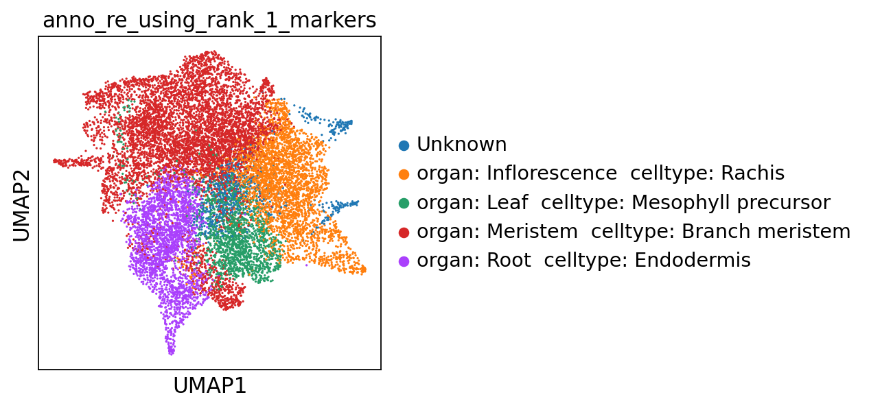

Memory collecting...

Memory information:

Used:

1951551488

Total:

201226063872

Used (%):

10.8

In [8]:

**del** scapp

gc**.**collect()

**with** open('SCAPP_0_Copy1.py','r') **as** f:

exec(f**.**read())

Out[8]:

452

Memory collecting...

Memory information:

Used:

1458675712

Total:

201226063872

Used (%):

10.6

**1.2 Use matrix.mtx.gz**

**1.2.1 Single file**

In [9]:

filepath **=** '~/data/rice/PRJNA706435/SRR13853439/cellranger_SRR13853439_without_introns/outs/filtered_feature_bc_matrix/matrix.mtx.gz'

In [10]:

scapp **=** SCAPP_0()

scapp**.**to_annotation_0(filepath **=** filepath)

scanpy==1.9.2 anndata==0.8.0 umap==0.5.3 numpy==1.21.5 scipy==1.7.3 pandas==1.5.2 scikit-learn==1.2.1 statsmodels==0.13.5 python-igraph==0.10.4 louvain==0.8.0 pynndescent==0.5.8

--> This might be very slow. Consider passing `cache=True`, which enables much faster reading from a cache file.

Before filter

normalizing counts per cell

finished (0:00:00)

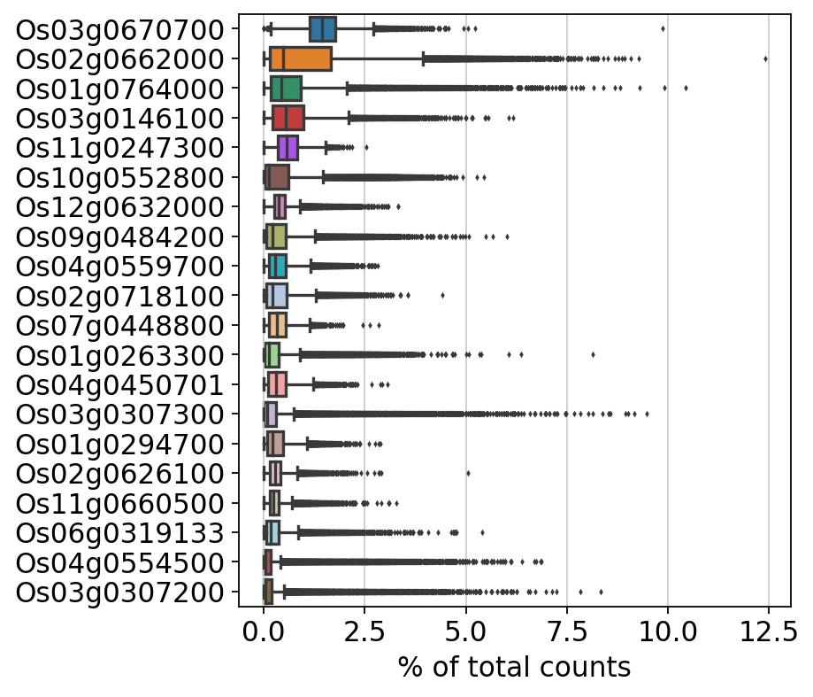

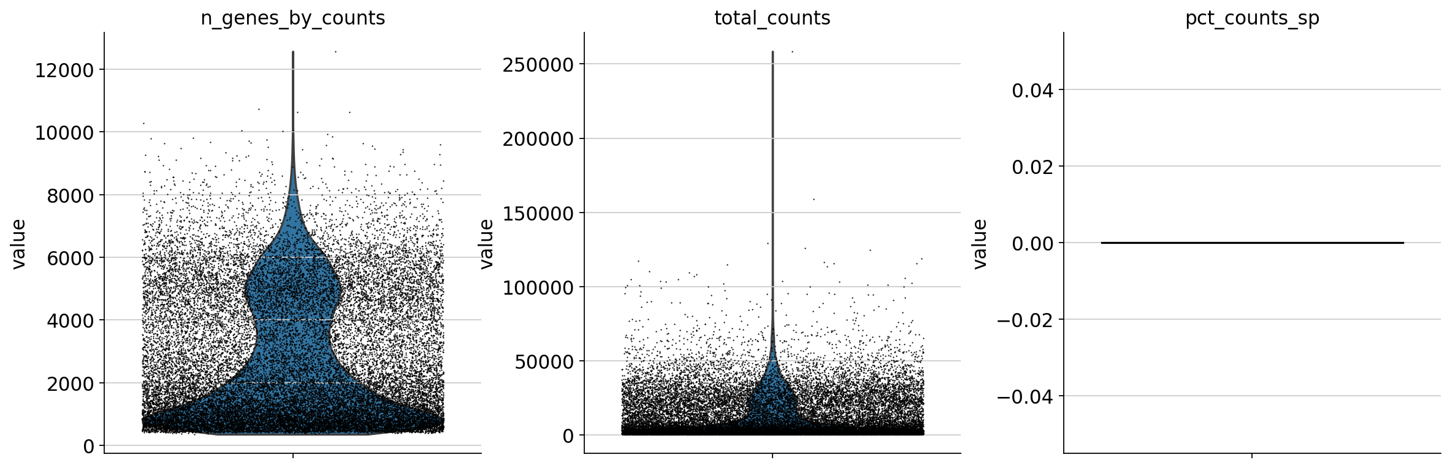

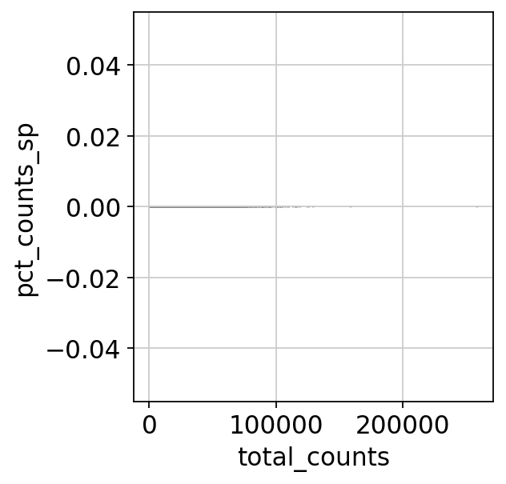

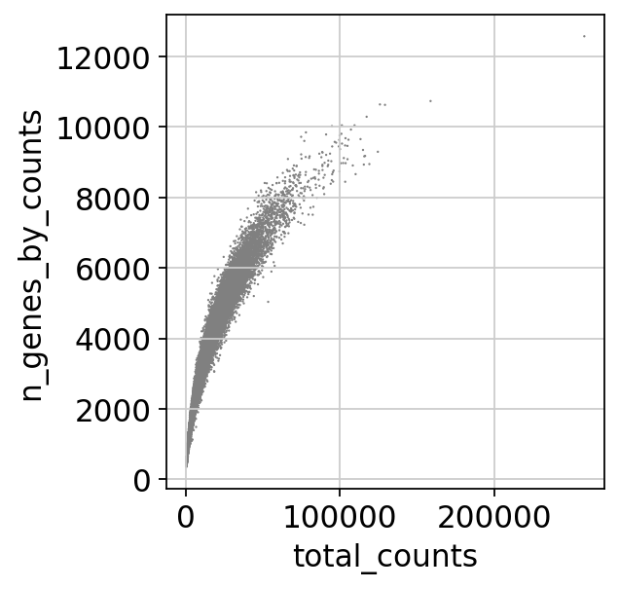

After filter

filtered out 8819 genes that are detected in less than 3 cells

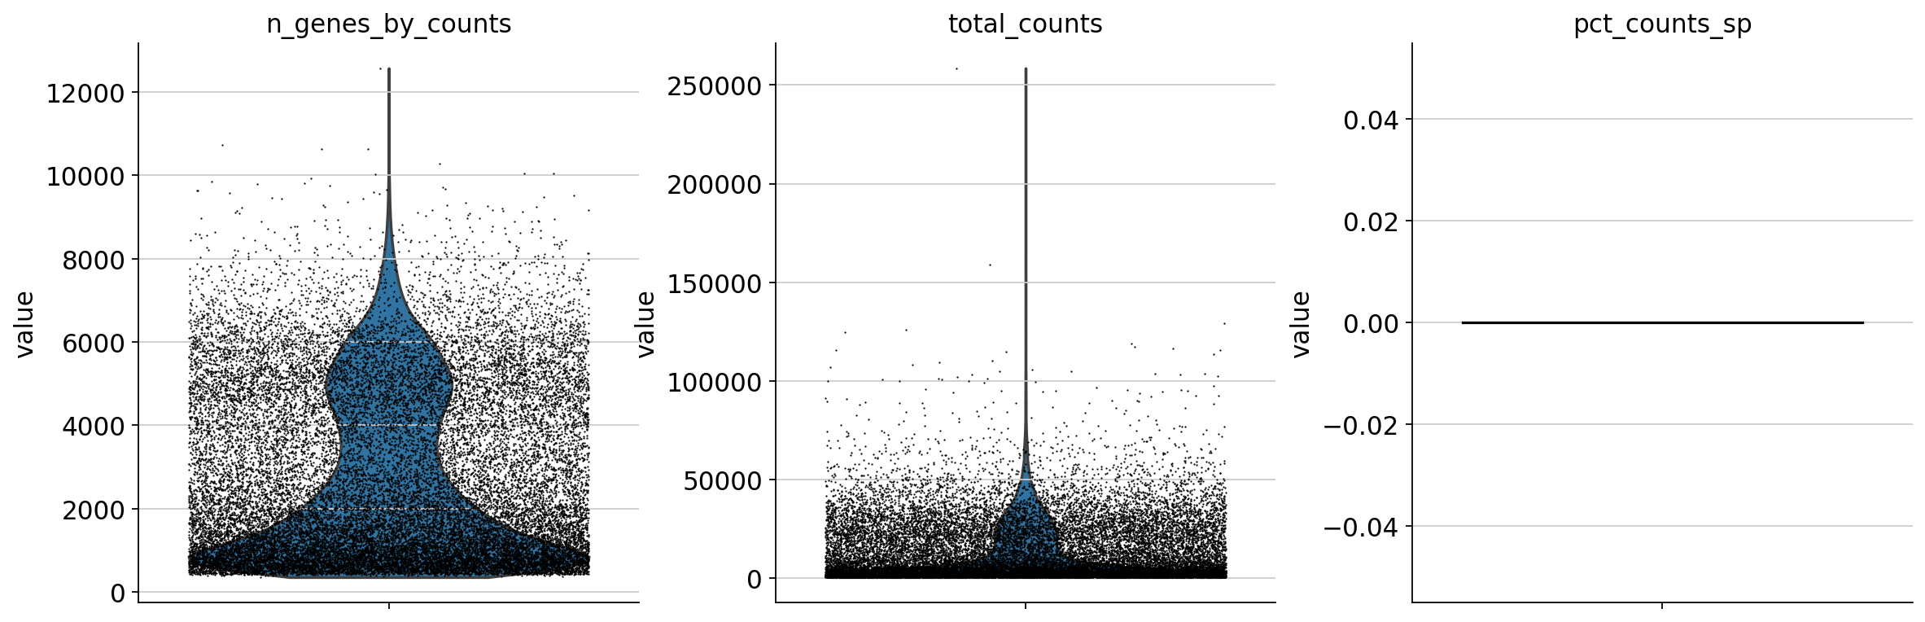





Before filter

count 27697.000000

mean 12059.548828

std 14801.410156

min 500.000000

25% 1503.000000

50% 4907.000000

75% 19715.000000

max 258543.000000

Name: total_counts, dtype: float64

count 27697.000000

mean 2742.901217

std 2021.177035

min 356.000000

25% 978.000000

50% 2042.000000

75% 4434.000000

max 12571.000000

Name: n_genes_by_counts, dtype: float64

count 27697.0

mean 0.0

std 0.0

min 0.0

25% 0.0

50% 0.0

75% 0.0

max 0.0

Name: pct_counts_sp, dtype: float64

After filter

count 27697.000000

mean 12059.548828

std 14801.410156

min 500.000000

25% 1503.000000

50% 4907.000000

75% 19715.000000

max 258543.000000

Name: total_counts, dtype: float64

count 27697.000000

mean 2742.901217

std 2021.177035

min 356.000000

25% 978.000000

50% 2042.000000

75% 4434.000000

max 12571.000000

Name: n_genes_by_counts, dtype: float64

count 27697.0

mean 0.0

std 0.0

min 0.0

25% 0.0

50% 0.0

75% 0.0

max 0.0

Name: pct_counts_sp, dtype: float64

normalizing counts per cell

finished (0:00:00)

extracting highly variable genes

finished (0:00:02)

--> added

'highly_variable', boolean vector (adata.var)

'means', float vector (adata.var)

'dispersions', float vector (adata.var)

'dispersions_norm', float vector (adata.var)

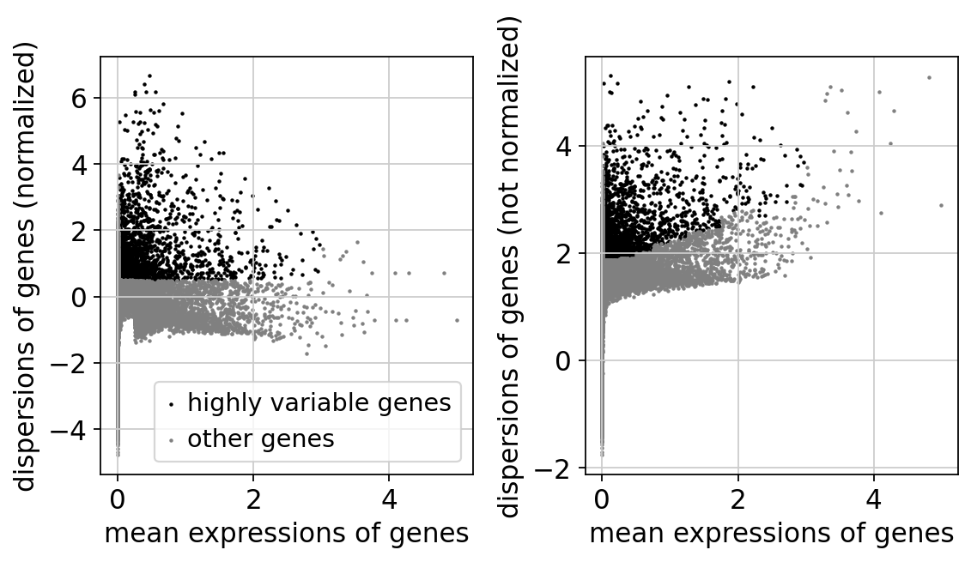

regressing out ['total_counts']

sparse input is densified and may lead to high memory use

finished (0:01:01)

computing PCA

on highly variable genes

with n_comps=50

finished (0:00:02)

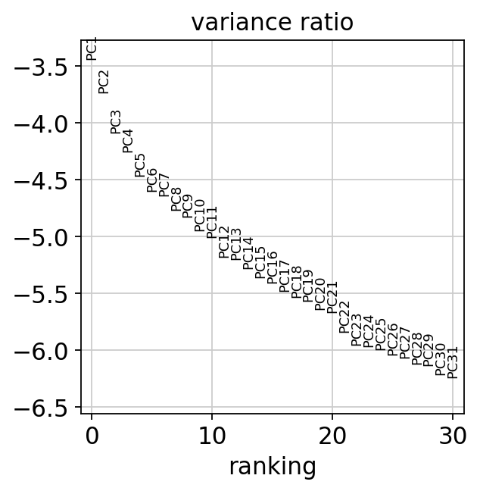

computing neighbors

using 'X_pca' with n_pcs = 40

finished: added to `.uns['neighbors']`

`.obsp['distances']`, distances for each pair of neighbors

`.obsp['connectivities']`, weighted adjacency matrix (0:00:04)

computing UMAP

finished: added

'X_umap', UMAP coordinates (adata.obsm) (0:00:34)

running Leiden clustering

finished: found 29 clusters and added

'leiden', the cluster labels (adata.obs, categorical) (0:00:05)

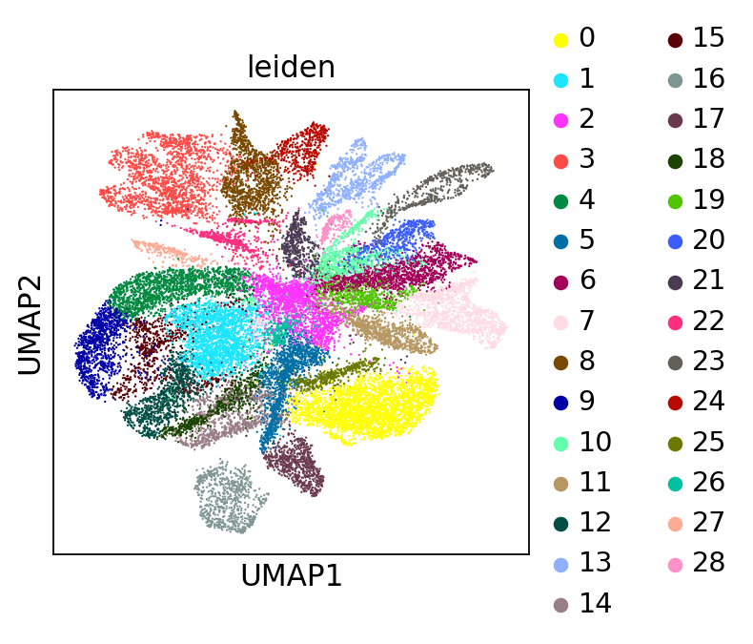

running PAGA

finished: added

'paga/connectivities', connectivities adjacency (adata.uns)

'paga/connectivities_tree', connectivities subtree (adata.uns) (0:00:01)

--> added 'pos', the PAGA positions (adata.uns['paga'])

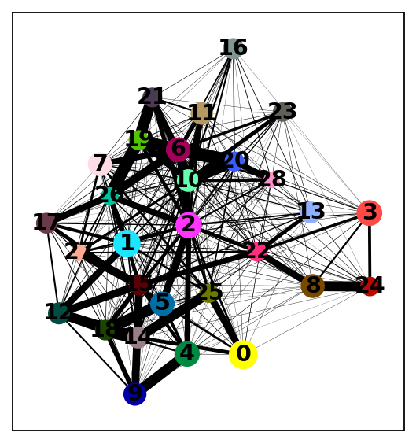

computing UMAP

finished: added

'X_umap', UMAP coordinates (adata.obsm) (0:00:33)

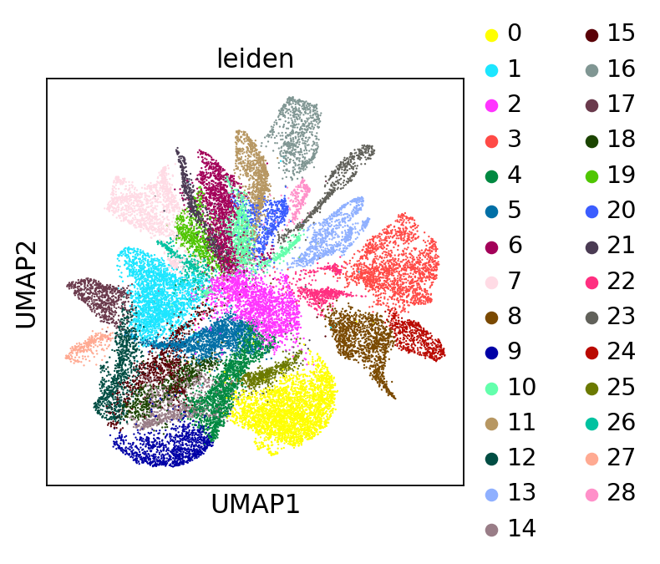

ranking genes

finished: added to `.uns['rank_genes_groups']`

'names', sorted np.recarray to be indexed by group ids

'scores', sorted np.recarray to be indexed by group ids

'logfoldchanges', sorted np.recarray to be indexed by group ids

'pvals', sorted np.recarray to be indexed by group ids

'pvals_adj', sorted np.recarray to be indexed by group ids (0:00:15)

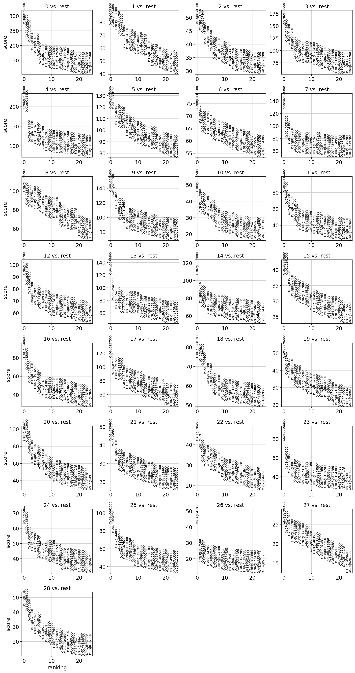

The below is the top marker gene list for each cluster.

You can change the annotation result according to this.

The list of top marker genes

col : clusters

0 1 2 3 4 \

0 Os10g0552800 Os03g0307200 Os03g0121300 Os07g0542900 Os06g0681600

1 Os02g0662000 Os06g0547400 Os02g0121300 Os07g0499500 Os01g0263300

2 Os10g0552700 Os03g0307300 Os10g0397400 Os10g0546100 Os05g0499300

3 Os03g0385400 Os12g0570700 Os04g0418800 Os10g0555700 Os01g0284500

4 Os01g0914300 Os06g0486800 Os10g0169200 Os04g0472200 Os10g0417600

5 Os04g0554500 Os11g0167800 Os01g0611000 Os04g0674800 Os03g0146100

6 Os06g0711900 Os01g0764000 Os08g0116500 Os02g0663800 Os01g0294700

7 Os04g0619800 Os05g0247100 Os01g0243700 Os06g0335900 Os08g0482700

8 Os10g0371000 Os09g0249000 Os03g0171300 Os09g0367700 Os11g0557800

9 Os01g0296700 Os02g0662000 Os09g0539800 Os12g0163700 Os07g0590700

10 Os06g0696400 Os11g0484000 Os06g0691200 Os10g0530200 Os05g0413200

11 Os02g0236600 Os11g0704500 Os07g0568700 Os01g0294500 Os01g0644600

12 Os10g0169200 Os02g0102300 Os01g0124401 Os06g0319133 Os05g0563600

13 Os03g0708000 Os03g0237100 Os03g0563600 Os03g0831400 Os10g0555600

14 Os04g0450701 Os11g0134900 Os01g0328400 Os02g0719000 Os03g0661300

15 Os11g0115100 Os07g0529800 Os03g0115000 Os03g0608000 Os04g0450701

16 Os04g0495400 Os04g0416700 Os05g0459900 Os01g0594300 Os03g0742900

17 Os12g0454600 Os09g0434500 Os02g0115900 Os08g0532700 Os05g0199100

18 Os07g0600700 Os10g0330000 Os01g0124200 Os01g0591300 Os08g0498100

19 Os08g0502400 Os02g0306401 Os03g0807800 Os01g0119000 Os11g0178800

5 6 7 8 9 ... \

0 Os05g0563600 Os08g0116500 Os04g0423800 Os02g0256200 Os06g0681600 ...

1 Os01g0668100 Os12g0567700 Os02g0653200 Os05g0134700 Os01g0263300 ...

2 Os09g0469600 Os03g0408300 Os04g0684300 Os08g0127100 Os08g0482700 ...

3 Os07g0590700 Os03g0424800 Os12g0567700 Os01g0294700 Os04g0677300 ...

4 Os02g0653000 Os05g0160200 Os08g0116500 Os10g0528300 Os02g0653200 ...

5 Os07g0574800 Os03g0781501 Os10g0155100 Os03g0223400 Os03g0194900 ...

6 Os05g0499300 Os03g0598800 Os01g0263300 Os05g0276500 Os05g0576600 ...

7 Os01g0644600 Os02g0717800 Os05g0459900 Os03g0830200 Os01g0884300 ...

8 Os01g0294700 Os01g0896700 Os09g0258600 Os06g0306300 Os03g0820300 ...

9 Os03g0661300 Os10g0411800 Os05g0160200 Os11g0649600 Os01g0358100 ...

10 Os07g0112700 Os03g0139100 Os01g0896700 Os05g0134800 Os03g0218400 ...

11 Os04g0497200 Os01g0328400 Os01g0276000 Os02g0157600 Os01g0294700 ...

12 Os05g0199100 Os01g0191100 Os03g0794700 Os03g0368000 Os01g0667900 ...

13 Os01g0805900 Os05g0477300 Os03g0234200 Os01g0284500 Os10g0444700 ...

14 Os07g0635900 Os10g0411700 Os02g0717800 Os10g0444700 Os01g0639600 ...

15 Os08g0498100 Os08g0117300 Os03g0424800 Os07g0630400 Os06g0143100 ...

16 Os05g0386800 Os05g0459900 Os03g0408300 Os05g0135000 Os01g0246700 ...

17 Os01g0282800 Os03g0337800 Os03g0598800 Os12g0625000 Os09g0367700 ...

18 Os01g0265100 Os09g0258600 Os05g0477300 Os03g0428700 Os10g0493600 ...

19 Os05g0413200 Os05g0155100 Os04g0349500 Os03g0368300 Os07g0635500 ...

19 20 21 22 23 \

0 Os03g0279200 Os09g0484200 Os01g0756900 Os11g0704500 Os05g0108600

1 Os05g0438700 Os08g0503000 Os04g0496300 Os10g0191300 Os01g0260800

2 Os04g0583600 Os08g0561500 Os01g0273100 Os03g0663400 Os07g0638500

3 Os01g0866200 Os02g0718100 Os03g0146300 Os05g0399300 Os03g0807500

4 Os05g0466600 Os10g0510000 Os01g0896400 Os12g0567800 Os01g0971400

5 Os08g0427700 Os11g0163100 Os02g0121300 Os12g0570700 Os02g0528100

6 Os08g0490900 Os04g0105300 Os03g0780200 Os02g0650300 Os03g0817800

7 Os06g0159450 Os05g0541750 Os03g0736500 Os12g0568500 Os02g0731400

8 Os03g0119900 Os01g0559900 Os08g0512600 Os02g0157600 Os11g0178800

9 Os01g0153100 Os06g0113900 Os10g0377150 Os12g0571100 Os01g0954000

10 Os06g0160100 Os01g0260800 Os01g0805600 Os12g0455000 Os01g0668100

11 Os03g0162200 Os01g0559750 Os05g0507000 Os03g0288000 Os05g0277500

12 Os05g0574300 Os06g0152100 Os03g0128300 Os07g0129200 Os03g0278000

13 Os01g0835900 Os12g0163700 Os02g0258200 Os03g0146100 Os06g0319133

14 Os01g0839500 Os01g0838350 Os10g0498900 Os08g0189200 Os02g0653000

15 Os02g0684500 Os02g0669100 Os06g0683900 Os03g0223400 Os04g0105200

16 Os12g0530000 Os10g0463600 Os06g0726800 Os12g0260500 Os07g0645000

17 Os01g0153300 Os02g0743400 Os03g0749500 Os02g0102300 Os06g0218600

18 Os07g0549900 Os11g0660500 Os03g0138500 Os11g0147800 Os07g0107300

19 Os02g0121300 Os10g0536700 Os07g0474300 Os01g0591300 Os03g0194300

24 25 26 27 28

0 Os05g0584200 Os02g0662000 Os04g0418800 Os03g0793800 Os03g0134900

1 Os10g0454200 Os09g0484200 Os03g0186900 Os07g0142200 Os12g0568900

2 Os01g0937050 Os07g0448800 Os02g0192500 Os10g0486100 Os03g0135100

3 Os11g0557800 Os01g0309100 Os03g0563600 Os02g0653200 Os01g0326000

4 Os03g0699800 Os03g0431100 Os06g0147000 Os07g0142500 Os01g0327400

5 Os10g0555700 Os09g0469600 Os01g0598600 Os11g0507200 Os04g0105200

6 Os07g0246200 Os06g0157000 Os02g0662000 Os10g0518000 Os01g0543100

7 Os02g0121300 Os02g0666200 Os06g0335500 Os07g0142300 Os10g0543800

8 Os09g0539800 Os07g0112700 Os07g0674100 Os05g0245300 Os02g0669100

9 Os07g0639000 Os08g0498100 Os03g0392600 Os03g0339400 Os01g0948600

10 Os01g0838200 Os06g0711900 Os04g0137201 Os01g0636400 Os03g0135200

11 Os03g0599800 Os02g0833900 Os01g0746700 Os04g0483500 Os01g0327000

12 Os02g0115900 Os10g0510000 Os04g0350100 Os03g0785900 Os12g0569300

13 Os10g0397400 Os10g0552800 Os07g0677300 Os03g0794000 Os03g0327600

14 Os05g0135200 Os10g0556100 Os03g0299600 Os01g0764000 Os09g0484200

15 Os02g0718900 Os02g0658100 Os01g0220100 Os08g0335600 Os09g0458900

16 Os01g0284500 Os07g0590700 Os02g0123700 Os10g0416800 Os10g0159600

17 Os05g0138200 Os01g0294700 Os02g0752200 Os11g0591200 Os02g0203700

18 Os02g0554900 Os03g0405500 Os11g0546500 Os07g0599600 Os01g0260800

19 Os02g0256200 Os07g0600700 Os05g0477900 Os07g0599900 Os01g0754100

[20 rows x 29 columns]

Top marker genes and their p-values of each cluster:

0_n 0_p 1_n 1_p 2_n \

0 Os10g0552800 0.0 Os03g0307200 0.000000e+00 Os03g0121300

1 Os02g0662000 0.0 Os06g0547400 0.000000e+00 Os02g0121300

2 Os10g0552700 0.0 Os03g0307300 0.000000e+00 Os10g0397400

3 Os03g0385400 0.0 Os12g0570700 0.000000e+00 Os04g0418800

4 Os01g0914300 0.0 Os06g0486800 0.000000e+00 Os10g0169200

5 Os04g0554500 0.0 Os11g0167800 0.000000e+00 Os01g0611000

6 Os06g0711900 0.0 Os01g0764000 0.000000e+00 Os08g0116500

7 Os04g0619800 0.0 Os05g0247100 0.000000e+00 Os01g0243700

8 Os10g0371000 0.0 Os09g0249000 0.000000e+00 Os03g0171300

9 Os01g0296700 0.0 Os02g0662000 0.000000e+00 Os09g0539800

10 Os06g0696400 0.0 Os11g0484000 0.000000e+00 Os06g0691200

11 Os02g0236600 0.0 Os11g0704500 0.000000e+00 Os07g0568700

12 Os10g0169200 0.0 Os02g0102300 0.000000e+00 Os01g0124401

13 Os03g0708000 0.0 Os03g0237100 0.000000e+00 Os03g0563600

14 Os04g0450701 0.0 Os11g0134900 0.000000e+00 Os01g0328400

15 Os11g0115100 0.0 Os07g0529800 0.000000e+00 Os03g0115000

16 Os04g0495400 0.0 Os04g0416700 0.000000e+00 Os05g0459900

17 Os12g0454600 0.0 Os09g0434500 0.000000e+00 Os02g0115900

18 Os07g0600700 0.0 Os10g0330000 3.418194e-304 Os01g0124200

19 Os08g0502400 0.0 Os02g0306401 2.986453e-300 Os03g0807800

2_p 3_n 3_p 4_n 4_p ... 24_n \

0 3.162020e-322 Os07g0542900 0.0 Os06g0681600 0.0 ... Os05g0584200

1 8.772933e-306 Os07g0499500 0.0 Os01g0263300 0.0 ... Os10g0454200

2 1.568798e-298 Os10g0546100 0.0 Os05g0499300 0.0 ... Os01g0937050

3 4.897288e-262 Os10g0555700 0.0 Os01g0284500 0.0 ... Os11g0557800

4 8.644336e-244 Os04g0472200 0.0 Os10g0417600 0.0 ... Os03g0699800

5 1.180384e-229 Os04g0674800 0.0 Os03g0146100 0.0 ... Os10g0555700

6 2.016216e-208 Os02g0663800 0.0 Os01g0294700 0.0 ... Os07g0246200

7 1.543056e-201 Os06g0335900 0.0 Os08g0482700 0.0 ... Os02g0121300

8 4.824294e-199 Os09g0367700 0.0 Os11g0557800 0.0 ... Os09g0539800

9 1.399091e-191 Os12g0163700 0.0 Os07g0590700 0.0 ... Os07g0639000

10 4.610020e-187 Os10g0530200 0.0 Os05g0413200 0.0 ... Os01g0838200

11 5.275566e-188 Os01g0294500 0.0 Os01g0644600 0.0 ... Os03g0599800

12 5.390509e-176 Os06g0319133 0.0 Os05g0563600 0.0 ... Os02g0115900

13 7.535839e-165 Os03g0831400 0.0 Os10g0555600 0.0 ... Os10g0397400

14 2.693819e-165 Os02g0719000 0.0 Os03g0661300 0.0 ... Os05g0135200

15 1.943235e-162 Os03g0608000 0.0 Os04g0450701 0.0 ... Os02g0718900

16 6.701202e-164 Os01g0594300 0.0 Os03g0742900 0.0 ... Os01g0284500

17 6.216662e-162 Os08g0532700 0.0 Os05g0199100 0.0 ... Os05g0138200

18 7.106728e-161 Os01g0591300 0.0 Os08g0498100 0.0 ... Os02g0554900

19 2.093293e-158 Os01g0119000 0.0 Os11g0178800 0.0 ... Os02g0256200

24_p 25_n 25_p 26_n 26_p \

0 1.111472e-244 Os02g0662000 0.000000e+00 Os04g0418800 1.688193e-135

1 5.577645e-219 Os09g0484200 0.000000e+00 Os03g0186900 1.546293e-52

2 9.850219e-184 Os07g0448800 4.472142e-261 Os02g0192500 5.919324e-50

3 4.445406e-184 Os01g0309100 1.021964e-217 Os03g0563600 1.704874e-46

4 1.478243e-176 Os03g0431100 1.030521e-201 Os06g0147000 9.825521e-42

5 3.31234515e-164 Os09g0469600 2.492540e-199 Os01g0598600 9.190135e-39

6 1.206783e-169 Os06g0157000 4.695977e-190 Os02g0662000 8.109909e-38

7 2.103004e-162 Os02g0666200 1.726634e-189 Os06g0335500 7.908931e-36

8 6.659210e-160 Os07g0112700 5.547742e-183 Os07g0674100 2.243290e-35

9 1.426848e-149 Os08g0498100 7.746984e-170 Os03g0392600 1.784418e-31

10 2.929355e-151 Os06g0711900 1.828939e-159 Os04g0137201 1.499233e-30

11 1.416245e-161 Os02g0833900 1.061354e-151 Os01g0746700 1.616874e-30

12 3.885580e-147 Os10g0510000 2.301033e-152 Os04g0350100 2.531430e-29

13 1.039070e-139 Os10g0552800 5.362627e-153 Os07g0677300 5.225776e-29

14 3.640537e-129 Os10g0556100 1.321017e-148 Os03g0299600 8.273903e-29

15 1.170433e-128 Os02g0658100 6.156096e-147 Os01g0220100 2.775772e-28

16 9.423397e-130 Os07g0590700 2.597834e-147 Os02g0123700 4.735836e-28

17 6.770407e-125 Os01g0294700 1.704480e-147 Os02g0752200 2.030086e-27

18 8.888565e-124 Os03g0405500 1.400293e-136 Os11g0546500 7.851069e-27

19 1.584588e-126 Os07g0600700 7.562637e-136 Os05g0477900 8.027841e-27

27_n 27_p 28_n 28_p

0 Os03g0793800 5.408303e-71 Os03g0134900 3.332765e-108

1 Os07g0142200 1.778533e-63 Os12g0568900 7.466379e-103

2 Os10g0486100 3.634946e-61 Os03g0135100 7.476013e-88

3 Os02g0653200 1.104097e-56 Os01g0326000 7.614875e-71

4 Os07g0142500 2.472411e-55 Os01g0327400 1.976684e-66

5 Os11g0507200 2.595827e-55 Os04g0105200 3.259688e-66

6 Os10g0518000 2.528857e-54 Os01g0543100 6.170552e-61

7 Os07g0142300 7.591063e-53 Os10g0543800 3.079635e-54

8 Os05g0245300 1.933222e-52 Os02g0669100 4.867662e-48

9 Os03g0339400 8.621088e-51 Os01g0948600 1.316818e-47

10 Os01g0636400 7.602663e-46 Os03g0135200 7.649669e-44

11 Os04g0483500 1.881881e-45 Os01g0327000 5.151964e-38

12 Os03g0785900 2.922226e-45 Os12g0569300 1.187222e-37

13 Os03g0794000 7.093397e-44 Os03g0327600 3.023961e-33

14 Os01g0764000 2.979298e-41 Os09g0484200 1.067875e-27

15 Os08g0335600 9.965884e-40 Os09g0458900 5.187819e-27

16 Os10g0416800 1.578040e-39 Os10g0159600 2.285333e-26

17 Os11g0591200 5.382415e-38 Os02g0203700 2.417098e-24

18 Os07g0599600 1.252676e-36 Os01g0260800 9.020069e-23

19 Os07g0599900 2.819597e-36 Os01g0754100 1.251413e-22

[20 rows x 58 columns]

cluster 0: organ: Root celltype: Cortex

cluster 1: organ: Inflorescence celltype: Meristem / organ: Meristem celltype: Inflorescence meristem / organ: Spikelet celltype: Cryptic bract

cluster 2: organ: Root celltype: Endodermis

cluster 3: organ: Root celltype: Trichoblast

cluster 4: organ: Root celltype: Stele

cluster 5: organ: Leaf celltype: Xylem / organ: Root celltype: Cortex

cluster 6: organ: Root celltype: Endodermis

cluster 7: organ: Root celltype: Endodermis

cluster 8: organ: Root celltype: Epidermis (near root hair) / organ: Root celltype: Trichoblast

cluster 9: organ: Root celltype: Stele

cluster 10: organ: Root celltype: Endodermis / organ: Root celltype: Endodermis

cluster 11: organ: Root celltype: Endodermis

cluster 12: organ: Leaf celltype: Mestome sheath / organ: Root celltype: Procambium

cluster 13: organ: Inflorescence celltype: Rachis / organ: Leaf celltype: Mestome sheath / organ: Meristem celltype: Spikelet meristem / organ: Root celltype: Procambium / organ: Spikelet celltype: Cryptic bract

cluster 14: organ: Root celltype: Cortex

cluster 15: organ: Leaf celltype: Mestome sheath / organ: Root celltype: Epidermis/exodermis/sclerenchyma

cluster 16: organ: Leaf celltype: Phloem / organ: Root celltype: Phloem

cluster 17: organ: Leaf celltype: Xylem / organ: Root celltype: Epidermis/exodermis/sclerenchyma / organ: Root celltype: Epidermis

cluster 18: organ: Leaf celltype: Xylem / organ: Root celltype: Cortex

cluster 19: organ: Inflorescence celltype: Spikelet / organ: Spikelet celltype: Cryptic bract/bract / organ: Spikelet celltype: Cryptic bract

cluster 20: organ: Leaf celltype: Xylem

cluster 21: organ: Meristem celltype: Spikelet meristem

cluster 22: organ: Root celltype: Trichoblast

cluster 23: organ: Root celltype: Xylem

cluster 24: organ: Root celltype: Epidermis (near root hair) / organ: Root celltype: Trichoblast

cluster 25: organ: Root celltype: Cortex

cluster 26: organ: Root celltype: Cortex

cluster 27: organ: Leaf celltype: Mestome sheath

cluster 28: organ: Leaf celltype: Phloem / organ: Meristem celltype: Spikelet meristem

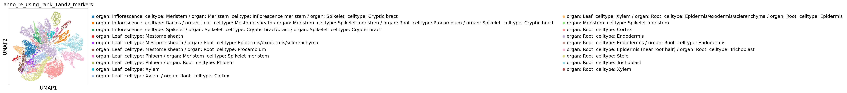

cluster 0: organ: Root celltype: Cortex

cluster 1: organ: Root celltype: Cortex

cluster 2: organ: Meristem celltype: Spikelet meristem

cluster 3: organ: Root celltype: Trichoblast

cluster 4: organ: Root celltype: Stele

cluster 5: organ: Meristem celltype: Branch meristem

cluster 6: organ: Root celltype: Endodermis

cluster 7: organ: Root celltype: Endodermis

cluster 8: organ: Meristem celltype: Branch meristem

cluster 9: organ: Meristem celltype: Branch meristem

cluster 10: organ: Root celltype: Endodermis

cluster 11: organ: Root celltype: Endodermis

cluster 12: Unknown

cluster 13: Unknown

cluster 14: organ: Root celltype: Cortex

cluster 15: organ: Meristem celltype: Branch meristem

cluster 16: organ: Root celltype: Phloem

cluster 17: organ: Root celltype: Epidermis

cluster 18: organ: Root celltype: Cortex

cluster 19: Unknown

cluster 20: organ: Root celltype: Endodermis

cluster 21: organ: Meristem celltype: Spikelet meristem

cluster 22: organ: Root celltype: Trichoblast

cluster 23: organ: Root celltype: Xylem

cluster 24: organ: Root celltype: Columella

cluster 25: organ: Root celltype: Cortex

cluster 26: organ: Meristem celltype: Branch meristem

cluster 27: organ: Leaf celltype: Mestome sheath

cluster 28: organ: Leaf celltype: Phloem

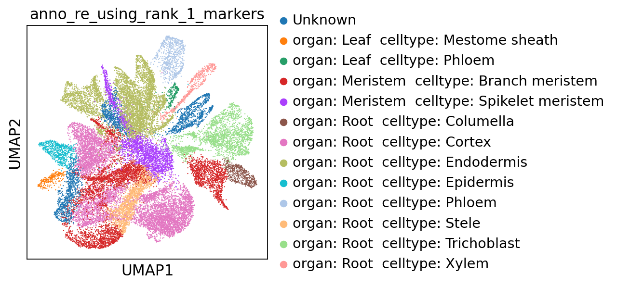

Memory collecting...

Memory information:

Used:

2320695296

Total:

201226063872

Used (%):

11.0

In [11]:

**del** scapp

gc**.**collect()

**with** open('SCAPP_0_Copy1.py','r') **as** f:

exec(f**.**read())

Out[11]:

519

Memory collecting...

Memory information:

Used:

1312759808

Total:

201226063872

Used (%):

10.5

**1.2.2 Multiple files**

In [ ]:

**with** open('SCAPP_0_Copy1.py','r') **as** f:

exec(f**.**read())

In [12]:

filepaths **=** ['~/data/rice/PRJNA706435/SRR13853439/cellranger_SRR13853439_without_introns/outs/filtered_feature_bc_matrix/matrix.mtx.gz',

'~/data/rice/PRJNA706435/SRR13853440/cellranger_SRR13853440_without_introns/outs/filtered_feature_bc_matrix/matrix.mtx.gz']

In [13]:

scapp **=** SCAPP_0()

scapp**.**to_annotation_0(filepaths **=** filepaths)

scanpy==1.9.2 anndata==0.8.0 umap==0.5.3 numpy==1.21.5 scipy==1.7.3 pandas==1.5.2 scikit-learn==1.2.1 statsmodels==0.13.5 python-igraph==0.10.4 louvain==0.8.0 pynndescent==0.5.8

--> This might be very slow. Consider passing `cache=True`, which enables much faster reading from a cache file.

--> This might be very slow. Consider passing `cache=True`, which enables much faster reading from a cache file.

Before filter

normalizing counts per cell

finished (0:00:00)

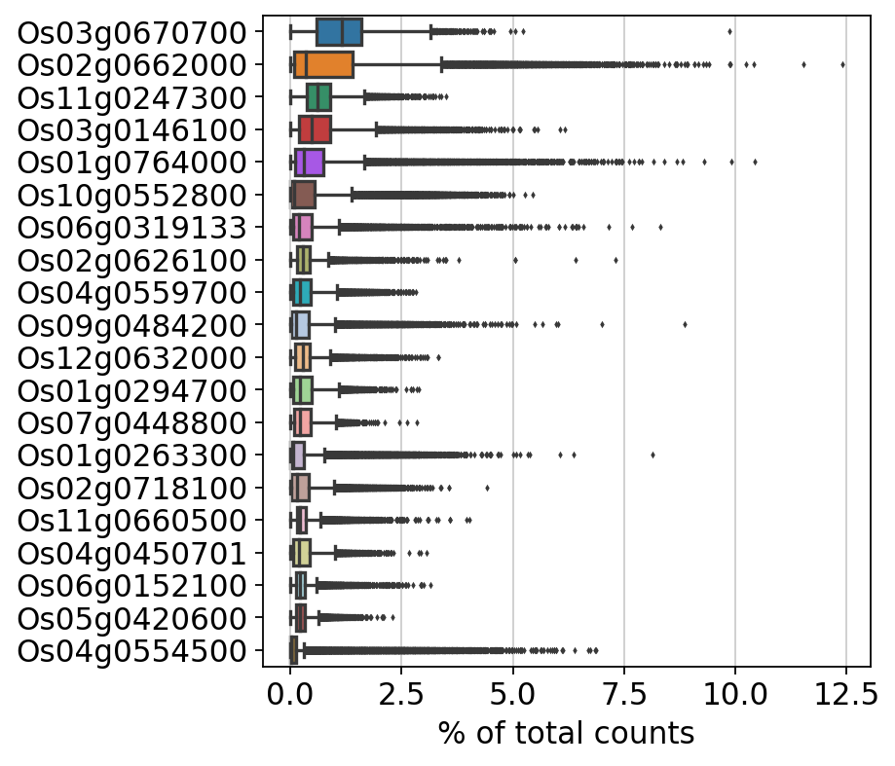

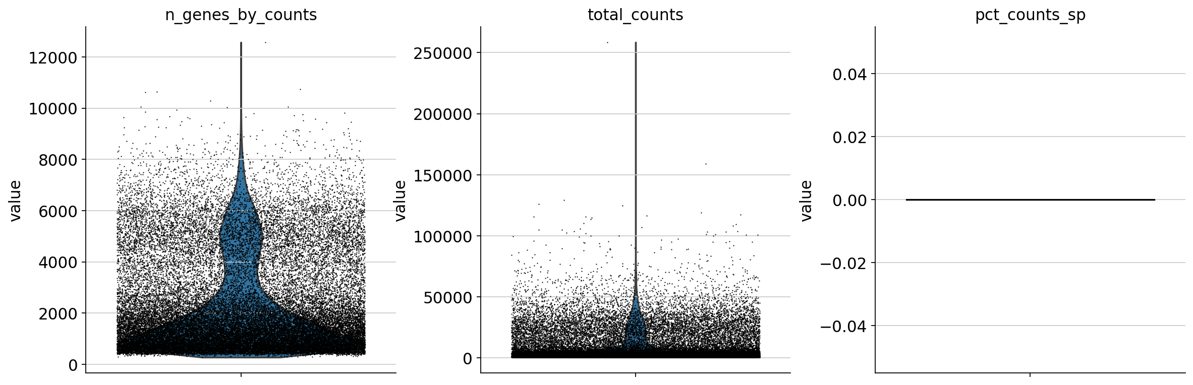

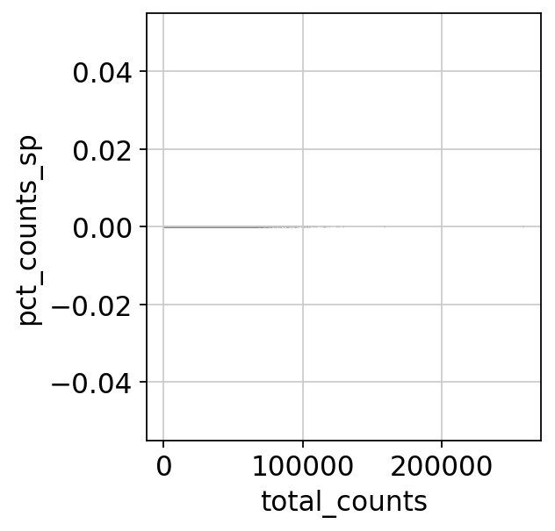

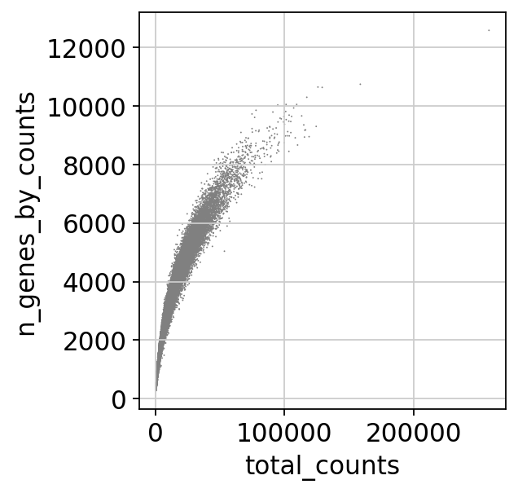

After filter

filtered out 8323 genes that are detected in less than 3 cells

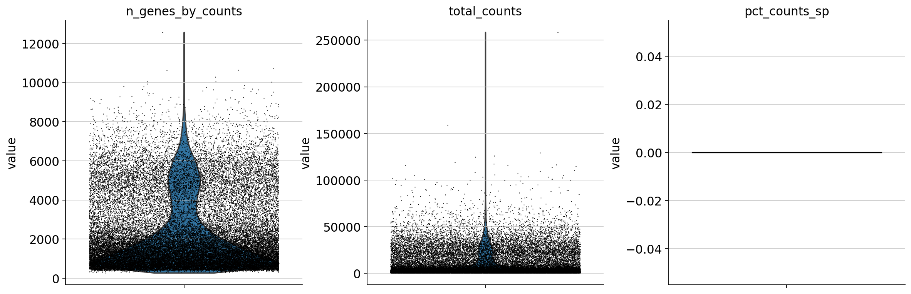





Before filter

count 40692.000000

mean 8966.039062

std 13052.052734

min 500.000000

25% 1331.000000

50% 2935.000000

75% 10567.000000

max 258543.000000

Name: total_counts, dtype: float64

count 40692.000000

mean 2264.228325

std 1841.166077

min 277.000000

25% 866.000000

50% 1532.000000

75% 3197.000000

max 12571.000000

Name: n_genes_by_counts, dtype: float64

count 40692.0

mean 0.0

std 0.0

min 0.0

25% 0.0

50% 0.0

75% 0.0

max 0.0

Name: pct_counts_sp, dtype: float64

After filter

count 40692.000000

mean 8966.039062

std 13052.052734

min 500.000000

25% 1331.000000

50% 2935.000000

75% 10567.000000

max 258543.000000

Name: total_counts, dtype: float64

count 40692.000000

mean 2264.228325

std 1841.166077

min 277.000000

25% 866.000000

50% 1532.000000

75% 3197.000000

max 12571.000000

Name: n_genes_by_counts, dtype: float64

count 40692.0

mean 0.0

std 0.0

min 0.0

25% 0.0

50% 0.0

75% 0.0

max 0.0

Name: pct_counts_sp, dtype: float64

normalizing counts per cell

finished (0:00:00)

extracting highly variable genes

finished (0:00:02)

--> added

'highly_variable', boolean vector (adata.var)

'means', float vector (adata.var)

'dispersions', float vector (adata.var)

'dispersions_norm', float vector (adata.var)

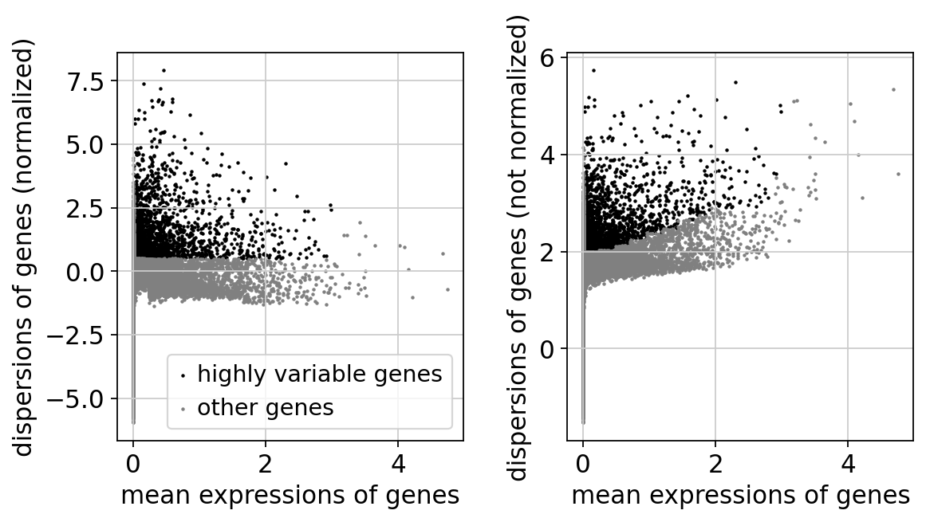

regressing out ['total_counts']

sparse input is densified and may lead to high memory use

finished (0:01:09)

computing PCA

on highly variable genes

with n_comps=50

finished (0:00:04)

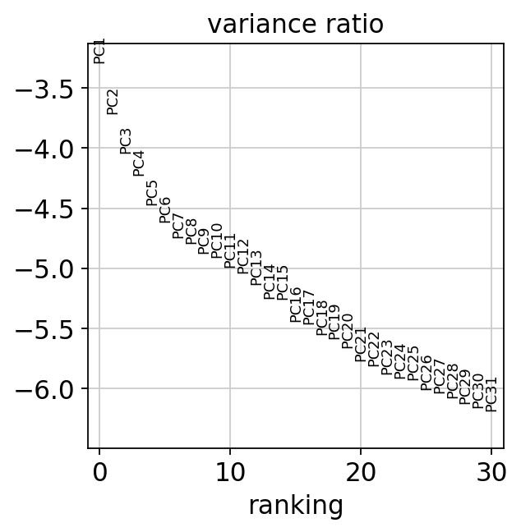

2023-03-23 21:56:50,771 - harmonypy - INFO - Iteration 1 of 10

2023-03-23 21:57:04,775 - harmonypy - INFO - Iteration 2 of 10

2023-03-23 21:57:16,221 - harmonypy - INFO - Iteration 3 of 10

2023-03-23 21:57:30,882 - harmonypy - INFO - Iteration 4 of 10

2023-03-23 21:57:44,294 - harmonypy - INFO - Iteration 5 of 10

2023-03-23 21:57:53,861 - harmonypy - INFO - Converged after 5 iterations

computing neighbors

finished: added to `.uns['neighbors']`

`.obsp['distances']`, distances for each pair of neighbors

`.obsp['connectivities']`, weighted adjacency matrix (0:00:06)

computing UMAP

finished: added

'X_umap', UMAP coordinates (adata.obsm) (0:00:51)

running Leiden clustering

finished: found 29 clusters and added

'leiden', the cluster labels (adata.obs, categorical) (0:00:07)

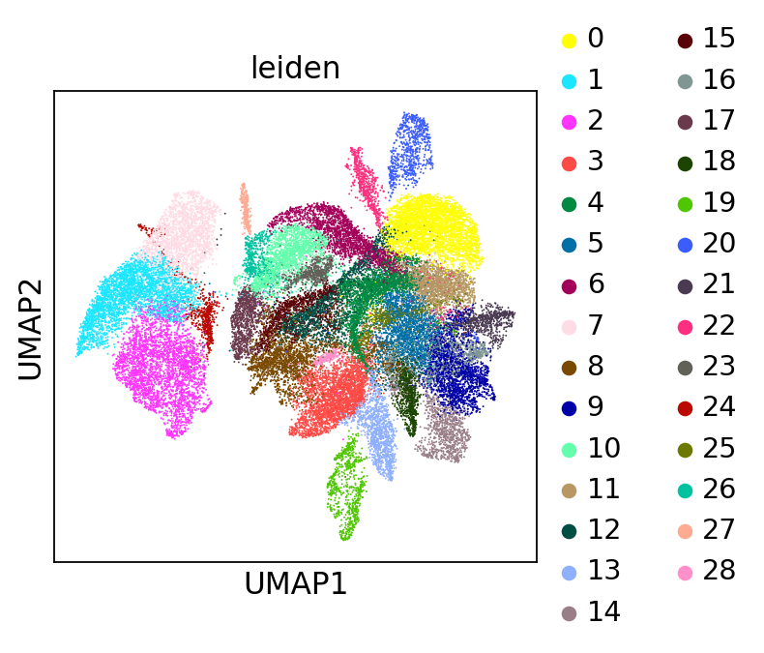

running PAGA

finished: added

'paga/connectivities', connectivities adjacency (adata.uns)

'paga/connectivities_tree', connectivities subtree (adata.uns) (0:00:02)

--> added 'pos', the PAGA positions (adata.uns['paga'])

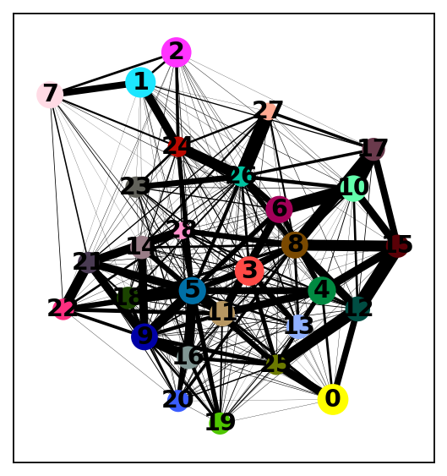

computing UMAP

finished: added

'X_umap', UMAP coordinates (adata.obsm) (0:00:49)

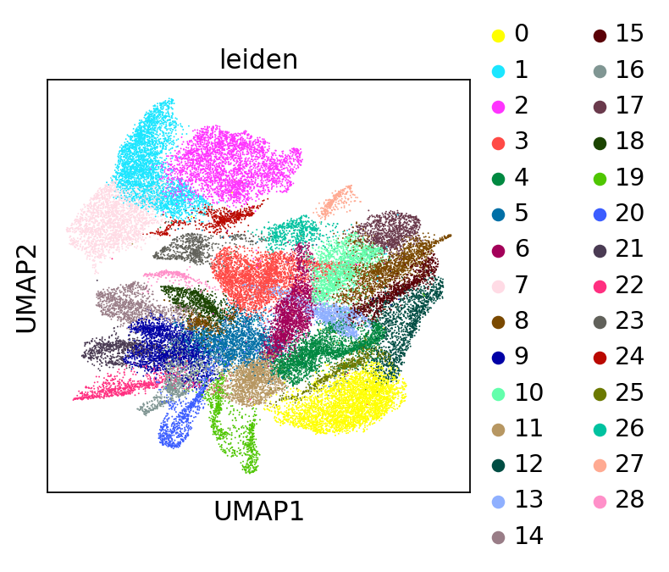

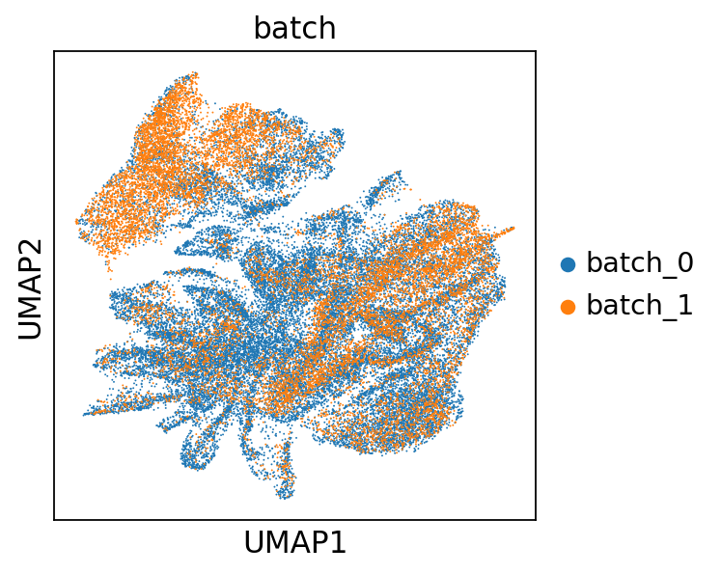

ranking genes

finished: added to `.uns['rank_genes_groups']`

'names', sorted np.recarray to be indexed by group ids

'scores', sorted np.recarray to be indexed by group ids

'logfoldchanges', sorted np.recarray to be indexed by group ids

'pvals', sorted np.recarray to be indexed by group ids

'pvals_adj', sorted np.recarray to be indexed by group ids (0:00:19)

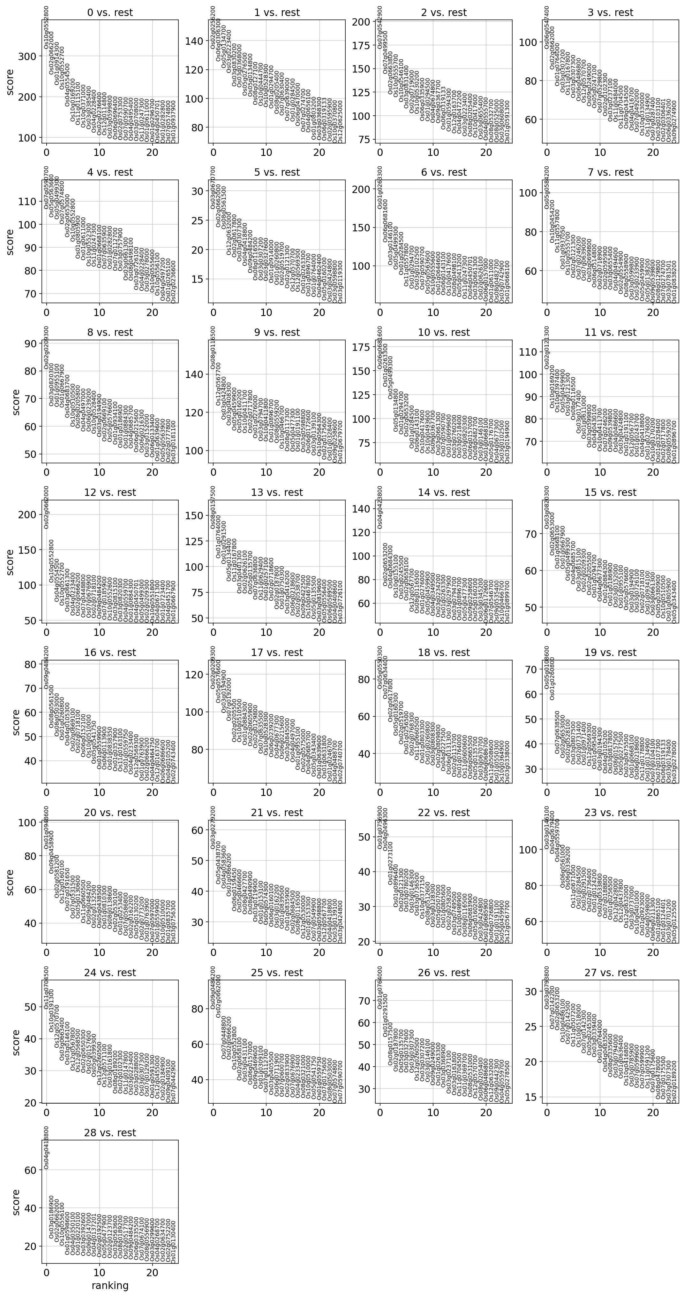

The below is the top marker gene list for each cluster.

You can change the annotation result according to this.

The list of top marker genes

col : clusters

0 1 2 3 4 \

0 Os10g0552800 Os02g0256200 Os07g0542900 Os06g0547400 Os07g0590700

1 Os02g0662000 Os06g0306300 Os07g0499500 Os02g0662000 Os05g0563600

2 Os01g0914300 Os05g0134700 Os02g0663800 Os01g0764000 Os05g0499300

3 Os10g0552700 Os03g0223400 Os10g0555700 Os03g0307200 Os07g0574800

4 Os04g0554500 Os03g0830200 Os10g0546100 Os11g0167800 Os02g0653000

5 Os10g0169200 Os03g0368000 Os03g0831400 Os03g0307300 Os10g0552800

6 Os11g0115100 Os05g0276500 Os02g0719000 Os06g0486800 Os01g0805900

7 Os10g0371000 Os05g0134800 Os10g0530200 Os12g0570700 Os01g0611000

8 Os03g0385400 Os08g0127100 Os06g0335900 Os09g0249000 Os10g0552300

9 Os04g0228400 Os10g0444700 Os01g0294500 Os05g0247100 Os11g0247300

10 Os02g0236600 Os10g0528300 Os04g0674800 Os07g0529800 Os01g0668100

11 Os12g0114800 Os01g0294700 Os09g0367700 Os02g0102300 Os07g0635900

12 Os03g0599800 Os08g0205400 Os06g0319133 Os03g0237100 Os01g0282800

13 Os06g0696400 Os07g0630400 Os01g0594300 Os11g0484000 Os07g0112700

14 Os02g0753300 Os07g0639000 Os12g0163700 Os11g0704500 Os03g0757900

15 Os07g0590700 Os01g0284500 Os04g0472200 Os09g0434500 Os03g0661300

16 Os04g0495400 Os06g0470000 Os03g0223400 Os04g0416700 Os08g0498100

17 Os03g0708000 Os07g0274700 Os08g0205400 Os07g0492000 Os03g0726100

18 Os11g0247300 Os04g0656100 Os10g0417600 Os10g0330000 Os04g0228400

19 Os01g0611000 Os01g0803200 Os03g0655400 Os11g0134900 Os03g0278000

5 6 7 8 9 ... \

0 Os03g0670700 Os01g0263300 Os05g0584200 Os02g0209300 Os08g0116500 ...

1 Os02g0662000 Os06g0681600 Os10g0454200 Os03g0820300 Os12g0567700 ...

2 Os08g0561500 Os03g0146100 Os11g0557800 Os01g0955100 Os03g0424800 ...

3 Os12g0632000 Os05g0499300 Os01g0937050 Os01g0667900 Os03g0408300 ...

4 Os02g0617800 Os01g0284500 Os10g0555700 Os04g0683700 Os05g0459900 ...

5 Os03g0307300 Os11g0557800 Os02g0121300 Os10g0510500 Os05g0160200 ...

6 Os04g0418800 Os01g0294700 Os07g0246200 Os08g0205800 Os10g0411700 ...

7 Os09g0484200 Os03g0102500 Os07g0639000 Os04g0497000 Os02g0717800 ...

8 Os08g0116500 Os07g0590700 Os03g0699800 Os06g0239200 Os01g0276000 ...

9 Os03g0307200 Os05g0563600 Os06g0514800 Os10g0528400 Os03g0794700 ...

10 Os03g0327600 Os10g0555600 Os02g0718900 Os03g0194900 Os10g0411800 ...

11 Os01g0914000 Os01g0644600 Os02g0595900 Os02g0669100 Os01g0896700 ...

12 Os01g0260800 Os06g0143100 Os03g0655400 Os05g0576600 Os08g0559200 ...

13 Os02g0519700 Os10g0417600 Os04g0494600 Os01g0934100 Os10g0466700 ...

14 Os02g0121300 Os08g0498100 Os02g0554900 Os01g0186900 Os08g0117300 ...

15 Os12g0570700 Os05g0413200 Os08g0558900 Os01g0884300 Os05g0477300 ...

16 Os12g0569300 Os11g0247300 Os03g0599800 Os04g0685700 Os01g0191100 ...

17 Os01g0263300 Os04g0450701 Os03g0233900 Os06g0215600 Os03g0598800 ...

18 Os01g0896700 Os03g0661300 Os05g0459900 Os06g0216300 Os06g0172600 ...

19 Os01g0764000 Os02g0626100 Os05g0138200 Os03g0152000 Os03g0139100 ...

19 20 21 22 23 \

0 Os05g0108600 Os01g0948600 Os03g0279200 Os01g0756900 Os03g0146100

1 Os01g0260800 Os09g0458900 Os05g0438700 Os04g0496300 Os04g0679400

2 Os07g0638500 Os02g0581200 Os04g0583600 Os01g0273100 Os04g0559700

3 Os02g0653000 Os12g0160100 Os01g0866200 Os01g0896400 Os06g0561000

4 Os02g0528100 Os07g0191650 Os06g0159450 Os02g0121300 Os06g0336200

5 Os03g0807500 Os07g0531500 Os05g0466600 Os03g0780200 Os11g0671000

6 Os02g0731400 Os05g0130600 Os08g0427700 Os03g0146300 Os01g0284500

7 Os01g0971400 Os11g0660500 Os08g0490900 Os03g0736500 Os03g0291500

8 Os12g0569300 Os09g0484200 Os03g0119900 Os10g0377150 Os02g0736400

9 Os01g0954000 Os02g0132500 Os01g0153100 Os08g0512600 Os01g0124200

10 Os03g0194300 Os05g0438500 Os05g0574300 Os03g0128300 Os02g0533800

11 Os04g0105200 Os01g0810300 Os06g0160100 Os05g0507000 Os07g0188800

12 Os03g0817800 Os08g0138600 Os03g0162200 Os01g0805600 Os01g0256500

13 Os08g0157500 Os02g0530100 Os01g0839500 Os02g0258200 Os12g0428000

14 Os05g0277500 Os01g0253400 Os01g0835900 Os03g0749500 Os12g0437800

15 Os03g0675500 Os07g0586800 Os02g0684500 Os10g0498900 Os12g0632000

16 Os01g0668100 Os02g0162200 Os08g0116500 Os08g0116500 Os03g0737000

17 Os06g0218600 Os05g0130200 Os12g0530000 Os06g0683900 Os10g0401000

18 Os11g0178800 Os02g0773200 Os01g0153300 Os05g0160200 Os01g0923000

19 Os01g0134900 Os01g0763900 Os07g0549900 Os03g0424800 Os04g0598000

24 25 26 27 28

0 Os11g0704500 Os09g0484200 Os01g0764000 Os03g0793800 Os04g0418800

1 Os10g0191300 Os02g0662000 Os01g0291500 Os07g0142200 Os03g0186900

2 Os12g0570700 Os07g0448800 Os08g0157500 Os02g0653200 Os02g0662000

3 Os03g0663400 Os02g0666200 Os02g0187800 Os10g0486100 Os10g0556100

4 Os03g0146100 Os10g0552800 Os05g0135700 Os07g0142500 Os01g0598600

5 Os12g0567800 Os02g0658100 Os03g0327600 Os11g0507200 Os04g0350100

6 Os12g0568500 Os03g0431100 Os03g0307300 Os10g0518000 Os01g0220100

7 Os02g0650300 Os06g0157000 Os12g0260500 Os07g0142300 Os03g0392600

8 Os02g0157600 Os09g0469600 Os03g0307200 Os05g0245300 Os06g0147000

9 Os05g0399300 Os01g0309100 Os03g0146100 Os03g0339400 Os04g0137201

10 Os12g0260500 Os07g0112700 Os09g0249000 Os01g0764000 Os02g0192500

11 Os12g0571100 Os03g0405500 Os01g0263300 Os04g0483500 Os05g0477900

12 Os03g0161800 Os06g0711900 Os03g0368900 Os08g0335600 Os02g0123700

13 Os08g0189200 Os07g0600700 Os03g0237100 Os03g0794000 Os03g0563600

14 Os02g0102300 Os02g0833900 Os03g0161800 Os01g0636400 Os08g0189200

15 Os11g0147800 Os07g0676900 Os11g0704500 Os10g0416800 Os02g0517700

16 Os03g0223400 Os04g0233400 Os01g0369700 Os03g0785900 Os09g0484200

17 Os03g0288000 Os08g0321000 Os08g0531000 Os07g0599600 Os06g0335500

18 Os03g0307300 Os10g0510000 Os12g0570700 Os07g0599900 Os07g0674100

19 Os07g0129200 Os05g0541750 Os08g0205400 Os11g0591200 Os08g0556900

[20 rows x 29 columns]

Top marker genes and their p-values of each cluster:

0_n 0_p 1_n 1_p 2_n 2_p 3_n \

0 Os10g0552800 0.0 Os02g0256200 0.0 Os07g0542900 0.0 Os06g0547400

1 Os02g0662000 0.0 Os06g0306300 0.0 Os07g0499500 0.0 Os02g0662000

2 Os01g0914300 0.0 Os05g0134700 0.0 Os02g0663800 0.0 Os01g0764000

3 Os10g0552700 0.0 Os03g0223400 0.0 Os10g0555700 0.0 Os03g0307200

4 Os04g0554500 0.0 Os03g0830200 0.0 Os10g0546100 0.0 Os11g0167800

5 Os10g0169200 0.0 Os03g0368000 0.0 Os03g0831400 0.0 Os03g0307300

6 Os11g0115100 0.0 Os05g0276500 0.0 Os02g0719000 0.0 Os06g0486800

7 Os10g0371000 0.0 Os05g0134800 0.0 Os10g0530200 0.0 Os12g0570700

8 Os03g0385400 0.0 Os08g0127100 0.0 Os06g0335900 0.0 Os09g0249000

9 Os04g0228400 0.0 Os10g0444700 0.0 Os01g0294500 0.0 Os05g0247100

10 Os02g0236600 0.0 Os10g0528300 0.0 Os04g0674800 0.0 Os07g0529800

11 Os12g0114800 0.0 Os01g0294700 0.0 Os09g0367700 0.0 Os02g0102300

12 Os03g0599800 0.0 Os08g0205400 0.0 Os06g0319133 0.0 Os03g0237100

13 Os06g0696400 0.0 Os07g0630400 0.0 Os01g0594300 0.0 Os11g0484000

14 Os02g0753300 0.0 Os07g0639000 0.0 Os12g0163700 0.0 Os11g0704500

15 Os07g0590700 0.0 Os01g0284500 0.0 Os04g0472200 0.0 Os09g0434500

16 Os04g0495400 0.0 Os06g0470000 0.0 Os03g0223400 0.0 Os04g0416700

17 Os03g0708000 0.0 Os07g0274700 0.0 Os08g0205400 0.0 Os07g0492000

18 Os11g0247300 0.0 Os04g0656100 0.0 Os10g0417600 0.0 Os10g0330000

19 Os01g0611000 0.0 Os01g0803200 0.0 Os03g0655400 0.0 Os11g0134900

3_p 4_n 4_p ... 24_n 24_p 25_n \

0 0.0 Os07g0590700 0.0 ... Os11g0704500 1.170390e-211 Os09g0484200

1 0.0 Os05g0563600 0.0 ... Os10g0191300 8.954777e-178 Os02g0662000

2 0.0 Os05g0499300 0.0 ... Os12g0570700 4.811959e-157 Os07g0448800

3 0.0 Os07g0574800 0.0 ... Os03g0663400 2.761465e-136 Os02g0666200

4 0.0 Os02g0653000 0.0 ... Os03g0146100 6.853405e-133 Os10g0552800

5 0.0 Os10g0552800 0.0 ... Os12g0567800 1.034710e-120 Os02g0658100

6 0.0 Os01g0805900 0.0 ... Os12g0568500 3.448362e-118 Os03g0431100

7 0.0 Os01g0611000 0.0 ... Os02g0650300 3.340256e-117 Os06g0157000

8 0.0 Os10g0552300 0.0 ... Os02g0157600 7.084798e-116 Os09g0469600

9 0.0 Os11g0247300 0.0 ... Os05g0399300 3.790713e-110 Os01g0309100

10 0.0 Os01g0668100 0.0 ... Os12g0260500 9.426392e-98 Os07g0112700

11 0.0 Os07g0635900 0.0 ... Os12g0571100 9.767719e-94 Os03g0405500

12 0.0 Os01g0282800 0.0 ... Os03g0161800 1.412169e-93 Os06g0711900

13 0.0 Os07g0112700 0.0 ... Os08g0189200 1.111849e-83 Os07g0600700

14 0.0 Os03g0757900 0.0 ... Os02g0102300 1.563597e-83 Os02g0833900

15 0.0 Os03g0661300 0.0 ... Os11g0147800 1.173594e-82 Os07g0676900

16 0.0 Os08g0498100 0.0 ... Os03g0223400 1.685835e-81 Os04g0233400

17 0.0 Os03g0726100 0.0 ... Os03g0288000 8.219338e-81 Os08g0321000

18 0.0 Os04g0228400 0.0 ... Os03g0307300 1.924233e-80 Os10g0510000

19 0.0 Os03g0278000 0.0 ... Os07g0129200 5.528795e-79 Os05g0541750

25_p 26_n 26_p 27_n 27_p \

0 0.000000e+00 Os01g0764000 2.507568e-281 Os03g0793800 6.509233e-84

1 0.000000e+00 Os01g0291500 1.994187e-225 Os07g0142200 3.185051e-74

2 6.429019e-230 Os08g0157500 6.090409e-172 Os02g0653200 5.439854e-74

3 9.271451e-225 Os02g0187800 1.647509e-157 Os10g0486100 1.597080e-67

4 8.193367e-200 Os05g0135700 3.132937e-157 Os07g0142500 1.708476e-66

5 1.435138e-167 Os03g0327600 8.374947e-156 Os11g0507200 3.532502e-65

6 5.662744e-167 Os03g0307300 1.729323e-155 Os10g0518000 7.412938e-65

7 3.866557e-157 Os12g0260500 4.078207e-137 Os07g0142300 8.954594e-62

8 5.614287e-147 Os03g0307200 1.526346e-136 Os05g0245300 9.162848e-61

9 1.564428e-144 Os03g0146100 2.884167e-139 Os03g0339400 1.074743e-59

10 7.012175e-137 Os09g0249000 1.250884e-128 Os01g0764000 3.908577e-57

11 1.540807e-128 Os01g0263300 8.486915e-129 Os04g0483500 6.250619e-52

12 9.682883e-125 Os03g0368900 1.326407e-122 Os08g0335600 3.194611e-49

13 1.273061e-123 Os03g0237100 2.836454e-109 Os03g0794000 6.650033e-49

14 2.149147e-121 Os03g0161800 1.282363e-105 Os01g0636400 2.584674e-48

15 7.465776e-121 Os11g0704500 3.900700e-103 Os10g0416800 1.209344e-44

16 2.297097e-120 Os01g0369700 2.869085e-102 Os03g0785900 4.202567e-44

17 4.733578e-120 Os08g0531000 1.688181e-100 Os07g0599600 1.904602e-43

18 1.302625e-117 Os12g0570700 3.851950e-98 Os07g0599900 4.688415e-43

19 8.813559e-116 Os08g0205400 1.566222e-93 Os11g0591200 5.102748e-43

28_n 28_p

0 Os04g0418800 1.778477e-154

1 Os03g0186900 1.040120e-67

2 Os02g0662000 1.395305e-62

3 Os10g0556100 7.292490e-56

4 Os01g0598600 3.262352e-39

5 Os04g0350100 1.216731e-38

6 Os01g0220100 1.349323e-38

7 Os03g0392600 1.054675e-37

8 Os06g0147000 3.383690e-37

9 Os04g0137201 2.859134e-36

10 Os02g0192500 2.094676e-35

11 Os05g0477900 1.485393e-33

12 Os02g0123700 1.827555e-33

13 Os03g0563600 7.378977e-33

14 Os08g0189200 9.372110e-33

15 Os02g0517700 2.111954e-31

16 Os09g0484200 4.140286e-31

17 Os06g0335500 6.011747e-30

18 Os07g0674100 1.361507e-29

19 Os08g0556900 1.010586e-27

[20 rows x 58 columns]

cluster 0: organ: Root celltype: Cortex

cluster 1: organ: Root celltype: Epidermis (near root hair) / organ: Root celltype: Trichoblast

cluster 2: organ: Root celltype: Trichoblast

cluster 3: organ: Leaf celltype: Mestome sheath / organ: Root celltype: Cortex / organ: Root celltype: Trichoblast

cluster 4: organ: Leaf celltype: Xylem / organ: Root celltype: Cortex

cluster 5: organ: Inflorescence celltype: Spikelet / organ: Meristem celltype: Spikelet meristem / organ: Root celltype: Endodermis / organ: Spikelet celltype: Palea

cluster 6: organ: Leaf celltype: Mestome sheath / organ: Root celltype: Procambium / organ: Root celltype: Stele

cluster 7: organ: Root celltype: Epidermis (near root hair) / organ: Root celltype: Trichoblast

cluster 8: organ: Inflorescence celltype: Leaf / organ: Inflorescence celltype: Meristem / organ: Leaf celltype: Large paremchyma / organ: Meristem celltype: Branch meristem / organ: Root celltype: Xylem / organ: Spikelet celltype: Floret meristem / organ: Spikelet celltype: Spikelet supporting cell

cluster 9: organ: Root celltype: Endodermis

cluster 10: organ: Root celltype: Stele

cluster 11: organ: Root celltype: Endodermis

cluster 12: organ: Root celltype: Cortex

cluster 13: organ: Leaf celltype: Xylem / organ: Root celltype: Epidermis/exodermis/sclerenchyma / organ: Root celltype: Epidermis

cluster 14: organ: Root celltype: Endodermis

cluster 15: organ: Inflorescence celltype: Meristem / organ: Leaf celltype: Mesophyll precursor / organ: Meristem celltype: Inflorescence meristem / organ: Root celltype: Cortex / organ: Spikelet celltype: Cryptic bract/bract / organ: Spikelet celltype: Cryptic bract / organ: Spikelet celltype: Floret meristem / organ: Spikelet celltype: Lodicule

cluster 16: organ: Leaf celltype: Xylem

cluster 17: organ: Inflorescence celltype: Leaf / organ: Inflorescence celltype: Meristem / organ: Leaf celltype: Large paremchyma / organ: Meristem celltype: Branch meristem / organ: Root celltype: Xylem / organ: Spikelet celltype: Floret meristem / organ: Spikelet celltype: Spikelet supporting cell

cluster 18: organ: Root celltype: Endodermis

cluster 19: organ: Root celltype: Metaxylem / organ: Root celltype: Xylem

cluster 20: organ: Root celltype: Phloem

cluster 21: organ: Inflorescence celltype: Spikelet / organ: Spikelet celltype: Cryptic bract/bract / organ: Spikelet celltype: Cryptic bract

cluster 22: organ: Meristem celltype: Spikelet meristem

cluster 23: organ: Leaf celltype: Mesophyll precursor

cluster 24: organ: Root celltype: Trichoblast

cluster 25: organ: Root celltype: Cortex

cluster 26: organ: Leaf celltype: Mestome sheath / organ: Root celltype: Epidermis/exodermis/sclerenchyma

cluster 27: organ: Leaf celltype: Mestome sheath

cluster 28: organ: Root celltype: Cortex



cluster 0: organ: Root celltype: Cortex

cluster 1: organ: Meristem celltype: Branch meristem

cluster 2: organ: Root celltype: Trichoblast

cluster 3: organ: Root celltype: Cortex

cluster 4: organ: Root celltype: Cortex

cluster 5: organ: Root celltype: Endodermis

cluster 6: organ: Root celltype: Stele

cluster 7: organ: Root celltype: Columella

cluster 8: organ: Meristem celltype: Branch meristem

cluster 9: organ: Root celltype: Endodermis

cluster 10: organ: Root celltype: Stele

cluster 11: organ: Root celltype: Endodermis

cluster 12: organ: Root celltype: Cortex

cluster 13: organ: Root celltype: Epidermis

cluster 14: organ: Root celltype: Endodermis

cluster 15: organ: Meristem celltype: Branch meristem

cluster 16: organ: Root celltype: Endodermis

cluster 17: organ: Meristem celltype: Branch meristem

cluster 18: organ: Root celltype: Endodermis

cluster 19: organ: Root celltype: Xylem

cluster 20: organ: Root celltype: Phloem

cluster 21: Unknown

cluster 22: organ: Meristem celltype: Spikelet meristem

cluster 23: Unknown

cluster 24: organ: Root celltype: Trichoblast

cluster 25: organ: Root celltype: Cortex

cluster 26: organ: Root celltype: Stele

cluster 27: organ: Leaf celltype: Mestome sheath

cluster 28: organ: Root celltype: Cortex

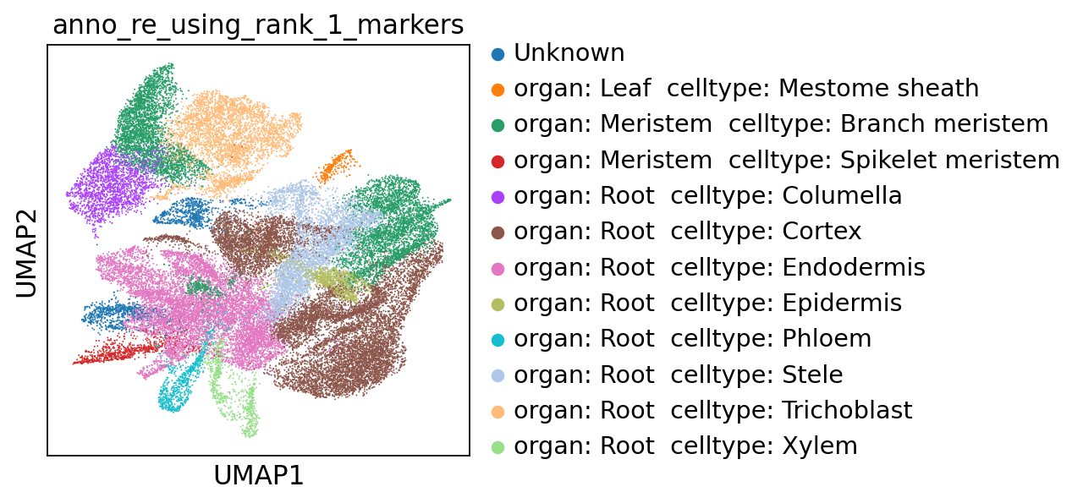

Memory collecting...

Memory information:

Used:

3331264512

Total:

201226063872

Used (%):

11.5

In [14]:

**del** scapp

gc**.**collect()

**with** open('SCAPP_0_Copy1.py','r') **as** f:

exec(f**.**read())

Out[14]:

534

Memory collecting...

Memory information:

Used:

2086985728

Total:

201226063872

Used (%):

10.9

**1.3 Use anndata**

In [15]:

filepath **=** '~/data/rice/PRJNA767589/SRR16127058/counts.tsv.gz'

In [16]:

adata **=** sc**.**read_umi_tools(filepath)

In [17]:

scapp **=** SCAPP_0()

scapp**.**data_input_0_from_anndata(anndata **=** adata)

scapp**.**to_annotation_0()

scanpy==1.9.2 anndata==0.8.0 umap==0.5.3 numpy==1.21.5 scipy==1.7.3 pandas==1.5.2 scikit-learn==1.2.1 statsmodels==0.13.5 python-igraph==0.10.4 louvain==0.8.0 pynndescent==0.5.8

Before filter

normalizing counts per cell

finished (0:00:00)



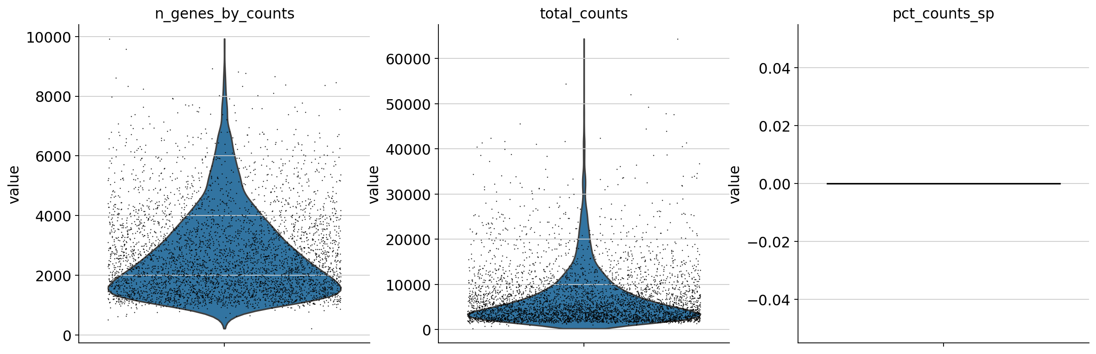





After filter

filtered out 2998 genes that are detected in less than 3 cells

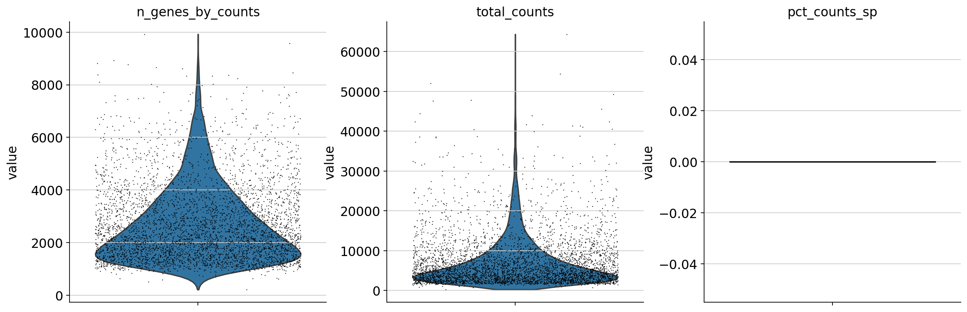





Before filter

count 4336.000000

mean 7103.151983

std 6376.242052

min 249.000000

25% 3012.000000

50% 4970.000000

75% 8760.250000

max 64352.000000

Name: total_counts, dtype: float64

count 4336.000000

mean 2698.808118

std 1424.931102

min 215.000000

25% 1605.750000

50% 2324.000000

75% 3431.500000

max 9922.000000

Name: n_genes_by_counts, dtype: float64

count 4336.0

mean 0.0

std 0.0

min 0.0

25% 0.0

50% 0.0

75% 0.0

max 0.0

Name: pct_counts_sp, dtype: float64

After filter

count 4336.000000

mean 7103.151983

std 6376.242052

min 249.000000

25% 3012.000000

50% 4970.000000

75% 8760.250000

max 64352.000000

Name: total_counts, dtype: float64

count 4336.000000

mean 2698.808118

std 1424.931102

min 215.000000

25% 1605.750000

50% 2324.000000

75% 3431.500000

max 9922.000000

Name: n_genes_by_counts, dtype: float64

count 4336.0

mean 0.0

std 0.0

min 0.0

25% 0.0

50% 0.0

75% 0.0

max 0.0

Name: pct_counts_sp, dtype: float64

normalizing counts per cell

finished (0:00:00)

extracting highly variable genes

finished (0:00:00)

--> added

'highly_variable', boolean vector (adata.var)

'means', float vector (adata.var)

'dispersions', float vector (adata.var)

'dispersions_norm', float vector (adata.var)



regressing out ['total_counts']

sparse input is densified and may lead to high memory use

finished (0:00:19)

computing PCA

on highly variable genes

with n_comps=50

finished (0:00:00)



computing neighbors

using 'X_pca' with n_pcs = 40

finished: added to `.uns['neighbors']`

`.obsp['distances']`, distances for each pair of neighbors

`.obsp['connectivities']`, weighted adjacency matrix (0:00:00)

computing UMAP

finished: added

'X_umap', UMAP coordinates (adata.obsm) (0:00:13)

running Leiden clustering

finished: found 15 clusters and added

'leiden', the cluster labels (adata.obs, categorical) (0:00:00)

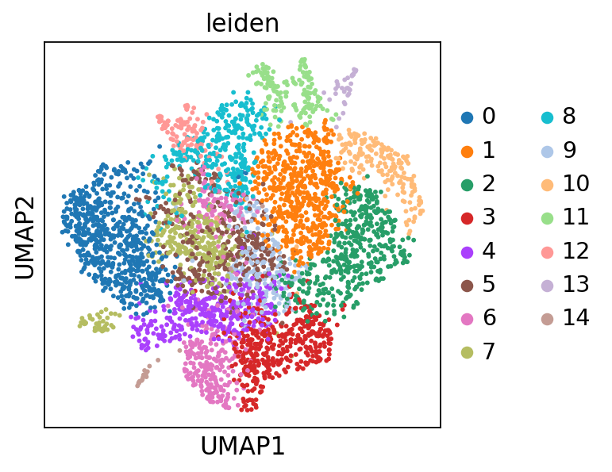

running PAGA

finished: added

'paga/connectivities', connectivities adjacency (adata.uns)

'paga/connectivities_tree', connectivities subtree (adata.uns) (0:00:00)

--> added 'pos', the PAGA positions (adata.uns['paga'])



computing UMAP

finished: added

'X_umap', UMAP coordinates (adata.obsm) (0:00:13)

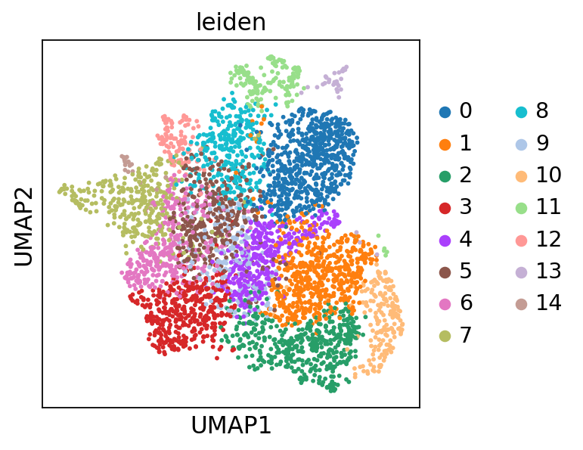

ranking genes

finished: added to `.uns['rank_genes_groups']`

'names', sorted np.recarray to be indexed by group ids

'scores', sorted np.recarray to be indexed by group ids

'logfoldchanges', sorted np.recarray to be indexed by group ids

'pvals', sorted np.recarray to be indexed by group ids

'pvals_adj', sorted np.recarray to be indexed by group ids (0:00:01)



The below is the top marker gene list for each cluster.

You can change the annotation result according to this.

The list of top marker genes

col : clusters

0 1 2 3 4 \

0 Os09g0551600 Os02g0593700 Os08g0524200 Os02g0115900 Os04g0447700

1 Os02g0586500 Os03g0241900 Os07g0150700 Os04g0402100 Os01g0740700

2 Os03g0345200 Os08g0538600 Os02g0274100 Os04g0614650 Os03g0227800

3 Os06g0728000 Os11g0106700 Os08g0482700 Os12g0635400 Os05g0186300

4 Os08g0129200 Os05g0231700 Os04g0677500 Os02g0551100 Os02g0705400

5 Os01g0834600 Os08g0524200 Os04g0673300 Os04g0447700 Os04g0209200

6 Os11g0247300 Os03g0266900 Os11g0139700 Os03g0850400 Os03g0326200

7 Os01g0191100 Os05g0272900 Os11g0502700 Os04g0614700 Os09g0454600

8 Os01g0267900 Os10g0510500 Os05g0138300 Os03g0227800 Os08g0480100

9 Os03g0149200 Os03g0741600 Os06g0711100 Os08g0557600 Os08g0557600

10 Os03g0670700 Os08g0157900 Os12g0555000 Os03g0180900 Os01g0911100

11 Os04g0349500 Os03g0356484 Os03g0218400 Os08g0482700 Os06g0239200

12 Os08g0128500 Os07g0671800 Os10g0528300 Os08g0127100 Os05g0194500

13 Os04g0486600 Os03g0326500 Os03g0133400 Os07g0492000 Os11g0147150

14 Os02g0610600 Os03g0802200 Os12g0603800 Os11g0537375 Os12g0603800

15 Os11g0660500 Os08g0546100 Os01g0660200 Os06g0111500 Os09g0511600

16 Os10g0466700 Os08g0558100 Os03g0636800 Os03g0599800 Os10g0577800

17 Os02g0503400 Os04g0488700 Os01g0813400 Os02g0467200 Os08g0387050

18 Os05g0486700 Os07g0593400 Os05g0495300 Os02g0695800 Os02g0702100

19 Os04g0564600 Os08g0205800 Os07g0186000 Os01g0895600 Os06g0711100

5 6 7 8 9 \

0 Os02g0669100 Os01g0905800 Os01g0948600 Os03g0152000 Os01g0740700

1 Os07g0164800 Os11g0210300 Os12g0147800 Os01g0667900 Os02g0669100

2 Os04g0531100 Os01g0313300 Os03g0327600 Os03g0241900 Os08g0482700

3 Os03g0655400 Os05g0469600 Os01g0839900 Os08g0504700 Os10g0510500

4 Os05g0349800 Os07g0530600 Os02g0203700 Os02g0527300 Os07g0635500

5 Os05g0453700 Os02g0601300 Os02g0669100 Os05g0380900 Os06g0711100

6 Os06g0184300 Os05g0402700 Os02g0656100 Os08g0492500 Os07g0150700

7 Os03g0285700 Os04g0677500 Os03g0586700 Os03g0353400 Os07g0418500

8 Os06g0254700 Os10g0167300 Os01g0559900 Os07g0680600 Os01g0283500

9 Os07g0186000 Os08g0339200 Os12g0112000 Os04g0591100 Os05g0534800

10 Os07g0529800 Os06g0318800 Os04g0653600 Os01g0135700 Os03g0655400

11 Os11g0660500 Os01g0817700 Os04g0599650 Os05g0176700 Os07g0529800

12 Os08g0129800 Os06g0142400 Os08g0127800 Os03g0764100 Os02g0467200

13 Os01g0256500 Os11g0112000 Os01g0559000 Os03g0820400 Os05g0539700

14 Os05g0111300 Os03g0367900 Os07g0508900 Os02g0739100 Os04g0209200

15 Os03g0670700 Os06g0142200 Os02g0121300 Os07g0164800 Os01g0797600

16 Os04g0450100 Os11g0148500 Os02g0673700 Os09g0457900 Os11g0147150

17 Os02g0327000 Os07g0674800 Os03g0340900 Os01g0582600 Os08g0387050

18 Os05g0498400 Os04g0543500 Os08g0494000 Os03g0266900 Os01g0930200

19 Os02g0719600 Os05g0453700 Os01g0788200 Os01g0863300 Os07g0629500

10 11 12 13 14

0 Os08g0524200 Os08g0509600 Os05g0111300 Os01g0251400 Os07g0150100

1 Os05g0186300 Os03g0152000 Os06g0643500 Os05g0419800 Os03g0260600

2 Os12g0603800 Os01g0186900 Os02g0629800 Os03g0803066 Os02g0673700

3 Os01g0660200 Os05g0176700 Os03g0353400 Os01g0201600 Os01g0260800

4 Os07g0564200 Os01g0726400 Os02g0527300 Os03g0750700 Os03g0327600

5 Os03g0240600 Os07g0680600 Os07g0592600 Os10g0575600 Os04g0613700

6 Os02g0232400 Os08g0485000 Os06g0697000 Os11g0660500 Os04g0674000

7 Os05g0495300 Os05g0380900 Os07g0603300 Os01g0756600 Os02g0731400

8 Os04g0528300 Os10g0471100 Os01g0667900 Os01g0896700 Os03g0440900

9 Os04g0119500 Os02g0661100 Os08g0485000 Os03g0342900 Os04g0618600

10 Os03g0438100 Os03g0353400 Os01g0309100 Os09g0539800 Os12g0112000

11 Os01g0609300 Os05g0128200 Os06g0184300 Os10g0411800 Os04g0684800

12 Os04g0615200 Os03g0342900 Os02g0625300 Os03g0177400 Os01g0734200

13 Os11g0596250 Os04g0414500 Os05g0380900 Os05g0132100 Os03g0329700

14 Os03g0290300 Os09g0522000 Os03g0327600 Os03g0345200 Os03g0586700

15 Os03g0221200 Os03g0764100 Os02g0669100 Os04g0486600 Os05g051234500

16 Os04g0673300 Os02g0791500 Os11g0247300 Os11g0127900 Os02g0752800

17 Os11g0139700 Os03g0334200 Os06g0203800 Os03g0683800 Os03g0762400

18 Os03g0142500 Os03g0741100 Os03g0727000 Os01g0191100 Os12g0515600

19 Os08g0384500 Os04g0301500 Os02g0735200 Os03g0818400 Os12g0257000

Top marker genes and their p-values of each cluster:

0_n 0_p 1_n 1_p 2_n \

0 Os09g0551600 1.681748e-205 Os02g0593700 3.667034e-127 Os08g0524200

1 Os02g0586500 2.372192e-178 Os03g0241900 1.161719e-108 Os07g0150700

2 Os03g0345200 3.480940e-187 Os08g0538600 2.237875e-106 Os02g0274100

3 Os06g0728000 3.644451e-187 Os11g0106700 7.172267e-92 Os08g0482700

4 Os08g0129200 1.778459e-159 Os05g0231700 8.696977e-86 Os04g0677500

5 Os01g0834600 4.064781e-158 Os08g0524200 3.281534e-88 Os04g0673300

6 Os11g0247300 3.124184e-167 Os03g0266900 1.945636e-83 Os11g0139700

7 Os01g0191100 9.328110e-150 Os05g0272900 4.238090e-82 Os11g0502700

8 Os01g0267900 8.708761e-150 Os10g0510500 1.474702e-87 Os05g0138300

9 Os03g0149200 1.686698e-144 Os03g0741600 3.262648e-80 Os06g0711100

10 Os03g0670700 1.179258e-160 Os08g0157900 8.735753e-83 Os12g0555000

11 Os04g0349500 1.099961e-152 Os03g0356484 1.896218e-78 Os03g0218400

12 Os08g0128500 3.085829e-142 Os07g0671800 1.603483e-74 Os10g0528300

13 Os04g0486600 3.590997e-143 Os03g0326500 1.729414e-75 Os03g0133400

14 Os02g0610600 4.773060e-146 Os03g0802200 7.117985e-78 Os12g0603800

15 Os11g0660500 2.401629e-149 Os08g0546100 1.305257e-70 Os01g0660200

16 Os10g0466700 7.362816e-134 Os08g0558100 1.106885e-73 Os03g0636800

17 Os02g0503400 1.752288e-133 Os04g0488700 8.622327e-72 Os01g0813400

18 Os05g0486700 4.941014e-133 Os07g0593400 1.314962e-68 Os05g0495300

19 Os04g0564600 1.203587e-132 Os08g0205800 4.109613e-73 Os07g0186000

2_p 3_n 3_p 4_n 4_p \

0 1.103507e-241 Os02g0115900 3.297941e-166 Os04g0447700 1.583132e-89

1 5.430284e-230 Os04g0402100 2.331593e-133 Os01g0740700 5.888242e-80

2 3.388274e-208 Os04g0614650 7.570852e-107 Os03g0227800 4.109123e-80

3 7.845371e-218 Os12g0635400 1.184051e-108 Os05g0186300 2.897250e-70

4 8.540899e-183 Os02g0551100 3.847427e-95 Os02g0705400 7.711190e-68

5 3.323978e-151 Os04g0447700 3.781844e-88 Os04g0209200 3.157047e-63

6 4.484162e-168 Os03g0850400 5.783041e-81 Os03g0326200 3.758599e-60

7 4.286616e-137 Os04g0614700 5.155225e-78 Os09g0454600 2.560224e-61

8 1.915706e-131 Os03g0227800 7.554606e-78 Os08g0480100 3.981814e-62

9 9.352638e-143 Os08g0557600 8.384925e-77 Os08g0557600 3.266922e-57

10 2.455604e-113 Os03g0180900 1.015163e-75 Os01g0911100 3.190931e-53

11 1.262708e-111 Os08g0482700 7.574216e-83 Os06g0239200 3.840307e-53

12 7.468191e-126 Os08g0127100 3.000819e-72 Os05g0194500 3.568041e-51

13 1.270833e-114 Os07g0492000 7.612992e-68 Os11g0147150 9.570786e-50

14 1.405511e-118 Os11g0537375 9.439661e-68 Os12g0603800 1.579974e-47

15 2.569364e-103 Os06g0111500 1.057357e-67 Os09g0511600 8.724235e-46

16 7.898138e-111 Os03g0599800 1.779514e-66 Os10g0577800 6.147898e-47

17 5.800844e-121 Os02g0467200 4.006799e-68 Os08g0387050 8.043339e-46

18 1.177949e-106 Os02g0695800 3.226644e-58 Os02g0702100 1.780464e-43

19 3.033481e-105 Os01g0895600 1.725739e-58 Os06g0711100 2.756394e-43

... 10_n 10_p 11_n 11_p \

0 ... Os08g0524200 5.671376e-116 Os08g0509600 7.767042e-60

1 ... Os05g0186300 6.325638e-82 Os03g0152000 6.906382e-58

2 ... Os12g0603800 2.408662e-70 Os01g0186900 1.035474e-59

3 ... Os01g0660200 3.252578e-61 Os05g0176700 1.038682e-54

4 ... Os07g0564200 4.163678e-59 Os01g0726400 5.311923e-53

5 ... Os03g0240600 4.302199e-65 Os07g0680600 1.345562e-51

6 ... Os02g0232400 3.857376e-60 Os08g0485000 5.177793e-49

7 ... Os05g0495300 1.174986e-61 Os05g0380900 3.687351e-47

8 ... Os04g0528300 3.611778e-52 Os10g0471100 3.623886e-43

9 ... Os04g0119500 1.796198e-54 Os02g0661100 2.543556e-43

10 ... Os03g0438100 3.033153e-50 Os03g0353400 1.361203e-43

11 ... Os01g0609300 2.006968e-51 Os05g0128200 2.604395e-43

12 ... Os04g0615200 5.191125e-48 Os03g0342900 2.790156e-44

13 ... Os11g0596250 2.108408e-47 Os04g0414500 1.042040e-41

14 ... Os03g0290300 5.020454e-48 Os09g0522000 7.541781e-39

15 ... Os03g0221200 9.212138e-47 Os03g0764100 5.755347e-39

16 ... Os04g0673300 9.561669e-46 Os02g0791500 1.946306e-38

17 ... Os11g0139700 3.676455e-47 Os03g0334200 8.954524e-38

18 ... Os03g0142500 6.761866e-45 Os03g0741100 9.499812e-36

19 ... Os08g0384500 2.200831e-44 Os04g0301500 1.168208e-33

12_n 12_p 13_n 13_p 14_n \

0 Os05g0111300 6.160960e-49 Os01g0251400 3.325803e-23 Os07g0150100

1 Os06g0643500 7.318557e-39 Os05g0419800 1.376443e-18 Os03g0260600

2 Os02g0629800 8.612943e-28 Os03g0803066 1.791430e-17 Os02g0673700

3 Os03g0353400 9.874195e-29 Os01g0201600 3.928354e-14 Os01g0260800

4 Os02g0527300 1.460096e-27 Os03g0750700 8.657408e-14 Os03g0327600

5 Os07g0592600 9.286675e-27 Os10g0575600 5.237782e-13 Os04g0613700

6 Os06g0697000 1.648564e-26 Os11g0660500 2.639330e-12 Os04g0674000

7 Os07g0603300 8.076934e-26 Os01g0756600 3.357273e-12 Os02g0731400

8 Os01g0667900 1.750544e-26 Os01g0896700 4.357857e-12 Os03g0440900

9 Os08g0485000 2.473360e-23 Os03g0342900 5.426547e-12 Os04g0618600

10 Os01g0309100 5.377386e-23 Os09g0539800 1.399063e-11 Os12g0112000

11 Os06g0184300 5.756816e-23 Os10g0411800 3.192613e-11 Os04g0684800

12 Os02g0625300 1.958087e-22 Os03g0177400 3.464777e-11 Os01g0734200

13 Os05g0380900 2.575778e-22 Os05g0132100 4.938019e-11 Os03g0329700

14 Os03g0327600 6.206318e-22 Os03g0345200 4.473448e-11 Os03g0586700

15 Os02g0669100 1.859949e-21 Os04g0486600 4.836850e-11 Os05g051234500

16 Os11g0247300 5.386650e-21 Os11g0127900 7.077623e-11 Os02g0752800

17 Os06g0203800 4.257906e-20 Os03g0683800 2.102171e-10 Os03g0762400

18 Os03g0727000 2.770461e-19 Os01g0191100 2.214469e-10 Os12g0515600

19 Os02g0735200 2.975603e-19 Os03g0818400 2.872530e-10 Os12g0257000

14_p

0 1.596082e-09

1 2.475658e-07

2 2.923385e-07

3 1.125948e-06

4 1.048660e-06

5 1.608418e-06

6 1.440558e-06

7 2.036221e-06

8 2.846178e-06

9 3.458044e-06

10 4.389196e-06

11 5.605457e-06

12 5.848828e-06

13 1.134921e-05

14 1.149524e-05

15 1.379944e-05

16 1.407998e-05

17 1.570654e-05

18 1.582700e-05

19 1.613504e-05

[20 rows x 30 columns]

cluster 0: organ: Root celltype: Endodermis

cluster 1: organ: Inflorescence celltype: Rachis / organ: Meristem celltype: Branch meristem / organ: Spikelet celltype: Palea

cluster 2: organ: Inflorescence celltype: Meristem / organ: Inflorescence celltype: Rachis / organ: Leaf celltype: Mestome sheath / organ: Meristem celltype: Branch meristem / organ: Root celltype: Procambium / organ: Spikelet celltype: Floret meristem

cluster 3: organ: Inflorescence celltype: Rachis / organ: Leaf celltype: Large paremchyma / organ: Root celltype: Procambium / organ: Root celltype: Trichoblast / organ: Spikelet celltype: Spikelet identity cell

cluster 4: organ: Inflorescence celltype: Leaf / organ: Leaf celltype: Large paremchyma / organ: Root celltype: Cortex / organ: Spikelet celltype: Floret meristem / organ: Spikelet celltype: Spikelet identity cell / organ: Spikelet celltype: Spikelet supporting cell

cluster 5: organ: Inflorescence celltype: Rachis

cluster 6: organ: Inflorescence celltype: Rachis / organ: Leaf celltype: Mestome sheath

cluster 7: organ: Leaf celltype: Mestome sheath / organ: Root celltype: Procambium

cluster 8: organ: Inflorescence celltype: Meristem / organ: Meristem celltype: Inflorescence meristem / organ: Root celltype: Cortex / organ: Spikelet celltype: Cryptic bract

cluster 9: organ: Inflorescence celltype: Leaf / organ: Inflorescence celltype: Rachis / organ: Leaf celltype: Mesophyll / organ: Leaf celltype: Phloem / organ: Root celltype: Procambium / organ: Spikelet celltype: Floret meristem

cluster 10: organ: Inflorescence celltype: Meristem / organ: Leaf celltype: Large paremchyma / organ: Meristem celltype: Branch meristem / organ: Root celltype: Cortex / organ: Spikelet celltype: Floret meristem

cluster 11: organ: Inflorescence celltype: Meristem / organ: Meristem celltype: Branch meristem / organ: Spikelet celltype: Cryptic bract

cluster 12: organ: Inflorescence celltype: Rachis

cluster 13: organ: Spikelet celltype: Cryptic bract / organ: Spikelet celltype: Sterile lemma

cluster 14: organ: Leaf celltype: Mestome sheath / organ: Root celltype: Procambium

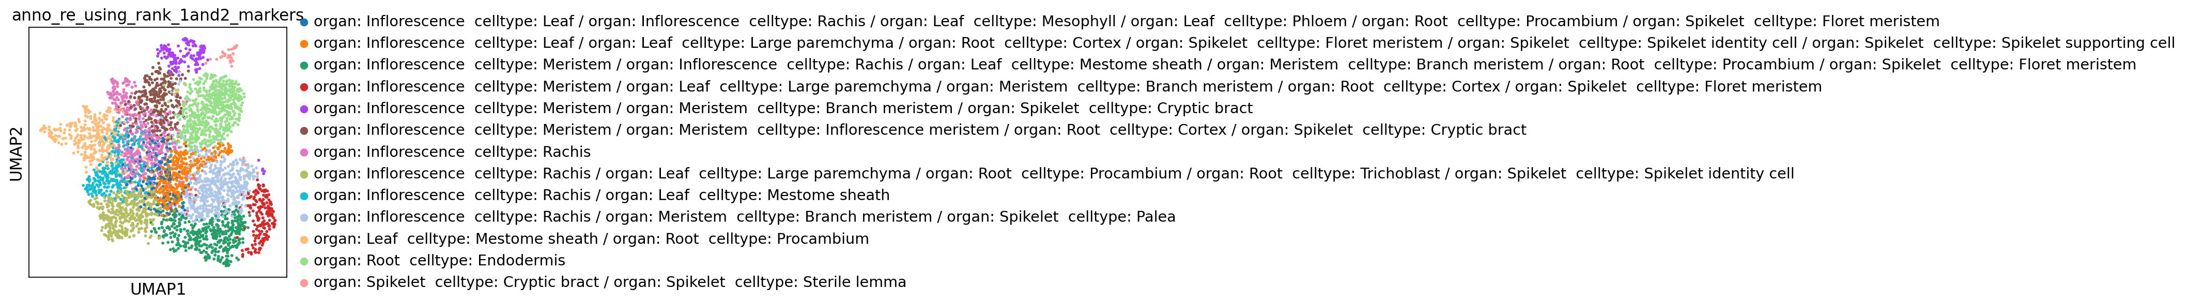

cluster 0: organ: Root celltype: Endodermis

cluster 1: organ: Meristem celltype: Branch meristem

cluster 2: organ: Meristem celltype: Branch meristem

cluster 3: organ: Meristem celltype: Branch meristem

cluster 4: organ: Meristem celltype: Branch meristem

cluster 5: organ: Inflorescence celltype: Rachis

cluster 6: organ: Inflorescence celltype: Rachis

cluster 7: organ: Inflorescence celltype: Rachis

cluster 8: Unknown

cluster 9: organ: Meristem celltype: Branch meristem

cluster 10: organ: Meristem celltype: Branch meristem

cluster 11: organ: Meristem celltype: Branch meristem

cluster 12: organ: Inflorescence celltype: Rachis

cluster 13: organ: Root celltype: Endodermis

cluster 14: organ: Inflorescence celltype: Rachis

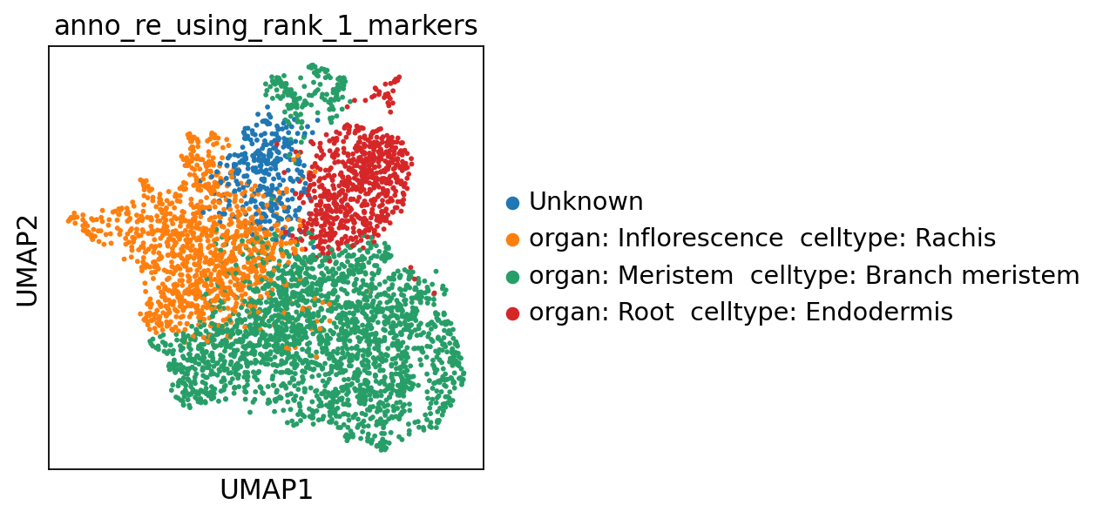

Memory collecting...

Memory information:

Used:

1623379968

Total:

201226063872

Used (%):

10.7

In [18]:

**del** scapp

gc**.**collect()

**with** open('SCAPP_0_Copy1.py','r') **as** f:

exec(f**.**read())

Out[18]:

426

Memory collecting...

Memory information:

Used:

1472589824

Total:

201226063872

Used (%):

10.6

**2 Specific processes**

In [19]:

**with** open('SCAPP_0_Copy1.py','r') **as** f:

exec(f**.**read())

Memory collecting...

Memory information:

Used:

1472589824

Total:

201226063872

Used (%):

10.6

In [20]:

filepath **=** "~/data/rice/CRA004082_PRJCA004855/Leaf-1/CRR279087/cellranger_CRR279087_without_introns/outs/filtered_feature_bc_matrix/matrix.mtx.gz"

In [21]:

scapp **=** SCAPP_0()

In [22]:

scapp**.**data_input_0(filepath **=** filepath)

--> This might be very slow. Consider passing `cache=True`, which enables much faster reading from a cache file.

In [23]:

scapp**.**set_default_0()

scanpy==1.9.2 anndata==0.8.0 umap==0.5.3 numpy==1.21.5 scipy==1.7.3 pandas==1.5.2 scikit-learn==1.2.1 statsmodels==0.13.5 python-igraph==0.10.4 louvain==0.8.0 pynndescent==0.5.8

**2.1 Filteration**

In [24]:

scapp**.**filter_0()

Before filter

normalizing counts per cell

finished (0:00:00)

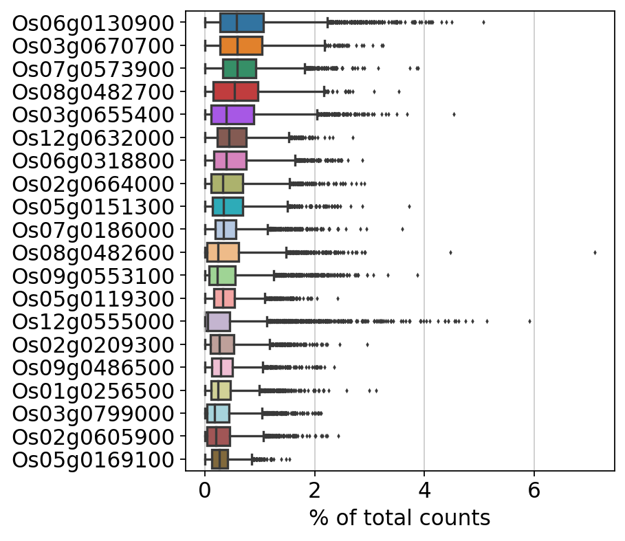

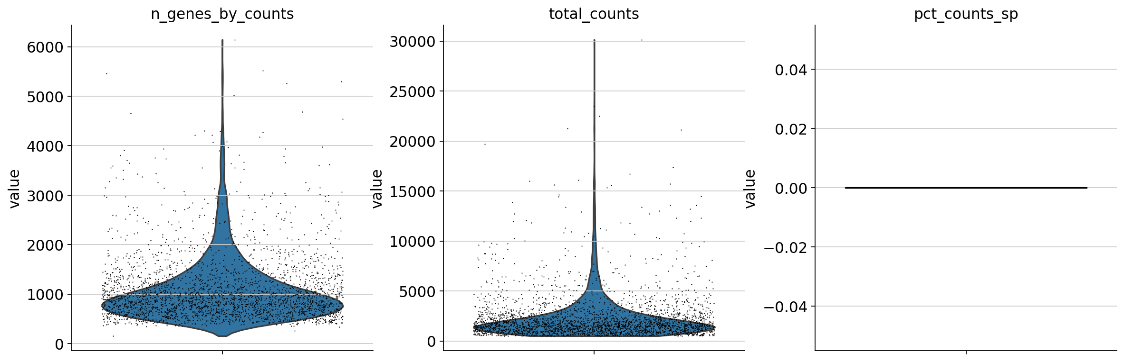

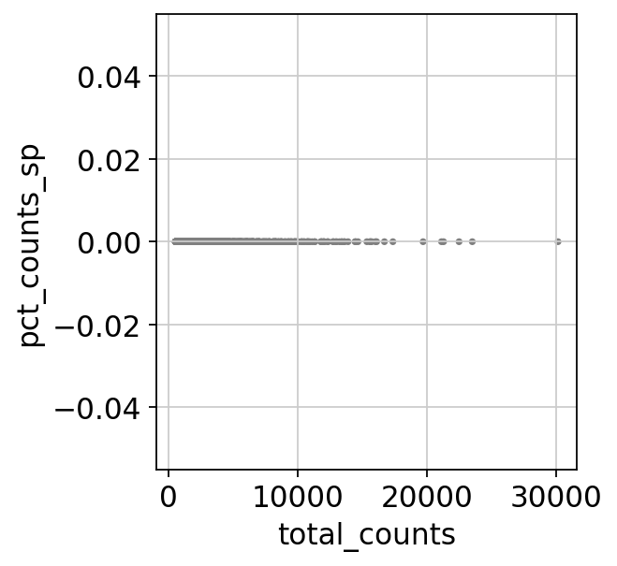

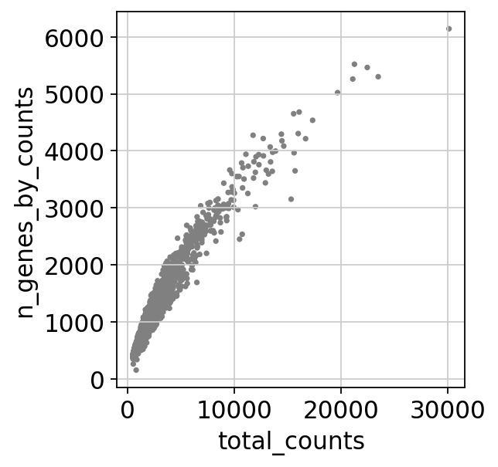

After filter

filtered out 1 cells that have less than 200 genes expressed

filtered out 15062 genes that are detected in less than 3 cells

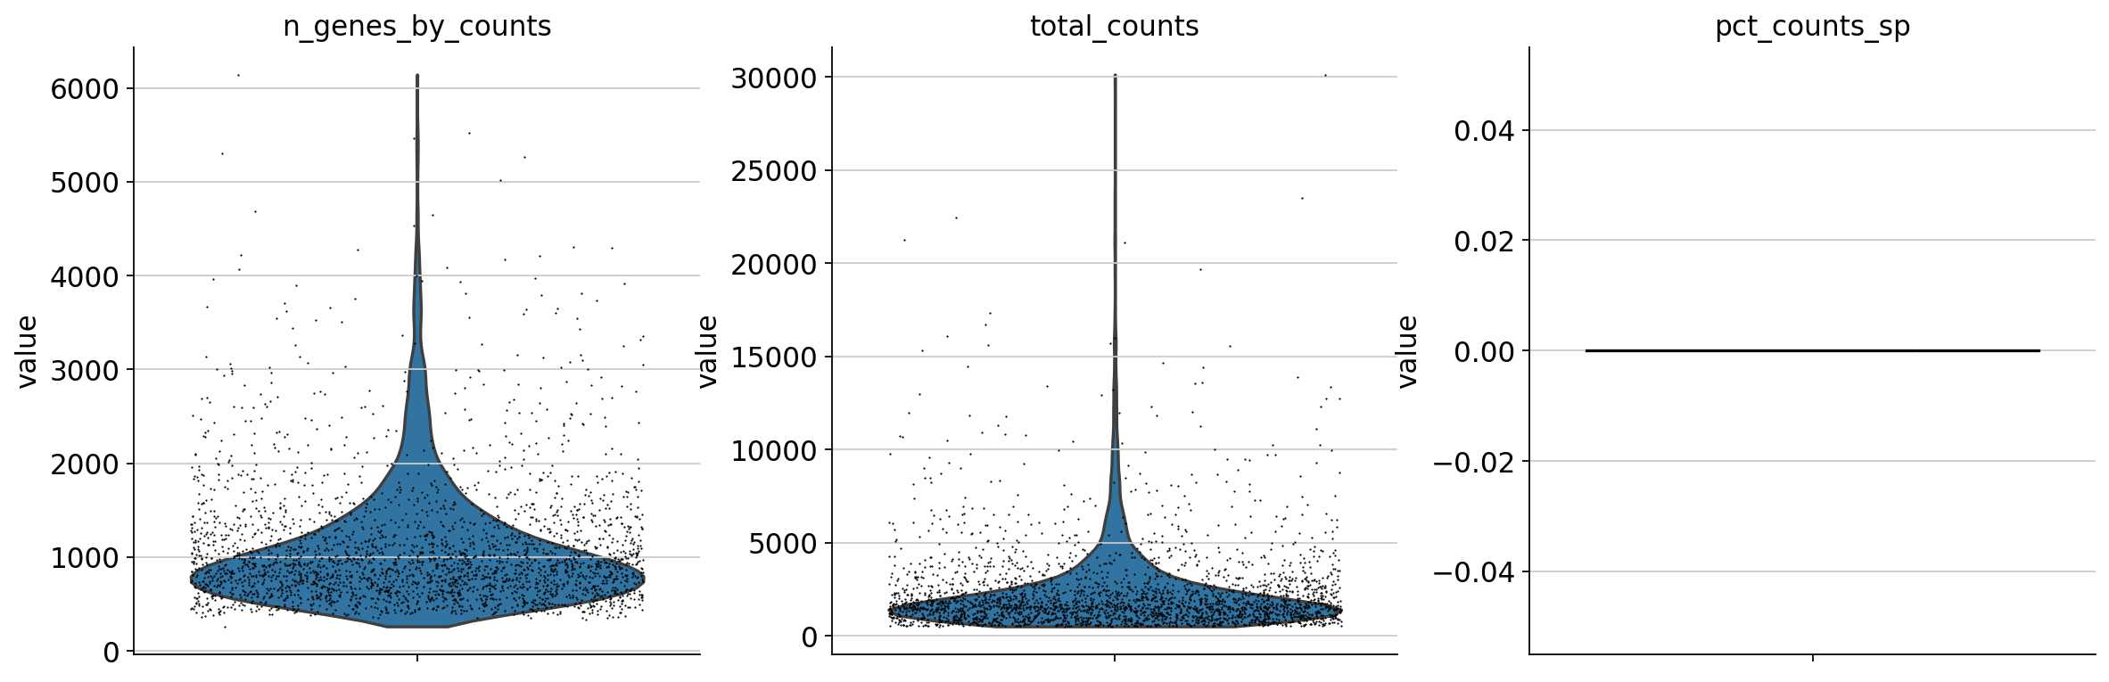

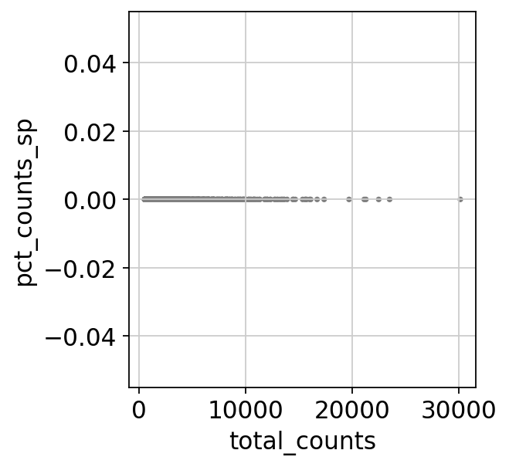

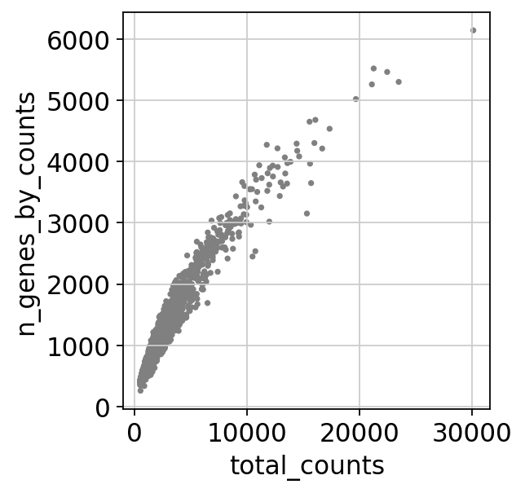

Before filter

count 2795.000000

mean 2293.302979

std 2263.849365

min 500.000000

25% 1090.500000

50% 1632.000000

75% 2556.000000

max 30131.000000

Name: total_counts, dtype: float64

count 2795.000000

mean 1085.045796

std 658.071797

min 153.000000

25% 672.500000

50% 910.000000

75% 1267.500000

max 6142.000000

Name: n_genes_by_counts, dtype: float64

count 2795.0

mean 0.0

std 0.0

min 0.0

25% 0.0

50% 0.0

75% 0.0

max 0.0

Name: pct_counts_sp, dtype: float64

After filter

count 2794.000000

mean 2293.835693

std 2264.080566

min 500.000000

25% 1091.250000

50% 1632.000000

75% 2556.500000

max 30131.000000

Name: total_counts, dtype: float64

count 2794.000000

mean 1085.379384

std 657.953189

min 260.000000

25% 673.000000

50% 910.500000

75% 1267.750000

max 6142.000000

Name: n_genes_by_counts, dtype: float64

count 2794.0

mean 0.0

std 0.0

min 0.0

25% 0.0

50% 0.0

75% 0.0

max 0.0

Name: pct_counts_sp, dtype: float64

**2.2 Select highly variable genes**

In [25]:

scapp**.**norm_log_hvg_filter_regress_scale_0()

normalizing counts per cell

finished (0:00:00)

extracting highly variable genes

finished (0:00:00)

--> added

'highly_variable', boolean vector (adata.var)

'means', float vector (adata.var)

'dispersions', float vector (adata.var)

'dispersions_norm', float vector (adata.var)

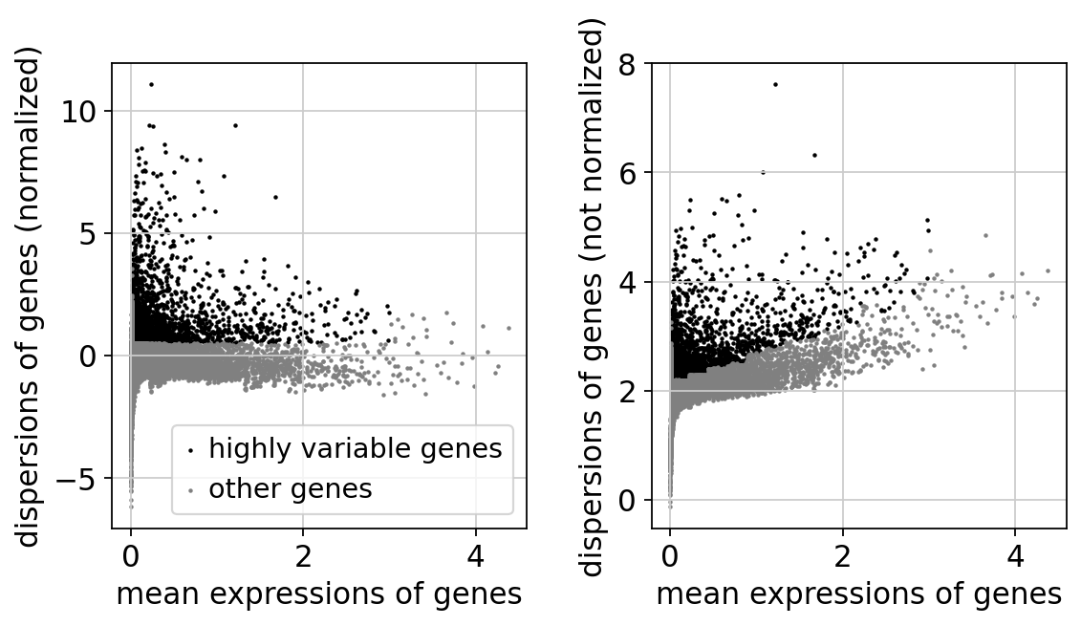

regressing out ['total_counts']

sparse input is densified and may lead to high memory use

finished (0:00:23)

**2.3 Select differentially expressed genes**

In [26]:

scapp**.**pca_cluster_markerSelect_0()

computing PCA

on highly variable genes

with n_comps=50

finished (0:00:00)

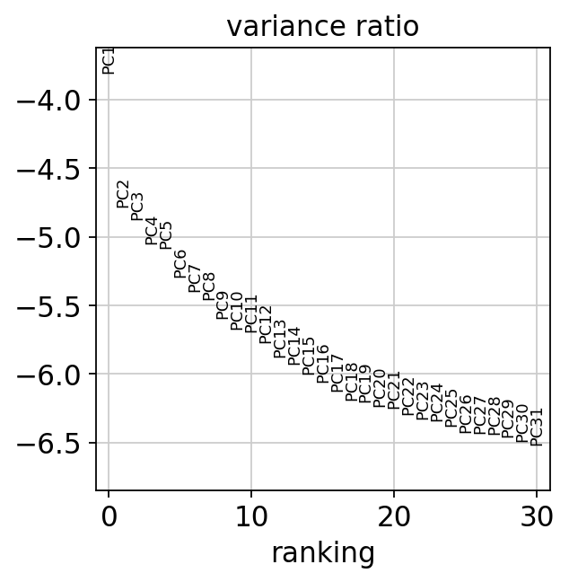

computing neighbors

using 'X_pca' with n_pcs = 40

finished: added to `.uns['neighbors']`

`.obsp['distances']`, distances for each pair of neighbors

`.obsp['connectivities']`, weighted adjacency matrix (0:00:00)

computing UMAP

finished: added

'X_umap', UMAP coordinates (adata.obsm) (0:00:09)

running Leiden clustering

finished: found 16 clusters and added

'leiden', the cluster labels (adata.obs, categorical) (0:00:00)

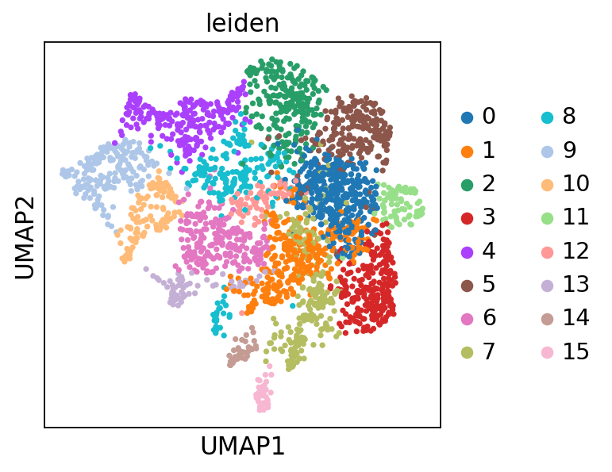

running PAGA

finished: added

'paga/connectivities', connectivities adjacency (adata.uns)

'paga/connectivities_tree', connectivities subtree (adata.uns) (0:00:00)

--> added 'pos', the PAGA positions (adata.uns['paga'])

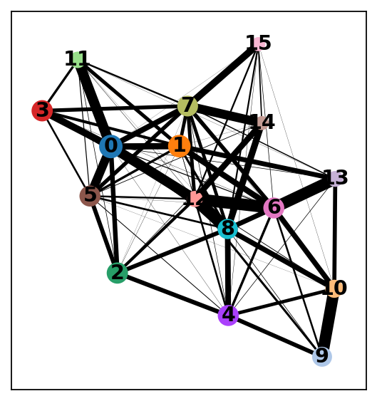

computing UMAP

finished: added

'X_umap', UMAP coordinates (adata.obsm) (0:00:08)

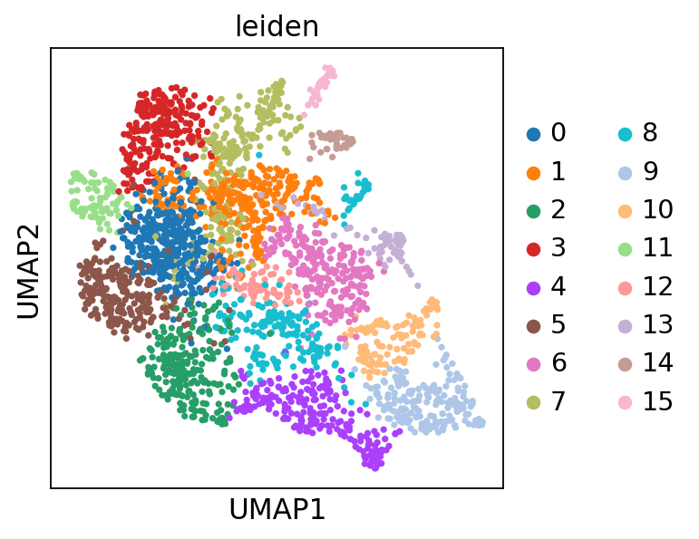

ranking genes

finished: added to `.uns['rank_genes_groups']`

'names', sorted np.recarray to be indexed by group ids

'scores', sorted np.recarray to be indexed by group ids

'logfoldchanges', sorted np.recarray to be indexed by group ids

'pvals', sorted np.recarray to be indexed by group ids

'pvals_adj', sorted np.recarray to be indexed by group ids (0:00:00)

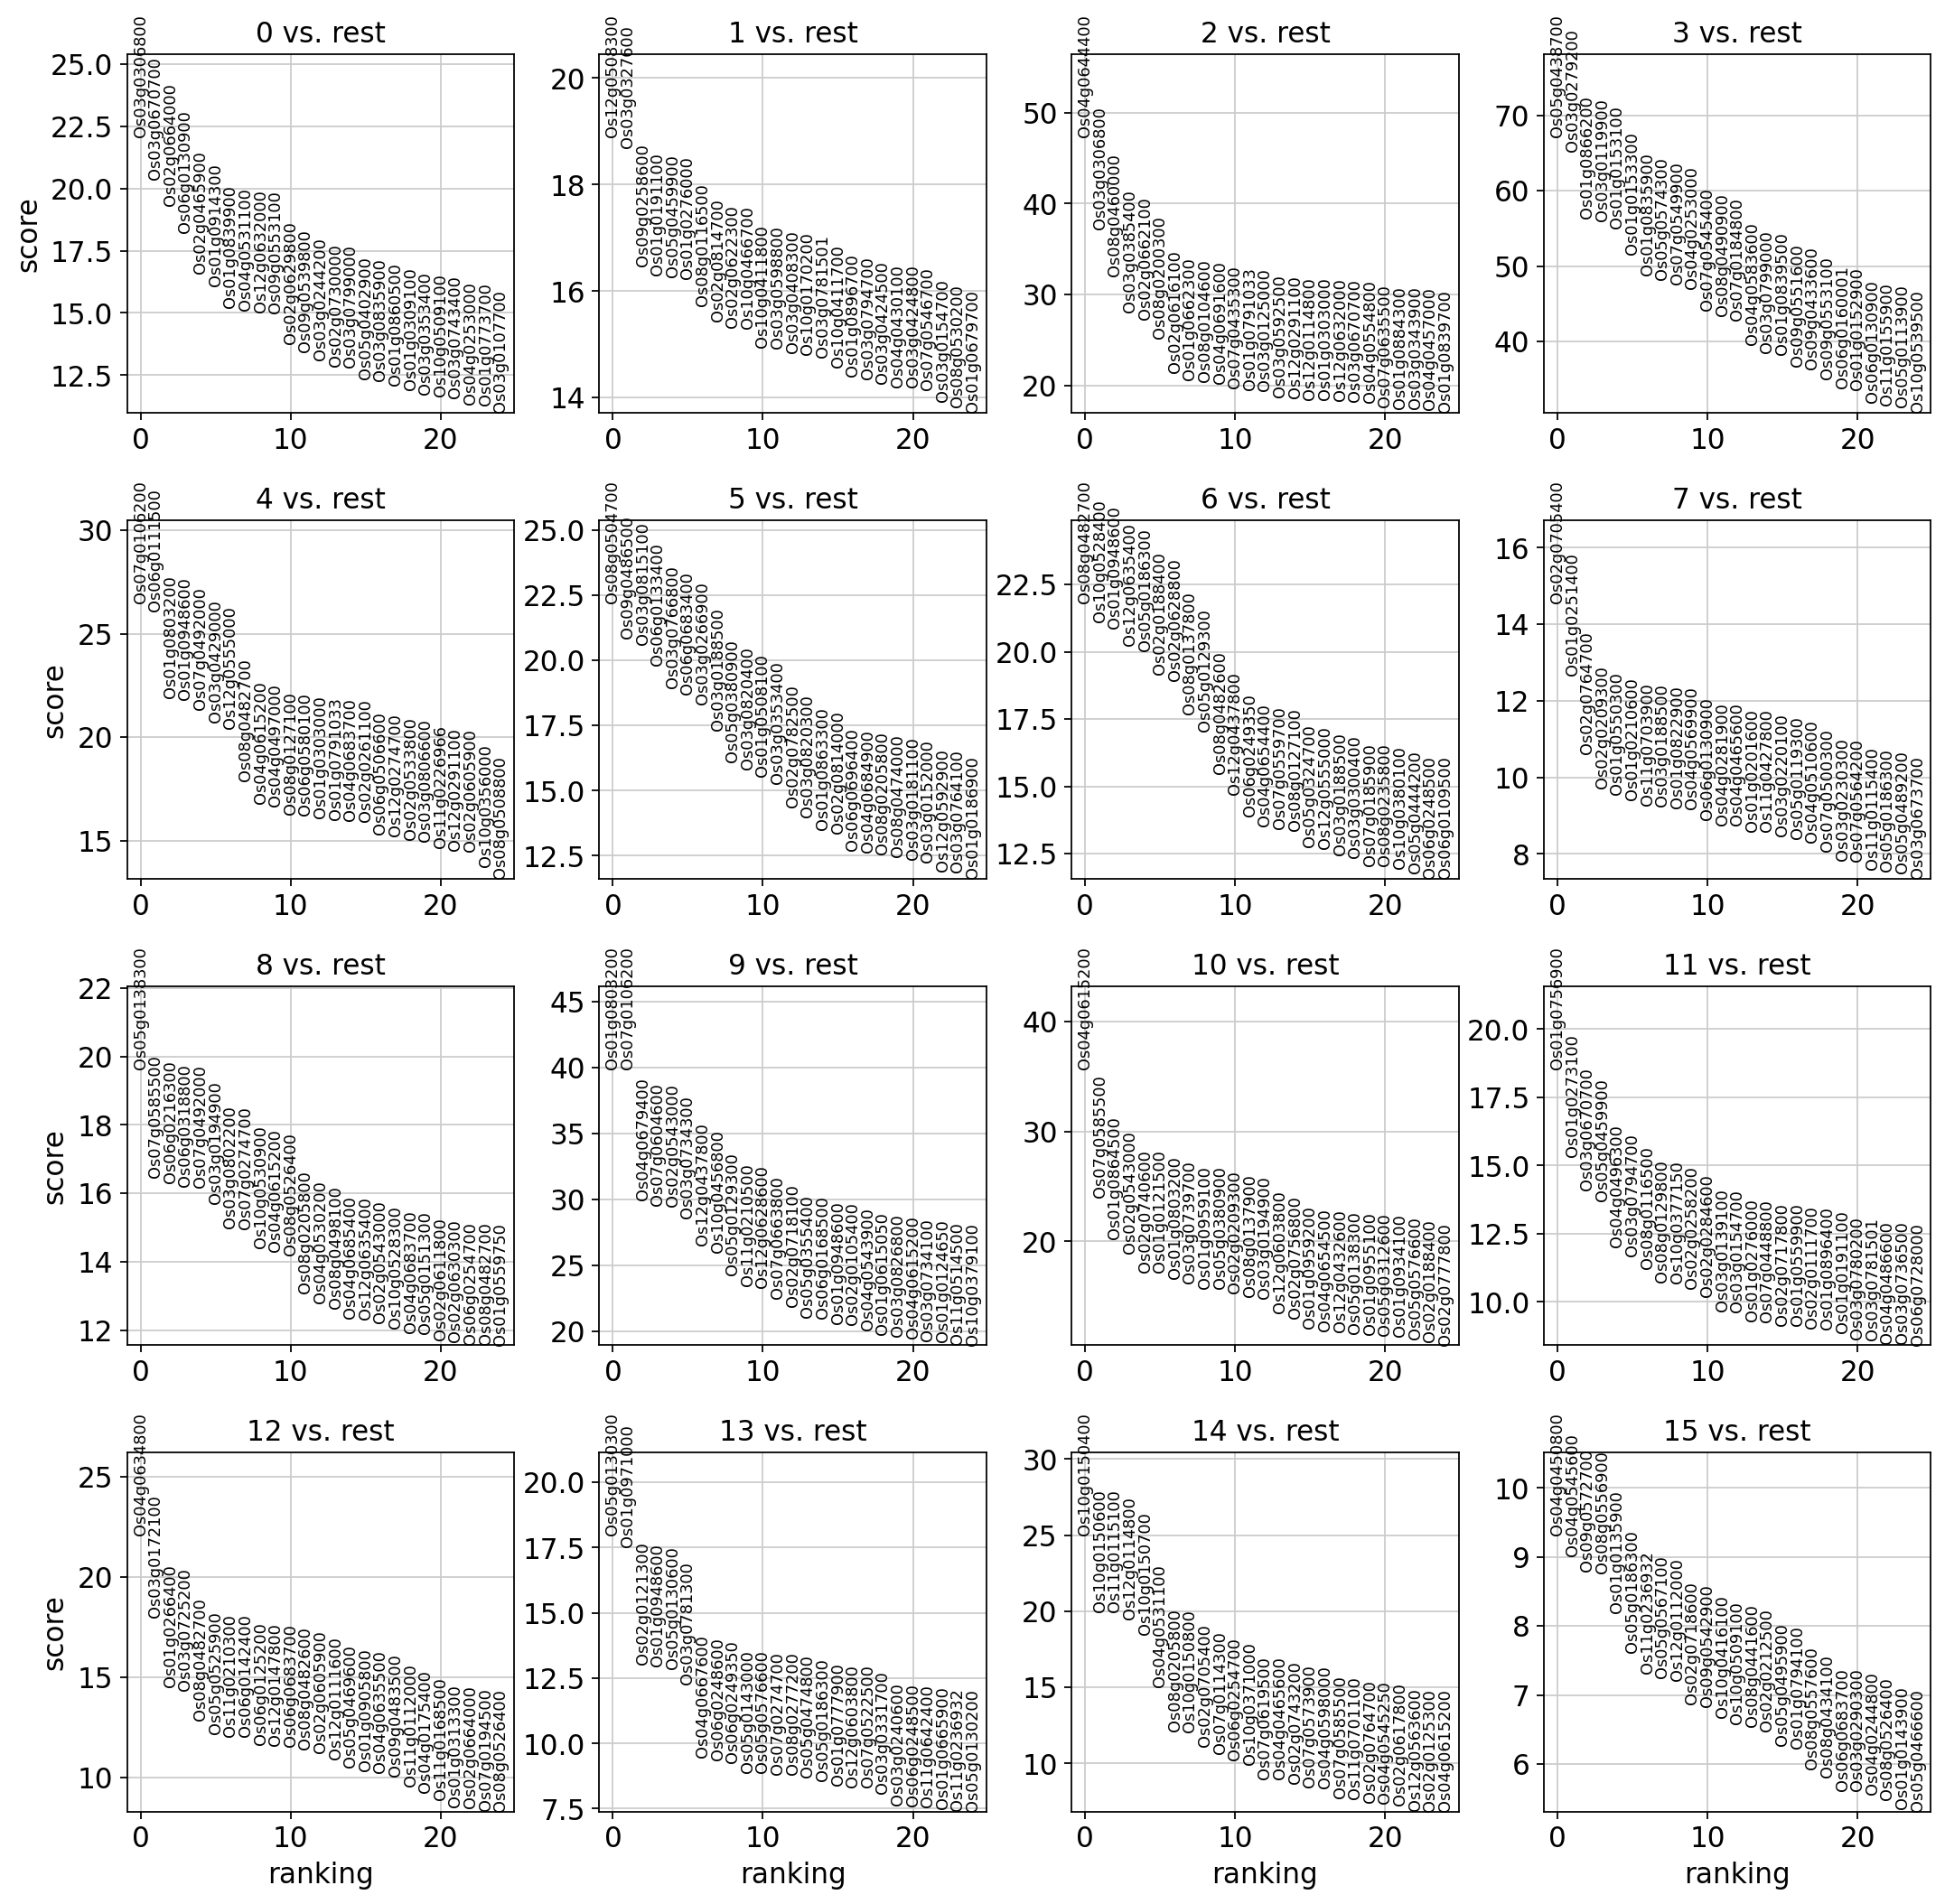

The below is the top marker gene list for each cluster.

You can change the annotation result according to this.

The list of top marker genes

col : clusters

0 1 2 3 4 \

0 Os03g0306800 Os12g0508300 Os04g0644400 Os05g0438700 Os07g0106200

1 Os03g0670700 Os03g0327600 Os03g0306800 Os03g0279200 Os06g0111500

2 Os02g0664000 Os09g0258600 Os08g0460000 Os01g0866200 Os01g0803200

3 Os06g0130900 Os01g0191100 Os03g0385400 Os03g0119900 Os01g0948600

4 Os02g0465900 Os05g0459900 Os02g0662100 Os01g0153100 Os07g0492000

5 Os01g0914300 Os01g0276000 Os08g0200300 Os01g0153300 Os03g0429000

6 Os01g0839900 Os08g0116500 Os02g0616100 Os01g0835900 Os12g0555000

7 Os04g0531100 Os02g0814700 Os01g0662300 Os05g0574300 Os08g0482700

8 Os12g0632000 Os02g0622300 Os08g0104600 Os07g0549900 Os04g0615200

9 Os09g0553100 Os10g0466700 Os04g0691600 Os04g0253000 Os04g0497000

10 Os02g0629800 Os10g0411800 Os07g0435300 Os07g0545400 Os08g0127100

11 Os09g0539800 Os03g0598800 Os01g0791033 Os08g0490900 Os06g0580100

12 Os03g0244200 Os03g0408300 Os03g0125000 Os07g0184800 Os01g0303000

13 Os02g0730000 Os10g0170200 Os03g0592500 Os04g0583600 Os01g0791033

14 Os03g0799000 Os03g0781501 Os12g0291100 Os03g0799000 Os04g0683700

15 Os05g0402900 Os10g0411700 Os12g0114800 Os01g0839500 Os02g0261100

16 Os03g0835900 Os01g0896700 Os01g0303000 Os09g0551600 Os06g0506600

17 Os01g0860500 Os03g0794700 Os12g0632000 Os09g0433600 Os12g0274700

18 Os01g0309100 Os03g0424500 Os03g0670700 Os09g0553100 Os02g0533800

19 Os03g0353400 Os04g0430100 Os04g0554800 Os06g0160001 Os03g0806600

5 6 7 8 9 \

0 Os08g0504700 Os08g0482700 Os02g0705400 Os05g0138300 Os01g0803200

1 Os09g0486500 Os10g0528400 Os01g0251400 Os07g0585500 Os07g0106200

2 Os03g0815100 Os01g0948600 Os02g0764700 Os06g0216300 Os04g0679400

3 Os06g0133400 Os12g0635400 Os02g0209300 Os06g0318800 Os07g0604600

4 Os03g0766800 Os05g0186300 Os01g0550300 Os07g0492000 Os02g0543000

5 Os06g0683400 Os02g0188400 Os01g0210600 Os03g0194900 Os03g0734300

6 Os03g0266900 Os02g0628800 Os11g0703900 Os03g0802200 Os12g0437800

7 Os03g0188500 Os08g0137800 Os03g0188500 Os07g0274700 Os10g0456800

8 Os05g0380900 Os05g0129300 Os01g0822900 Os10g0530900 Os05g0129300

9 Os03g0820400 Os08g0482600 Os04g0569900 Os04g0615200 Os11g0210500

10 Os01g0508100 Os12g0437800 Os06g0130900 Os08g0526400 Os12g0628600

11 Os03g0353400 Os06g0249350 Os04g0281900 Os08g0205800 Os07g0663800

12 Os02g0782500 Os04g0654400 Os04g0465600 Os04g0530200 Os02g0718100

13 Os03g0820300 Os07g0559700 Os01g0201600 Os08g0498100 Os05g0355400

14 Os01g0863300 Os08g0127100 Os11g0427800 Os04g0685400 Os06g0168500

15 Os02g0814000 Os05g0324700 Os03g0220100 Os12g0635400 Os01g0948600

16 Os06g0696400 Os12g0555000 Os05g0119300 Os02g0543000 Os02g0105400

17 Os04g0684900 Os03g0188500 Os04g0510600 Os10g0528300 Os04g0543900

18 Os08g0205800 Os03g0300400 Os07g0500300 Os04g0683700 Os01g0615050

19 Os08g0474000 Os07g0185900 Os03g0230300 Os05g0151300 Os03g0826800

10 11 12 13 14 \

0 Os04g0615200 Os01g0756900 Os04g0634800 Os05g0130300 Os10g0150400

1 Os07g0585500 Os01g0273100 Os03g0172100 Os01g0971000 Os10g0150600

2 Os01g0864500 Os03g0670700 Os01g0266400 Os02g0121300 Os11g0115100

3 Os02g0543000 Os05g0459900 Os03g0725200 Os01g0948600 Os12g0114800

4 Os02g0740600 Os04g0496300 Os08g0482700 Os05g0130600 Os10g0150700

5 Os01g0121500 Os03g0794700 Os05g0525900 Os03g0781300 Os04g0531100

6 Os01g0803200 Os08g0116500 Os11g0210300 Os04g0667600 Os08g0205800

7 Os03g0739700 Os08g0129800 Os06g0142400 Os06g0248600 Os10g0150800

8 Os01g0959100 Os10g0377150 Os06g0125200 Os06g0249350 Os02g0705400

9 Os05g0380900 Os02g0258200 Os12g0147800 Os05g0143000 Os07g0114300

10 Os02g0209300 Os02g0284600 Os06g0683700 Os05g0576600 Os06g0254700

11 Os08g0137900 Os03g0139100 Os08g0482600 Os07g0274700 Os10g0371000

12 Os03g0194900 Os03g0154700 Os02g0605900 Os08g0277200 Os07g0619500

13 Os12g0603800 Os01g0276000 Os12g0111600 Os05g0474800 Os04g0465600

14 Os02g0756800 Os07g0448800 Os05g0469600 Os05g0186300 Os02g0743200

15 Os01g0959200 Os02g0717800 Os01g0905800 Os01g0777900 Os07g0573900

16 Os04g0654500 Os01g0559900 Os04g0635500 Os12g0603800 Os04g0598000

17 Os12g0432600 Os02g0111700 Os09g0483500 Os07g0522500 Os07g0585500

18 Os05g0138300 Os01g0896400 Os11g0112000 Os03g0331700 Os11g0701100

19 Os01g0955100 Os01g0191100 Os04g0175400 Os03g0240600 Os02g0764700

15

0 Os04g0450800

1 Os04g0545600

2 Os09g0572700

3 Os08g0556900

4 Os01g0135900

5 Os05g0186300

6 Os11g0236932

7 Os05g0567100

8 Os12g0112000

9 Os02g0718600

10 Os09g0542900

11 Os10g0416100

12 Os10g0509100

13 Os08g0441600

14 Os02g0212500

15 Os05g0495900

16 Os01g0794100

17 Os08g0557600

18 Os08g0434100

19 Os06g0683700

Top marker genes and their p-values of each cluster:

0_n 0_p 1_n 1_p 2_n \

0 Os03g0306800 2.495046e-79 Os12g0508300 6.821100e-56 Os04g0644400

1 Os03g0670700 4.112021e-75 Os03g0327600 1.875123e-54 Os03g0306800

2 Os02g0664000 4.638194e-66 Os09g0258600 8.707506e-46 Os08g0460000

3 Os06g0130900 5.628687e-60 Os01g0191100 5.906231e-45 Os03g0385400

4 Os02g0465900 1.871382e-49 Os05g0459900 9.399410e-46 Os02g0662100

5 Os01g0914300 1.940196e-45 Os01g0276000 5.327998e-45 Os08g0200300

6 Os01g0839900 4.534094e-42 Os08g0116500 3.083181e-43 Os02g0616100

7 Os04g0531100 9.673682e-44 Os02g0814700 2.203970e-41 Os01g0662300

8 Os12g0632000 9.811990e-44 Os02g0622300 4.096607e-41 Os08g0104600

9 Os09g0553100 9.688592e-43 Os10g0466700 1.660328e-41 Os04g0691600

10 Os02g0629800 5.854466e-36 Os10g0411800 7.219533e-40 Os07g0435300

11 Os09g0539800 7.709255e-35 Os03g0598800 1.998304e-39 Os01g0791033

12 Os03g0244200 1.014084e-33 Os03g0408300 2.402549e-39 Os03g0125000

13 Os02g0730000 4.057956e-32 Os10g0170200 4.472987e-39 Os03g0592500

14 Os03g0799000 9.208098e-33 Os03g0781501 5.785176e-39 Os12g0291100

15 Os05g0402900 1.695289e-30 Os10g0411700 6.834259e-38 Os12g0114800

16 Os03g0835900 4.785222e-30 Os01g0896700 2.011614e-37 Os01g0303000

17 Os01g0860500 3.229937e-29 Os03g0794700 2.545967e-37 Os12g0632000

18 Os01g0309100 1.442297e-28 Os03g0424500 1.829679e-36 Os03g0670700

19 Os03g0353400 4.821873e-28 Os04g0430100 1.491817e-36 Os04g0554800

2_p 3_n 3_p 4_n 4_p \

0 4.213413e-131 Os05g0438700 1.029910e-205 Os07g0106200 1.003623e-77

1 1.737456e-136 Os03g0279200 2.237884e-203 Os06g0111500 1.297946e-82

2 3.648315e-90 Os01g0866200 1.399098e-225 Os01g0803200 9.812054e-63

3 9.466776e-82 Os03g0119900 1.512666e-241 Os01g0948600 1.426509e-63

4 2.242578e-78 Os01g0153100 2.304378e-183 Os07g0492000 3.264867e-63

5 6.807608e-73 Os01g0153300 2.880264e-153 Os03g0429000 1.708325e-57

6 1.817523e-57 Os01g0835900 5.053736e-164 Os12g0555000 2.190762e-57

7 4.830891e-56 Os05g0574300 4.510717e-137 Os08g0482700 6.566121e-55

8 8.010498e-56 Os07g0549900 7.864383e-169 Os04g0615200 1.981247e-44

9 7.780089e-55 Os04g0253000 2.112705e-175 Os04g0497000 8.473524e-44

10 1.431338e-53 Os07g0545400 3.080634e-168 Os08g0127100 2.002633e-42

11 3.477538e-56 Os08g0490900 2.844185e-123 Os06g0580100 8.425033e-42

12 4.504478e-52 Os07g0184800 1.258534e-160 Os01g0303000 4.224495e-41

13 3.614784e-50 Os04g0583600 1.908294e-114 Os01g0791033 8.418102e-40

14 5.033559e-50 Os03g0799000 4.217909e-159 Os04g0683700 4.697883e-41

15 2.376448e-48 Os01g0839500 2.800743e-128 Os02g0261100 1.138805e-40

16 5.666710e-50 Os09g0551600 2.448983e-117 Os06g0506600 1.595219e-39

17 1.363890e-54 Os09g0433600 2.034220e-114 Os12g0274700 8.542287e-37

18 7.187591e-56 Os09g0553100 3.721512e-129 Os02g0533800 3.768128e-38

19 1.410116e-46 Os06g0160001 5.376099e-96 Os03g0806600 7.993421e-36

... 11_n 11_p 12_n 12_p 13_n \

0 ... Os01g0756900 4.575349e-30 Os04g0634800 9.863468e-37 Os05g0130300

1 ... Os01g0273100 5.229926e-25 Os03g0172100 3.861370e-30 Os01g0971000

2 ... Os03g0670700 2.580066e-25 Os01g0266400 2.099535e-23 Os02g0121300

3 ... Os05g0459900 3.124693e-23 Os03g0725200 6.173386e-23 Os01g0948600

4 ... Os04g0496300 2.951271e-19 Os08g0482700 5.508189e-23 Os05g0130600

5 ... Os03g0794700 3.358460e-19 Os05g0525900 2.088810e-19 Os03g0781300

6 ... Os08g0116500 2.792144e-18 Os11g0210300 1.722824e-19 Os04g0667600

7 ... Os08g0129800 2.517802e-17 Os06g0142400 6.345457e-19 Os06g0248600

8 ... Os10g0377150 8.245321e-17 Os06g0125200 4.244991e-18 Os06g0249350

9 ... Os02g0258200 1.954065e-16 Os12g0147800 1.533973e-18 Os05g0143000

10 ... Os02g0284600 5.120949e-16 Os06g0683700 3.502826e-18 Os05g0576600

11 ... Os03g0139100 3.954734e-15 Os08g0482600 1.149191e-18 Os07g0274700

12 ... Os03g0154700 5.032021e-15 Os02g0605900 5.052869e-18 Os08g0277200

13 ... Os01g0276000 2.091783e-14 Os12g0111600 5.191676e-17 Os05g0474800

14 ... Os07g0448800 3.038969e-14 Os05g0469600 3.952172e-16 Os05g0186300

15 ... Os02g0717800 4.461244e-14 Os01g0905800 2.218524e-16 Os01g0777900

16 ... Os01g0559900 5.476627e-14 Os04g0635500 1.171380e-15 Os12g0603800

17 ... Os02g0111700 8.524985e-14 Os09g0483500 2.600421e-15 Os07g0522500

18 ... Os01g0896400 1.382042e-13 Os11g0112000 2.372462e-14 Os03g0331700

19 ... Os01g0191100 1.775284e-13 Os04g0175400 8.225258e-14 Os03g0240600

13_p 14_n 14_p 15_n 15_p

0 3.790443e-27 Os10g0150400 8.383655e-25 Os04g0450800 2.124997e-11

1 2.459404e-26 Os10g0150600 1.988575e-21 Os04g0545600 7.094912e-11

2 4.443330e-20 Os11g0115100 1.561323e-21 Os09g0572700 1.270802e-10

3 1.916661e-20 Os12g0114800 3.187515e-21 Os08g0556900 1.443137e-10

4 1.210793e-19 Os10g0150700 2.773070e-20 Os01g0135900 7.777280e-10

5 8.707716e-19 Os04g0531100 3.479713e-19 Os05g0186300 3.574750e-09

6 6.658095e-14 Os08g0205800 7.433943e-15 Os11g0236932 1.047551e-08

7 1.051053e-13 Os10g0150800 2.043755e-14 Os05g0567100 1.302984e-08

8 1.518793e-13 Os02g0705400 4.709660e-14 Os12g0112000 1.369807e-08

9 7.877279e-13 Os07g0114300 5.250633e-14 Os02g0718600 3.902147e-08

10 6.233053e-13 Os06g0254700 1.790333e-12 Os09g0542900 4.549833e-08

11 6.389362e-13 Os10g0371000 3.512302e-12 Os10g0416100 7.162596e-08

12 1.079860e-12 Os07g0619500 6.914487e-11 Os10g0509100 8.651951e-08

13 1.411677e-12 Os04g0465600 8.531865e-11 Os08g0441600 1.164111e-07

14 2.166972e-12 Os02g0743200 1.308086e-10 Os02g0212500 1.439044e-07

15 6.104749e-12 Os07g0573900 8.591996e-11 Os05g0495900 2.673508e-07

16 5.953034e-12 Os04g0598000 3.658906e-10 Os01g0794100 2.812560e-07

17 7.176643e-12 Os07g0585500 2.169936e-09 Os08g0557600 7.017509e-07

18 1.470205e-11 Os11g0701100 3.506020e-09 Os08g0434100 1.107853e-06

19 1.138723e-10 Os02g0764700 5.528794e-09 Os06g0683700 1.962006e-06

[20 rows x 32 columns]

**2.4 Annotation**

In [27]:

scapp**.**markergenepd_make_0()

scapp**.**annotation_with_marker_gene_list_0()

cluster 0: organ: Leaf celltype: Mesophyll

cluster 1: organ: Root celltype: Endodermis

cluster 2: organ: Leaf celltype: Mesophyll

cluster 3: organ: Inflorescence celltype: Spikelet / organ: Root celltype: Procambium / organ: Spikelet celltype: Cryptic bract/bract / organ: Spikelet celltype: Cryptic bract

cluster 4: organ: Leaf celltype: Large paremchyma / organ: Root celltype: Columella / organ: Root celltype: Epidermis (near root hair) / organ: Root celltype: Procambium

cluster 5: organ: Inflorescence celltype: Meristem / organ: Leaf celltype: Mesophyll precursor / organ: Meristem celltype: Inflorescence meristem / organ: Root celltype: Cortex / organ: Spikelet celltype: Cryptic bract

cluster 6: organ: Leaf celltype: Mestome sheath / organ: Root celltype: Procambium

cluster 7: organ: Leaf celltype: Mestome sheath / organ: Root celltype: Phloem

cluster 8: organ: Leaf celltype: Phloem / organ: Root celltype: Cortex

cluster 9: organ: Leaf celltype: Epidermis / organ: Meristem celltype: Branch meristem / organ: Root celltype: Columella / organ: Root celltype: Cortex

cluster 10: organ: Leaf celltype: Large paremchyma / organ: Root celltype: Procambium

cluster 11: organ: Root celltype: Endodermis

cluster 12: organ: Leaf celltype: Large paremchyma / organ: Root celltype: Procambium

cluster 13: organ: Leaf celltype: Phloem / organ: Root celltype: Phloem

cluster 14: organ: Leaf celltype: Fiber

cluster 15: organ: Root celltype: Cortex

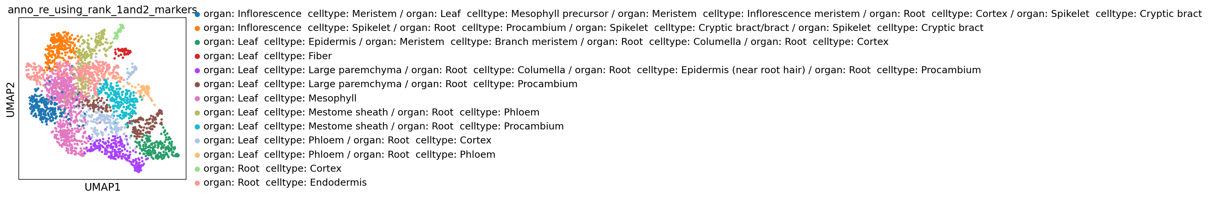

cluster 0: Unknown

cluster 1: organ: Root celltype: Endodermis

cluster 2: organ: Root celltype: Cortex

cluster 3: Unknown

cluster 4: organ: Meristem celltype: Branch meristem

cluster 5: organ: Root celltype: Cortex

cluster 6: organ: Meristem celltype: Branch meristem

cluster 7: organ: Meristem celltype: Branch meristem

cluster 8: organ: Meristem celltype: Branch meristem

cluster 9: organ: Leaf celltype: Large paremchyma

cluster 10: organ: Meristem celltype: Branch meristem

cluster 11: organ: Meristem celltype: Spikelet meristem

cluster 12: organ: Meristem celltype: Branch meristem

cluster 13: organ: Meristem celltype: Branch meristem

cluster 14: organ: Root celltype: Cortex

cluster 15: organ: Meristem celltype: Branch meristem

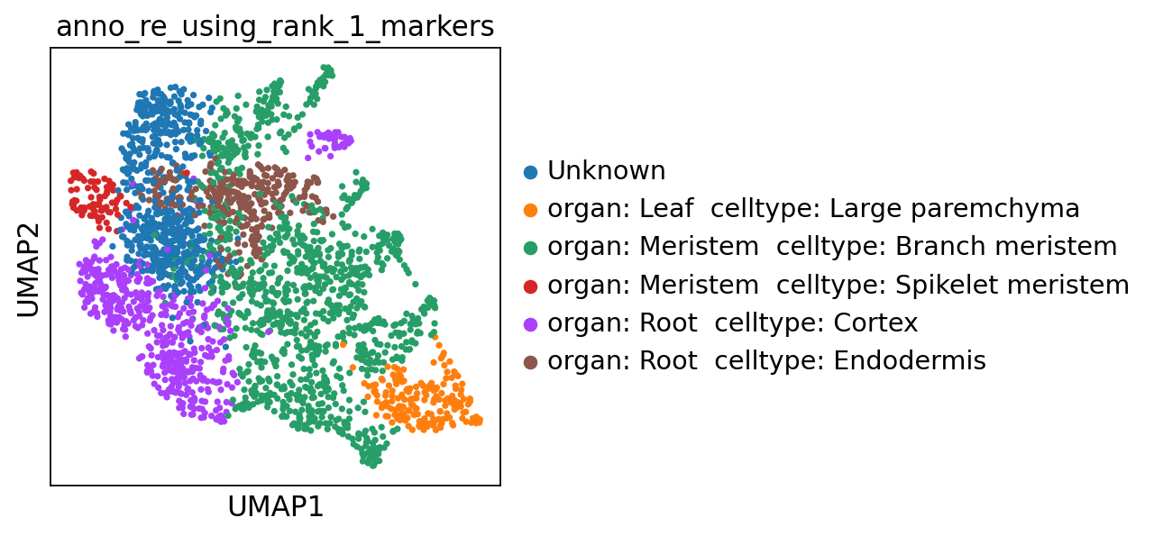

Memory collecting...

Memory information:

Used:

1539764224

Total:

201226063872

Used (%):

10.6

In [28]:

**del** scapp

gc**.**collect()

Out[28]:

519

**3 Extensions (temporarily unavailable)**

**3.1 Doublet detection (temporarily unavailable)**

In [ ]:

**APIs**

  1 Data imput

  2 To clusters

  3 To annotation

  4 Scanpy object accession

  5 Figure setting and downloading

In [ ]:

**with** open('SCAPP_0_Copy1.py','r') **as** f:

exec(f**.**read())

In [ ]:

scapp **=** SCAPP_0()

**1 Data imput**

In [ ]:

scapp**.**data_input_0(filepath**=None**)

scapp**.**batch_data_input_0(filepaths**=None**)

scapp**.**data_input_0_from_anndata(anndata**=None**)

**2 To clusters**

**The function below will filter out cells and genes based on the parameters below.**

**MAD is median absolute deviation.**

**MAD = | median( | median(X) - X | ) |**

**If "mad_coeffcient" is n, the function will filter out cells whose "n_genes_by_counts" or "total_counts" is not in (median - n x MAD, median + n x MAD)**

**The default "mad_coeffcient" is "None"**

In [ ]:

scapp**.**filter_0(self, n_top**=**20, num_min_genes**=**200, num_max_genes**=None**, num_min_cells**=**3,

max_percent_of_specific_genes**=**0.05,

genelist**=None**, mad_coeffcient**=None**)

**The fuction below will do standardization, normalization, regression, and select highly variable genes (HVGs).**

In [ ]:

scapp**.**norm_log_hvg_filter_regress_scale_0(norm_target_sum**=**1e4, hvg_min_mean**=**0.0125, hvg_max_mean**=**3,

hvg_min_dispersions**=**0.5, regresslist**=**['total_counts'], scale_max_value**=**10)

**The fuction below will do PCA, clustering and select differentially expressed genes (DEGs) for each cluster.**

**Use larger numbers of 'cluster_n_neighbors' and 'cluster_n_pcs', you will have a greater chance of getting more cell groups.**

**The default markerSelect_method is 't-test', while 'wilcoxon' and 'logreg' is ok too.**

**You can give a list of genes as 'pca_genelist' or 'umap_genelist' and have the PCA or umap results show genes of interest to you.**

**By default, the function will select 25 (the number of 'markerSelect_n_genes') DEGs and use top 20 DEGs (the number of 'show_n') for annotation.**

In [ ]:

scapp**.**pca_cluster_markerSelect_0(pca_svd_algorithm**=**'arpack', pca_genelist**=None**,

cluster_n_neighbors**=**20, cluster_n_pcs**=**40, use_rep**=None**, perform_umap**=True**,

umap_genelist**=None**, perform_paga**=True**,

markerSelect_method**=**['t-test'],

markerSelect_n_genes**=**25, show_n**=**20)

**3 To annotation**

**The fuction below will do annotation.**

In [ ]:

scapp**.**markergenepd_make_0()

scapp**.**annotation_with_marker_gene_list_0()

**4 Scanpy object accession**

**4.1 You can access the 'scanpy-anndata' object through 'scapp.obj'.**

In [ ]:

scapp**.**obj

**4.2 You can change names of genes or cells into the form you want by passing in a list of names.**

**Note that the length of the list you pass in must be the same as that of the existing list, and the names in the two lists must correspond to each other one by one.**

In [ ]:

scapp**.**obj**.**var_names **=** namelist1 *# change gene names*

scapp**.**obj**.**obs_names **=** namelist2 *# change cell names*

**5 Figure setting and downloading**

**5.1 The default dpi of figures is 80, you can change it to a larger number.**

In [ ]:

scapp**.**set_default_0(dpi**=**80)

**5.2 You can download the result by "File" -> "Download as" -> "HTML" / "Markdown" / "Python"**

In [ ]: